Here are some resources to learn about the structure of hemoglobin and the molecular basis of Sickle Cell Disease:

# | Resource Name | Authors (where available) | Link/Detail | Comment
1 | Online Macromolecular Museum  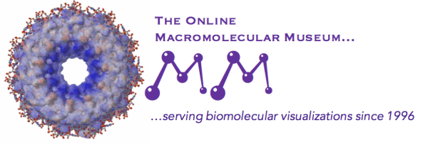 | David Marcey, Stephanie Levi-Blumer, and  Cassidy R. Terrell | https://earth.callutheran.edu/Academic_Programs/Departments/BioDev/omm/jsmolnew/hemo/hemoglobina.html | Hemoglobin A Structure, Sickle Cell Anemia, and Carbon Monoxide Toxicity
2 | PDB-101; Molecule of the Month | Shuchismita Dutta, David Goodsell | http://pdb101.rcsb.org/motm/41 | Hemoglobin
3 | Proteopedia | Eran Hodis, Michal Harel, Joel L. Sussman, Alexander Berchansky, Jaime Prilusky, Eric Martz, Karl Oberholser, Mark Hoelzer, Marc Gillespie, Ann Taylor | https://proteopedia.org/wiki/index.php/Hemoglobin | Hemoglobin
4 | MolviZ.Org | Eric Martz | hemoglobin.molviz.org | Hemoglobin
5 | CBM MSOE | MSOE | http://cbm.msoe.edu/includes/modules/jmolCRESTProteins/hemoglobin.html# | Hemoglobin
6 | HHMI | HHMI | https://www.hhmi.org/biointeractive/sickle-cell-disease | Sickle cell Disease
7 | National Center for Case Study Teaching in Science | Debra L. Stamper | http://sciencecases.lib.buffalo.edu/cs/files/sickle_cell.pdf | Sickle Cell Anemia
8 | National Heart Lung and Blood Institute | NHLBI | https://www.nhlbi.nih.gov/health-topics/education-and-awareness/sickle-cell | Sickle Cell Disease
9 | US Department of Health and Human Services, and National Institute of Health |  | https://www.nhlbi.nih.gov/files/docs/public/blood/Tagged2NHLBISickleCellTimeline.pdf | A Century of Progress: Milestones in Sickle Cell Disease Research and Care
10 | Emory Libraries and Information Technology | Emory Center for Digital Scholarship | http://scinfo.org/ | Sickle Cell Informational Center

:

