Molecular Explorations in a Biology class.

In this activity, students will explore the molecular bases of the following question:

What is the molecular basis for sickling in Sickle Cell Disease? What causes Nicholas’ pain crises?

The main learning objectives are organized as follows:
- Protein Structure:
  - Identify amino acids (backbone and side chains) within a protein molecule
  - Name, depict, and predict potential of chemical groups in small and biomacromolecules for noncovalent and covalent interactions
  - Describe the different levels of protein structure – i.e., identify primary (1°), secondary (2°), tertiary (3°), and quaternary (4°) structures within proteins
  - Identify covalent (coordinate) interactions between small molecule (O₂, CO) and metal ions in the Heme group
- Protein Function:
  - Explain the structure of native adult hemoglobin (HbA), including tetrameric structure, and the role of hemes in binding oxygen
  - Describe weak bonds (salt bridges) that stabilize the deoxy conformation of HbA
  - Describe how the structure and binding properties of hemoglobin (Hb) allows oxygen binding in different tissues and physiological states
- Cells and Molecules:
  - Explain the structural difference between native adult hemoglobin (HbA) and sickle cell (HbS) beta globin proteins and the genetic cause (molecular basis) of this difference
  - Describe how the sickle cell mutation affects different levels of protein structure and shape of cells.
  - Explain how red blood cell sickling can lead to pain
- Bioinformatics, Modeling, and Presentation:
  - Use of public Bioinformatics data resources and scientific literature to learn about specific topics in biology
  - Use online interactive web tutorials to display and understand structural features of biomacromolecules, ligands, and their interactions
  - Display different renderings of molecules and proteins using web-based molecular modeling programs, given instructions for their use
  - Optimally orient molecules in interactive web tutorials or display key feature of structure and function using web-based modeling programs
  - Use screen capture to create images and inclusion of information from public biological data resources to create an educational presentation explaining the molecular bases of a biological function or process.

Preparation: Prior to beginning the molecular explorations students should view the video at https://www.youtube.com/watch?v=iKQmQHh4E2w, be introduced to the overall structure of hemoglobin, and be aware of the mutation causing sickle cell disease. Reading some scientific literature about sickle cell disease prior to exploring relevant structures from the Protein Data Bank (PDB) may help with the explorations.
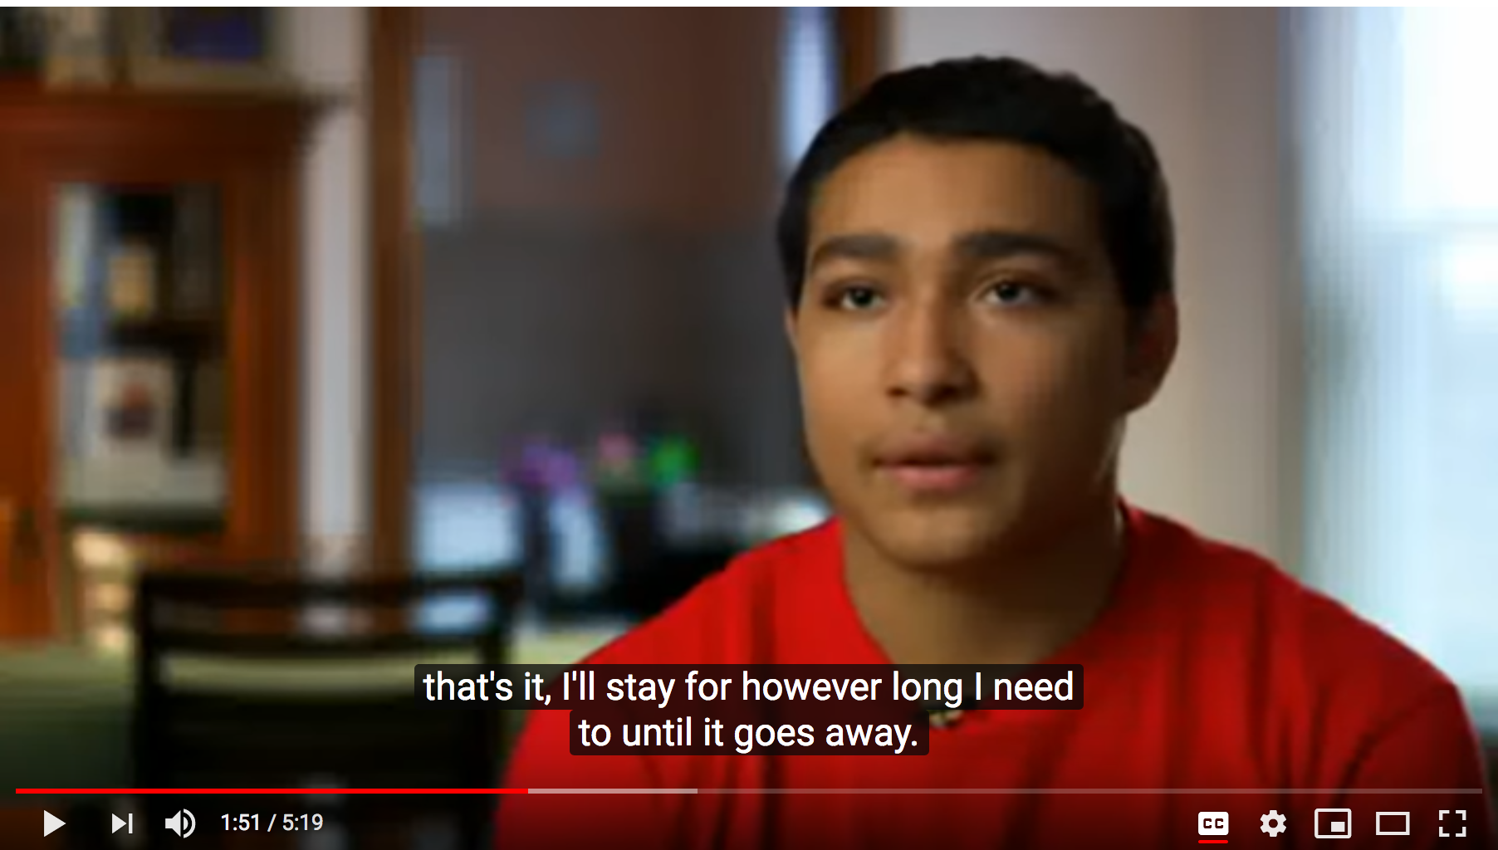
The exercise assumes no prior knowledge about molecular structures and visualization tools. Students may be directed to choose any one of the two molecular modeling approaches.
- Readymade virtual exhibits (e.g., JSmol tutorials), where students can select radio buttons to change renderings for their structural explorations. (Resource: Online Macromolecular Museum) OR
- Web-based visualization tools (e.g., RCSB PDB visualization tools or NCBI’s iCn3D), where students can load selected structures from the Protein Data Bank (PDB) and visualize/analyze them for their explorations.

- Explorations using readymade virtual exhibits at the Online Macromolecular Museum
Note: To learn about different kinds of covalent and non-covalent interactions, see the exhibit at
http://earth.callutheran.edu/Academic_Programs/Departments/BioDev/omm/jsmolnew/bonding/chymo.html

  - Begin exploring the structure of hemoglobin at
http://earth.callutheran.edu/Academic_Programs/Departments/BioDev/omm/jsmolnew/hemo/hemoglobina.html#intro
Explore the hemoglobin structure and examine its four polymer chains, illustrated in ribbon representations. Read the section of text associated with this JSmol interactive.

Q1. How many protein chains make up this structure? What are they?

Q2. Identify chain B in the structure and its N-terminus.
List names of the first 5 amino acids in its primary structure that you can see.
Classify these amino acids as small/large, polar/non-polar/charged etc.
(Hint: Mouse over each of the amino acids and note down the residue name and number).

Q3. What secondary structure(s) do(es) each of the above amino acids adopt in the structure seen here?

Q4. Describe the overall structure of chain B. What secondary structural elements are present? How is the tertiary structure organized?

  - Explore the Section II of the exhibit at
http://earth.callutheran.edu/Academic_Programs/Departments/BioDev/omm/jsmolnew/hemo/hemoglobina.html#II
In order to answer the following question, carefully examine the section about heme-mediated oxygen binding. See oxygen bound to heme groups in hemoglobin.

Q5. How does hemoglobin help carry oxygen? Include screenshots of the interaction(s) to substantiate your answer.

Q6. List one interaction through which heme groups are bound to the hemoglobin structure? Where does oxygen bind? Where does oxygen bind? Include screenshots of the interaction(s) to substantiate your answer.

Q7. How does hemoglobin’s ability to bind oxygen, change in different tissues? Include screenshots of the interaction(s) to substantiate your answer.

Q8. List one interaction within hemoglobin chains that is altered upon oxygen binding. Hint: Explore the structural basis for taut vs relaxed forms of hemoglobin, especially interactions involving His 146 in the beta hemoglobin chains (chains B and D). Include screenshots of the interaction(s) to substantiate your answer.

  - To learn about the physiological impact of the structural changes resulting from the mutation of Glutamate 6 to Valine
http://earth.callutheran.edu/Academic_Programs/Departments/BioDev/omm/jsmolnew/hemo/hemoglobina.html#III
Explore the structures in this section and answer the following questions.

Q9. In the hemoglobin beta chain Glutamate 6 is located on the surface. How would the surface properties of the sickle cell mutant protein change? Hint: What is the nature of the Valine side chain?

Q10. Which intermolecular forces (noncovalent interaction) leads to sickle cell hemoglobin (HbS) aggregation? Include screenshots of the interaction(s) to substantiate your answer.

Q11. Why do individuals with sickle cell disease have pain? If necessary, look up some recent scientific reviews to learn more about this.

- Explorations using web-based visualization tools (RCSB PDB visualization tools and NCBI’s iCn3D).

  - This exploration starts with learning a little about the composition of the molecular structure being explored, and how it is stabilized.

Go to the RCSB Protein Data Bank (https://www.rcsb.org/) and input the PDB ID 2dn2 into the PDB ID or Text search bars in the top menu. Once the structure summary page (https://www.rcsb.org/structure/2DN2) opens, review the page and answer the following questions.

Q1. How many protein chains make up this structure? List all polymer chains in the structure by their chain identifiers (Chain IDs) and molecular name. (Hint: Look for the polymers in the structure in the Macromolecules section of the page)

Q2. Are there any ligands/ cofactors/ ions/ inhibitors in this structure? if present, list what they are and how many of these ligands are present? (Hint: Look for ligands in the Small Molecules section of the page)

Q3. Identify chain B in the structure and its N-terminus. List names of the first 5 amino acids in the primary structure of Chain B. List only those residues that you can see. Classify these amino acids as small/large, polar/non-polar/charged etc.
A3. Click on the “3D View” tab or hyperlinked word “Structure”, below the image
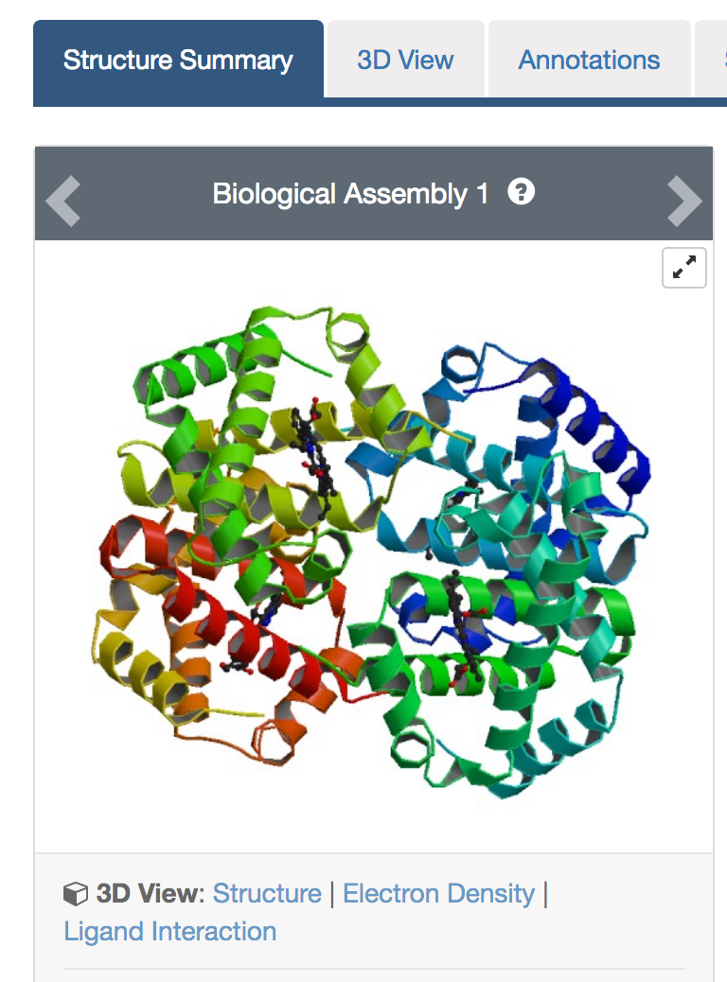
This should open an interactive view that shows the molecule as follows:

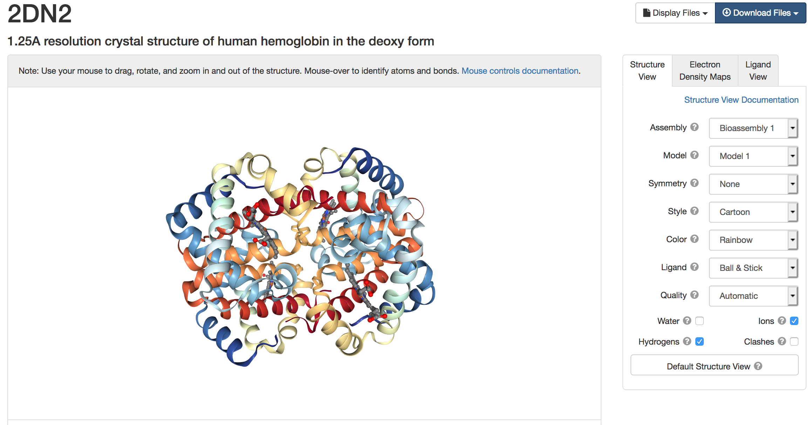

Rotate and explore molecular structure using the various menus and options.
Color the structure by Chains to see the following and use the different colors to identify chain B.
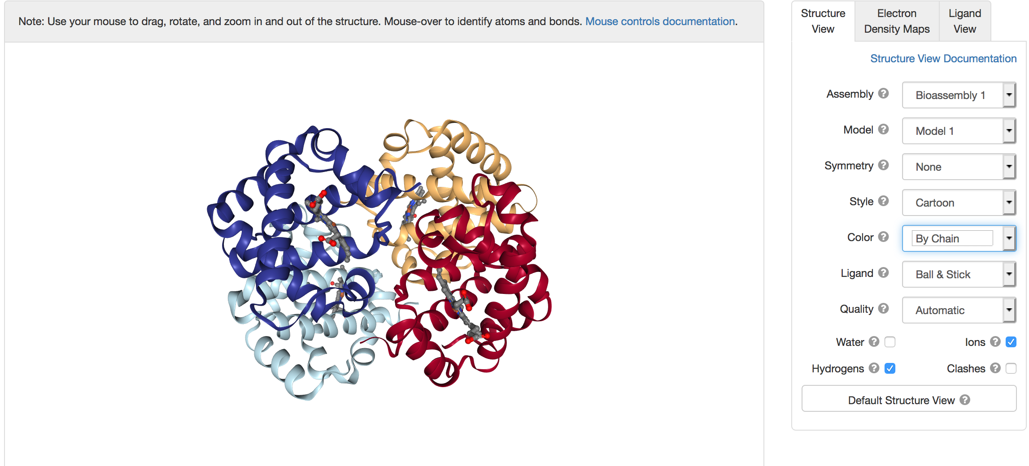
Mouse over the residue at the N-terminus and the next 4 residues of the light blue chain and list the primary sequence of chain B (residues 1-5):

Q4. Describe the overall structure of chain B. What secondary structural elements are present? How are they organized? Include screenshots of the interaction(s) to substantiate your answer.

Explore the various interactions stabilizing the bound heme groups in the hemoglobin molecule, click on the Ligand view tab on the right of the screen and select a specific heme group (HEM 142 in chain A) to explore its interactions with the hemoglobin A chain, see below:
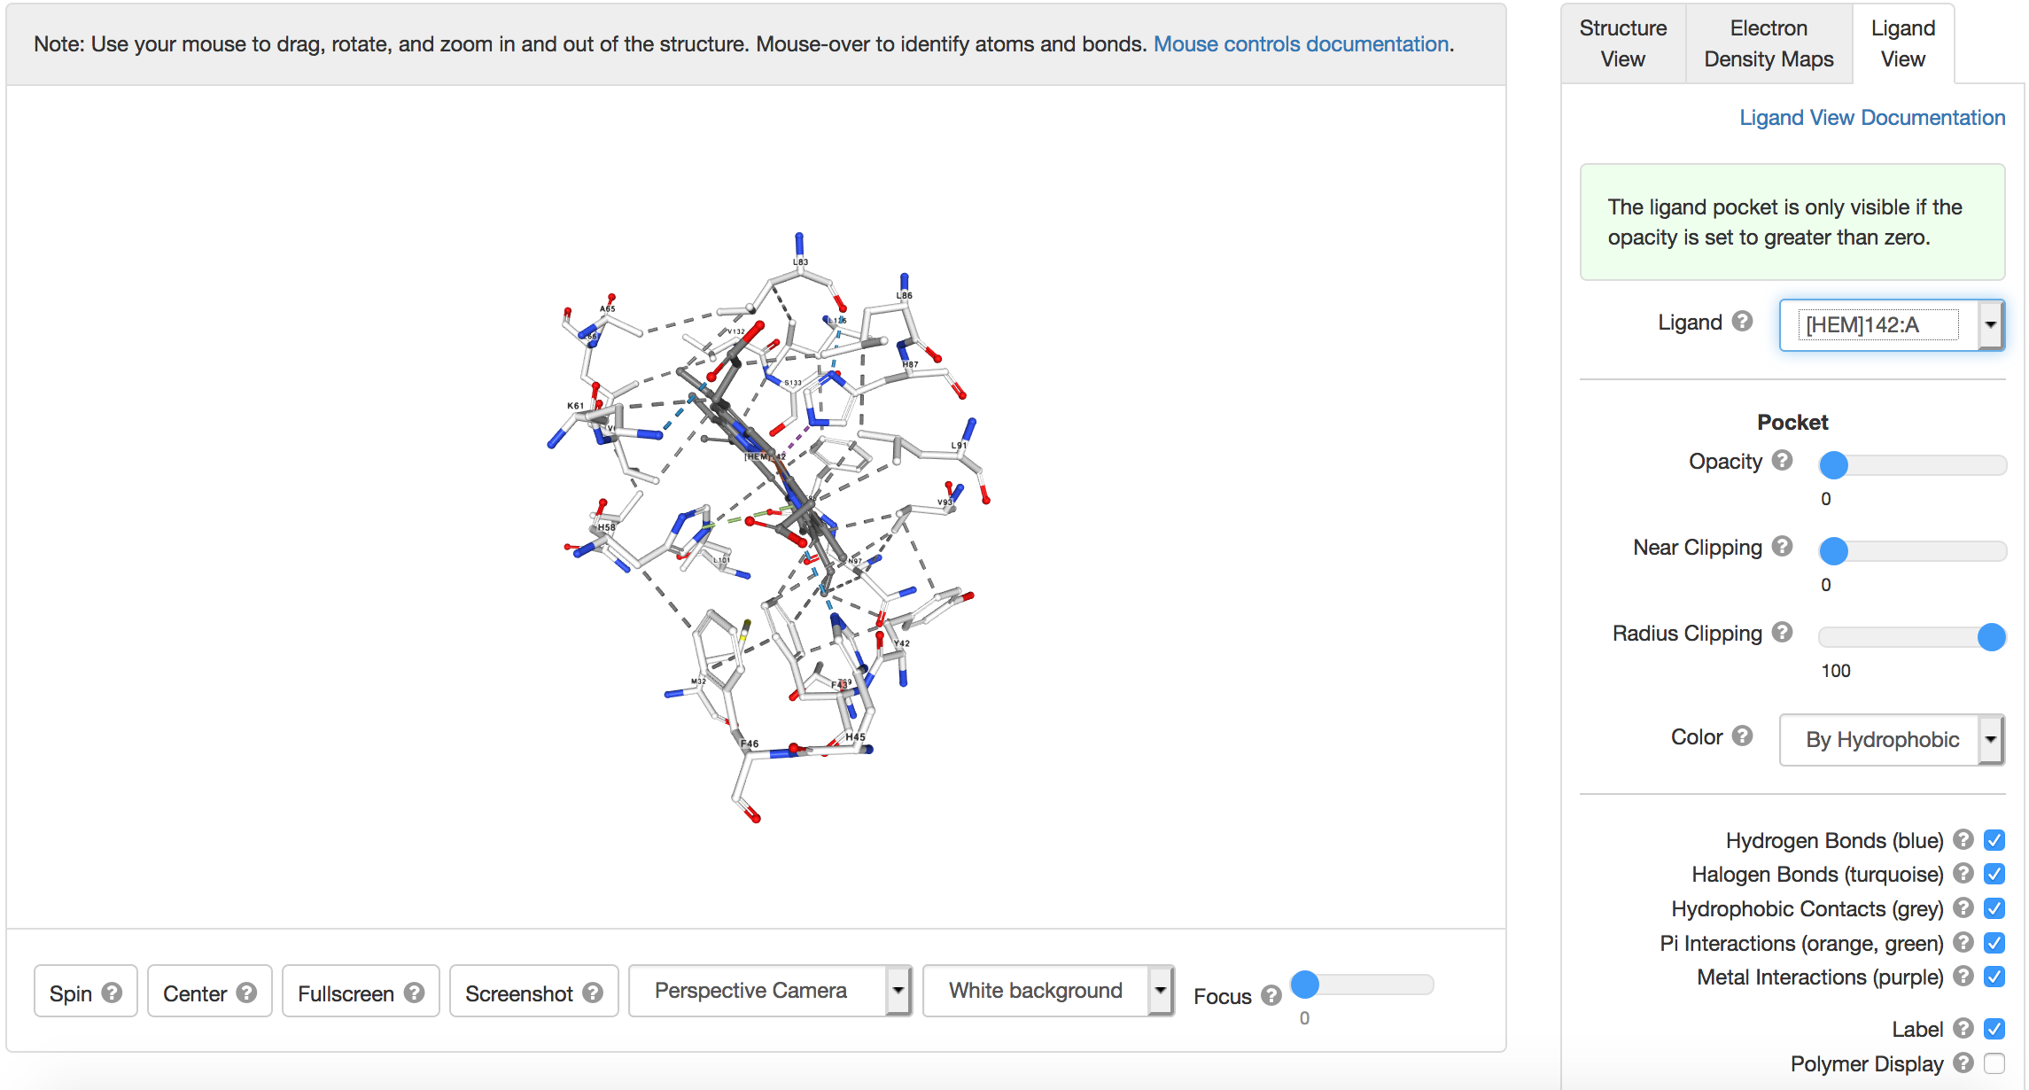

Note, atoms are displayed in using CPK coloring system (in the above diagram). The protein polymer chain is not shown here for clarity. The atoms are color coded so that: Red = oxygen; Blue = nitrogen; Gray = carbon; Yellow = sulfur; Orange = iron. Hydrogen atoms are not typically shown in a protein structure, instead they are assumed to be present.
Rotate the molecular display to examine the interactions. Learn about different kinds of covalent and non-covalent interactions

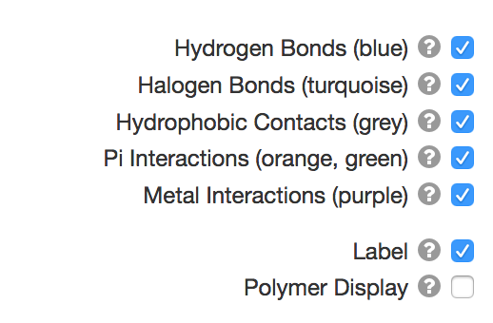

Turn on/off the various types of interactions shown here to explore them closely

Q5. List two different interaction through which the heme group is bound to the hemoglobin molecule? Include screenshots of the interaction(s) to substantiate your answer.

Q6. Which part of the hemoglobin molecule(s) binds to and carries oxygen? Include screenshots of the interaction(s) to substantiate your answer. Hint: Explore the binding of ligand OXY in an oxyhemoglobin structure (PDB ID 2dn1).

Ligand Explorer is a web-based tool that allows exploration of various non-covalent interactions in the neighborhood of specific ligands in any structure in the PDB. However, if you wish to explore the rest of the structure in similar detail we can use another web-based tool called iCn3D.

  - To open a PDB file in iCn3D modeling software, first go to the website https://www.ncbi.nlm.nih.gov/Structure/icn3d/full.html. Now, click on the file menu >> Retrieve by ID >> PDB ID >> type in 2dn2 >> Load
This should open a new window/tab with a view as shown below.

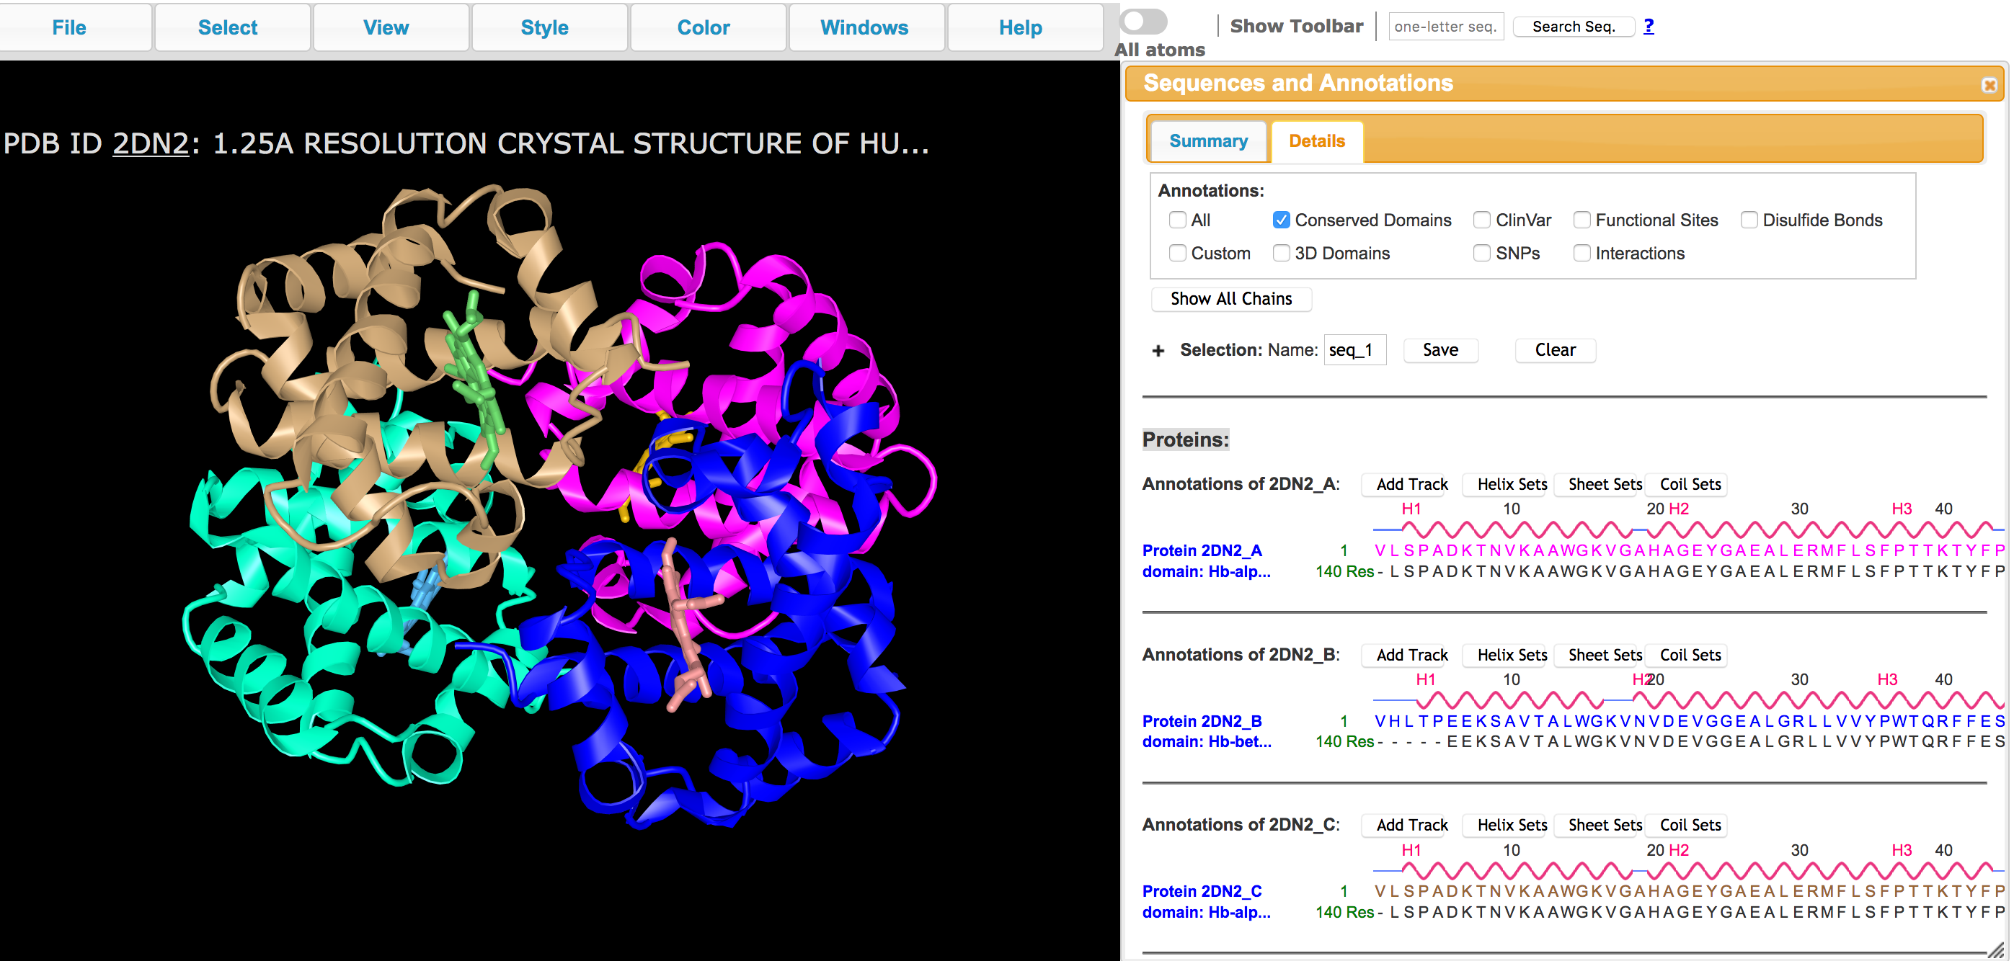

Now open the Windows >> Sequence and Annotations >> Details to see the sequences

You can click on any of the amino acids (shown in one letter code) in the above window and drag the mouse to select it. Note that the same amino acid is highlighted in the graphics window.
You can now show the side chain of the selected amino acid by clicking on Styles >> Side chains >> Stick.
To select other amino acids in the neighborhood of the selected amino acid click on Select >> by Distance >> a new window opens as shown below:
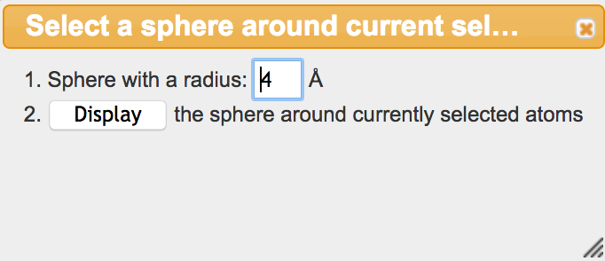

For most cases, 4A is a good distance range to be exploring. If necessary, you can change the distance in the box above.
Once you have selected the neighboring residues, you can use the commands above to display the side chains (i.e., Styles >> Side chains >> Stick)

Q7. Describe and compare the overall structures of T (deoxy, PDB ID 2dn2) and R (oxy, PDB ID 2dn1) states of hemoglobin. Include screenshots of the interaction(s) to substantiate your answer.

Q8. Explain how these Hb structures allow oxygen binding and release in different tissues. List one interaction within hemoglobin chains that is altered upon oxygen binding. Hint: Explore the structural basis for taut vs relaxed forms of hemoglobin, especially interactions involving His 146 in the beta hemoglobin chains (chains B and D). Include screenshots of the interaction(s) to substantiate your answer.

  - Explore the physiological impact of the structural changes resulting from the mutation at Glutamate 6 to Valine. Open the NCBI - iCn3D modeling software
(https://www.ncbi.nlm.nih.gov/Structure/icn3d/full.html).
Open the file > Retrieve by ID > type in PDB ID 2hbs
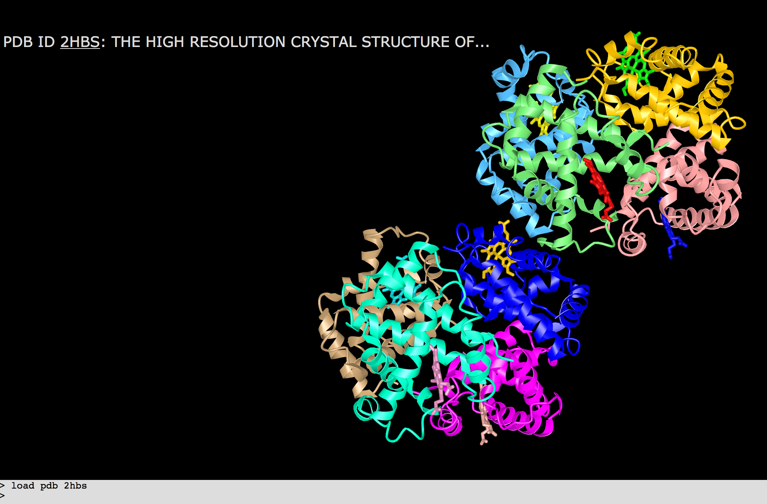

Note that the light and dark blue chains are both hemoglobin beta chains with the Glu6Val mutation. Explore the interactions of the Val6 in the light blue chain (chain H) with amino acid residues of the dark blue chain (chain B) to understand how the hemoglobin molecules interact with each other sequentially to form a fiber. From the top tool bar, click on Windows >> Sequences and Annotations > select the Details tab.

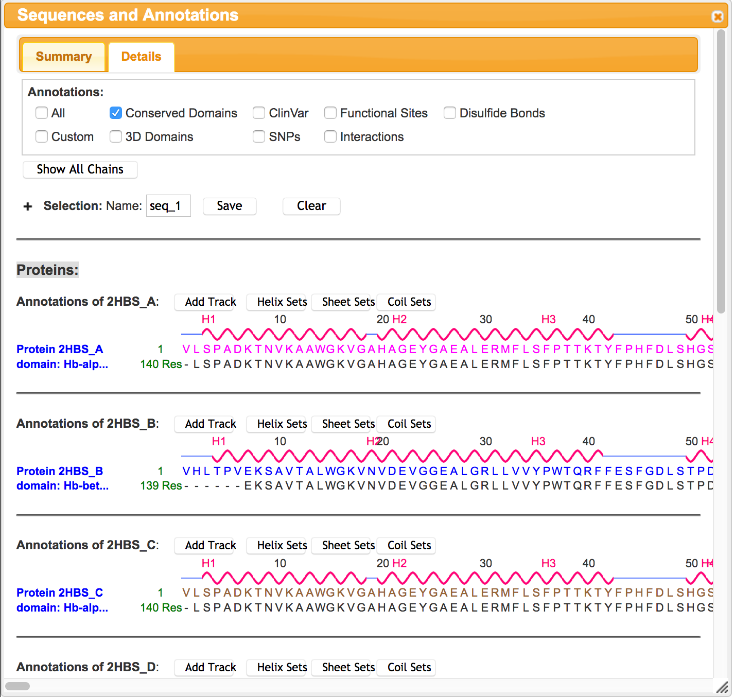

Scroll down to see the sequence of chain H. Select the mutated residue Val 6 by clicking and dragging on the V6

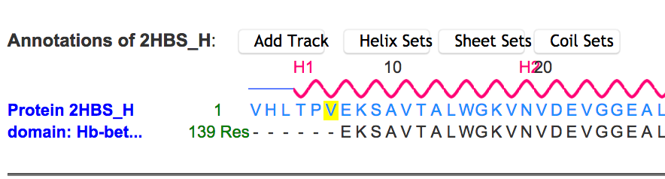

This should highlight the amino acid residue in the graphics window too. From top menu bar, select styles > sidechains > stick. While the residue is still selected (highlighted with a yellow outline) color it by clicking on menu Color >> Atom. Now select all atoms within 5 A to explore the residue’s interactions. Click on Select >> by Distance >> set distance to 5A >> Display

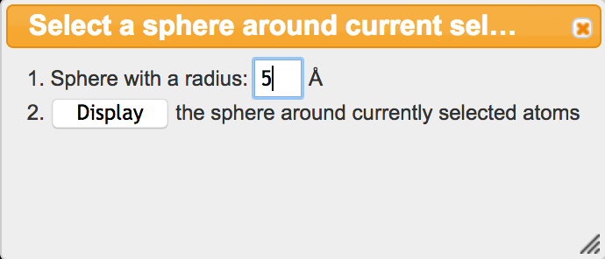

Now show the side chain atoms and color them by Atom colors as above to see the following:

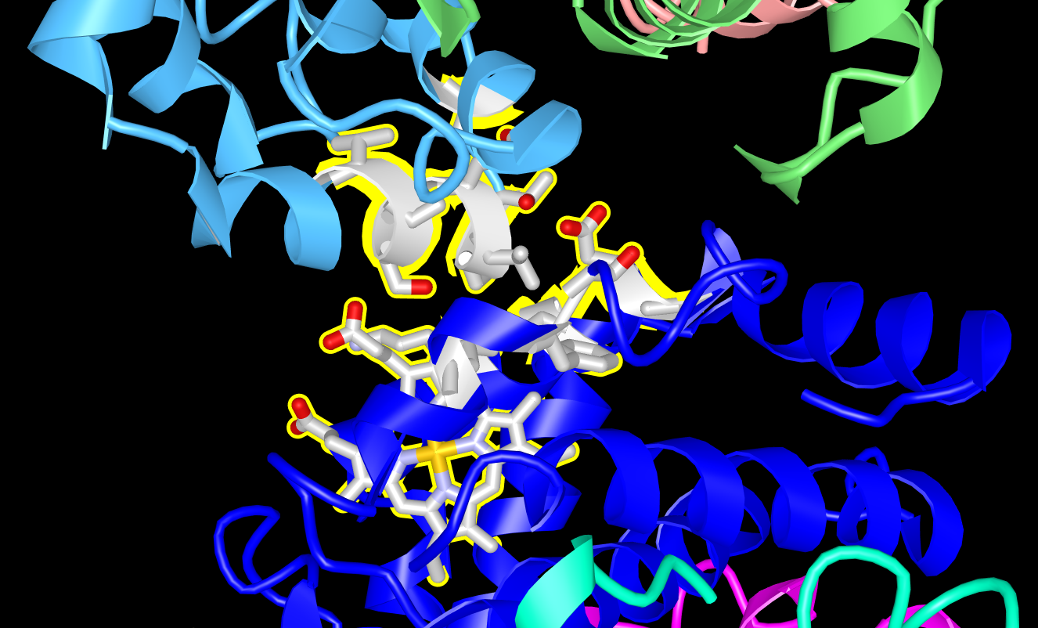

Explore the interactions and answer the following questions:

Q9. Which intermolecular forces (noncovalent interaction) leads to sickle cell hemoglobin (HbS) aggregation?

Q10. Why do individuals with sickle cell disease have pain? If necessary, look up some recent scientific reviews to learn more about this.

