Molecular Explorations in an Introductory Chemistry class.

In this activity, students will explore the molecular bases of the following question:

What is the molecular basis for sickling in Sickle Cell Disease?

In this activity you will learn
- To identify different kinds of intermolecular forces (IMFs), stabilizing biomacromolecules (protein, nucleic acid, etc., in this case hemoglobin)
- To identify and differentiate covalent and noncovalent interactions of a ligand to a biomacromolecule (in this case heme and oxygen binding to hemoglobin)
- To visually explore, analyze, and explain how mutation in a protein can lead to altered protein structure/ function/ properties.
- To use public scientific data resources (RCSB Protein Data Bank) and visualization tools.

Preparation: Prior to beginning the molecular explorations students should view the video at https://www.youtube.com/watch?v=iKQmQHh4E2w, be introduced to the overall structure of hemoglobin, and be aware of the mutation causing sickle cell disease. Reading some scientific literature about sickle cell disease prior to exploring relevant structures from the Protein Data Bank (PDB) may help with the explorations.
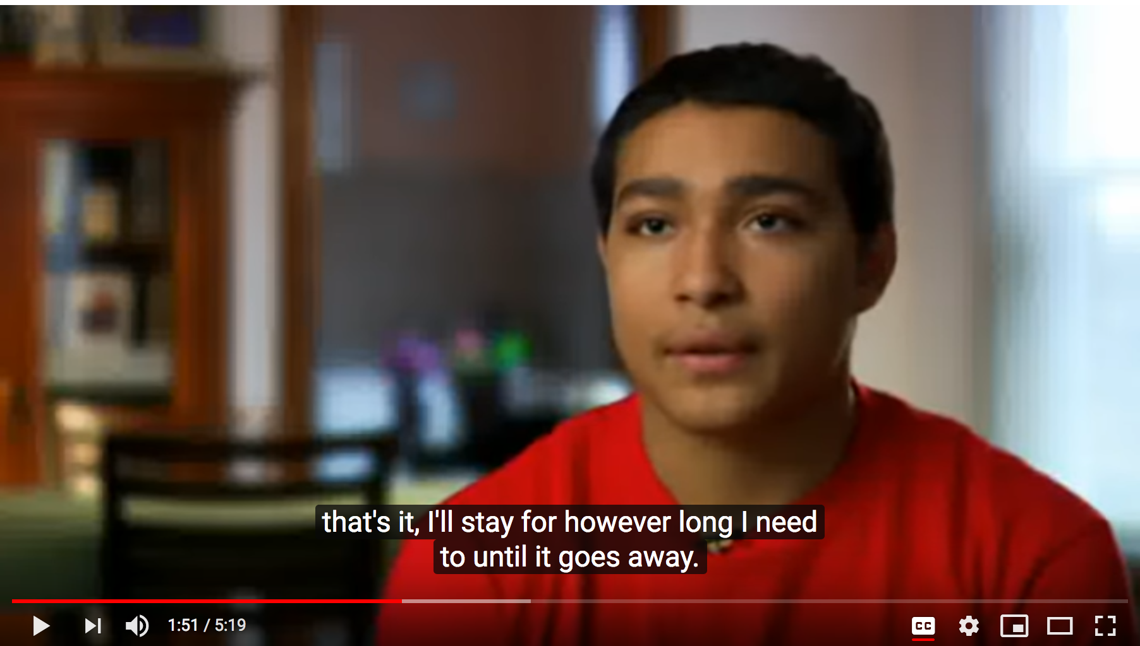
The exercise assumes no prior knowledge about molecular structures and visualization tools. Students may be directed to choose any one of the two molecular modeling approaches.
- Readymade virtual exhibits (e.g., JSmol tutorials), where students can select radio buttons to change renderings for their structural explorations. (Resource: Online Macromolecular Museum) OR
- Web-based visualization tools (e.g., RCSB PDB visualization tools or NCBI’s iCn3D), where students can load selected structures from the Protein Data Bank (PDB) and visualize/analyze them for their explorations.

- Explorations using readymade virtual exhibits at the Online Macromolecular Museum
  - Explore the Section II of the exhibit at
http://earth.callutheran.edu/Academic_Programs/Departments/BioDev/omm/jsmolnew/hemo/hemoglobina.html#II
Explore the hemoglobin structure and examine its four polymer chains, illustrated in ribbon representations. In order to answer the following question, carefully examine the section about heme mediated oxygen binding.

Q1. List one interaction through with the Heme group is bound to the hemoglobin structure? Include screenshots of the interaction(s) to substantiate your answer.

Q2. Where does the oxygen bind and how? Include screenshots of the interactions to substantiate your answer.

  - To learn about different kinds of covalent and non-covalent interactions, see the exhibit at
http://earth.callutheran.edu/Academic_Programs/Departments/BioDev/omm/jsmolnew/bonding/chymo.html
Explore the section on hydrophobic interactions and answer the following question.

Q3. List four amino acids that participate in hydrophobic interactions. Include screenshots of the interactions to substantiate your answer.

Extra credit: As you explore the hydrophobic residues note the PDB ID at the bottom of the page. Type the PDB ID in the top search box of the RCSB PDB website (www.rcsb.org) to find out what this protein is.

Q3extra: What is the name of the protein that you are exploring?

  - To learn about the physiological impact of the structural changes resulting from the mutation of Glutamate 6 to Valine
http://earth.callutheran.edu/Academic_Programs/Departments/BioDev/omm/jsmolnew/hemo/hemoglobina.html#III
Explore the structures in this section and answer the following questions.

Q4. In the hemoglobin beta chain Glutamate 6 is located on the surface. How would the surface properties of the Sickle cell mutant protein change? Hint: What is the nature of the Valine side chain?

Q5. Which intermolecular forces (noncovalent interaction) leads to sickle cell hemoglobin (HbS) aggregation? Include screenshots of the interaction(s) to substantiate your answer.

- Web-based visualization tools (RCSB PDB visualization tools and NCBI’s iCn3D)

Go to the RCSB Protein Data Bank (https://www.rcsb.org/) and input the PDB ID 2dn2 into the PDB ID or Text search bars in the top menu. Once the structure summary page (https://www.rcsb.org/structure/2DN2) opens, click on the “3D View” tab or the hyperlinked word “Structure”, below the image

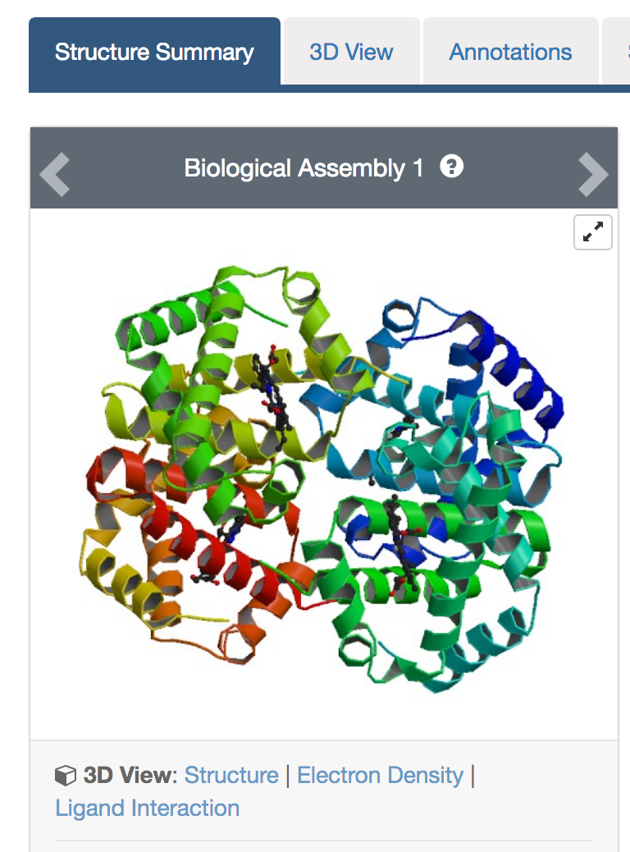

This should open an interactive view that shows the molecule as follows:

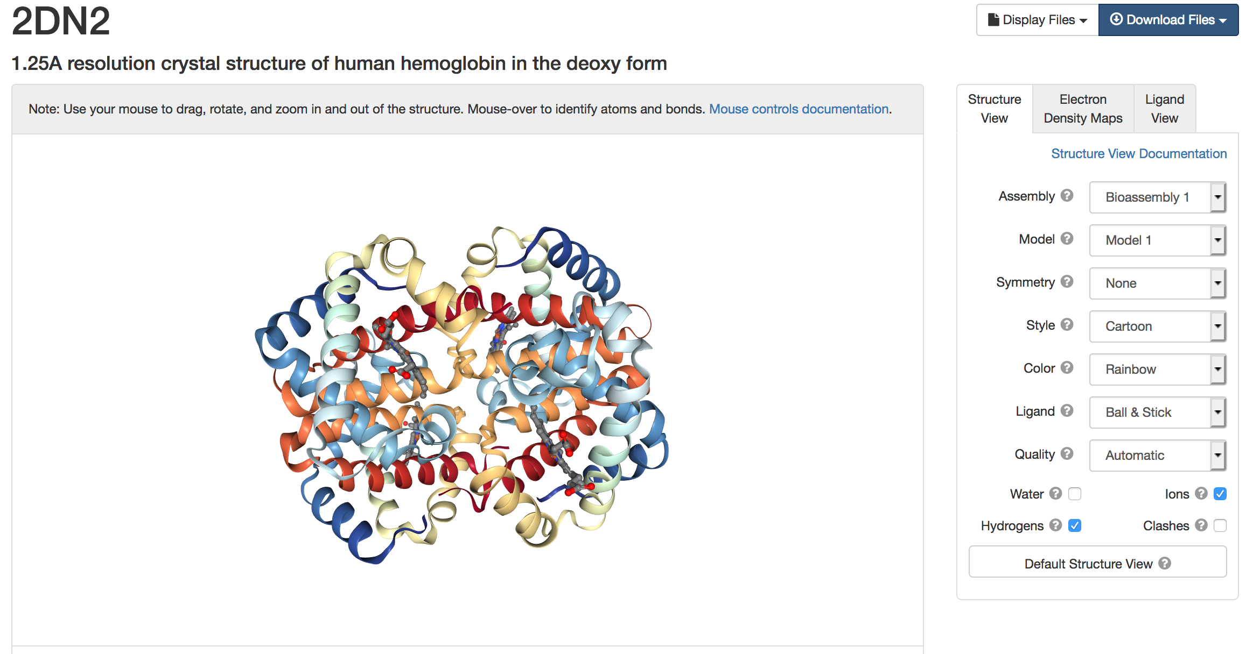
Rotate and explore molecular structure using the various menus and options.

- To explore the various kinds of non-covalent interactions stabilizing the bound heme groups in the hemoglobin molecule, click on the Ligand view tab on the right of the screen and select a specific heme group (HEM 142 in chain A) to explore its interactions with the hemoglobin A chain, see below:
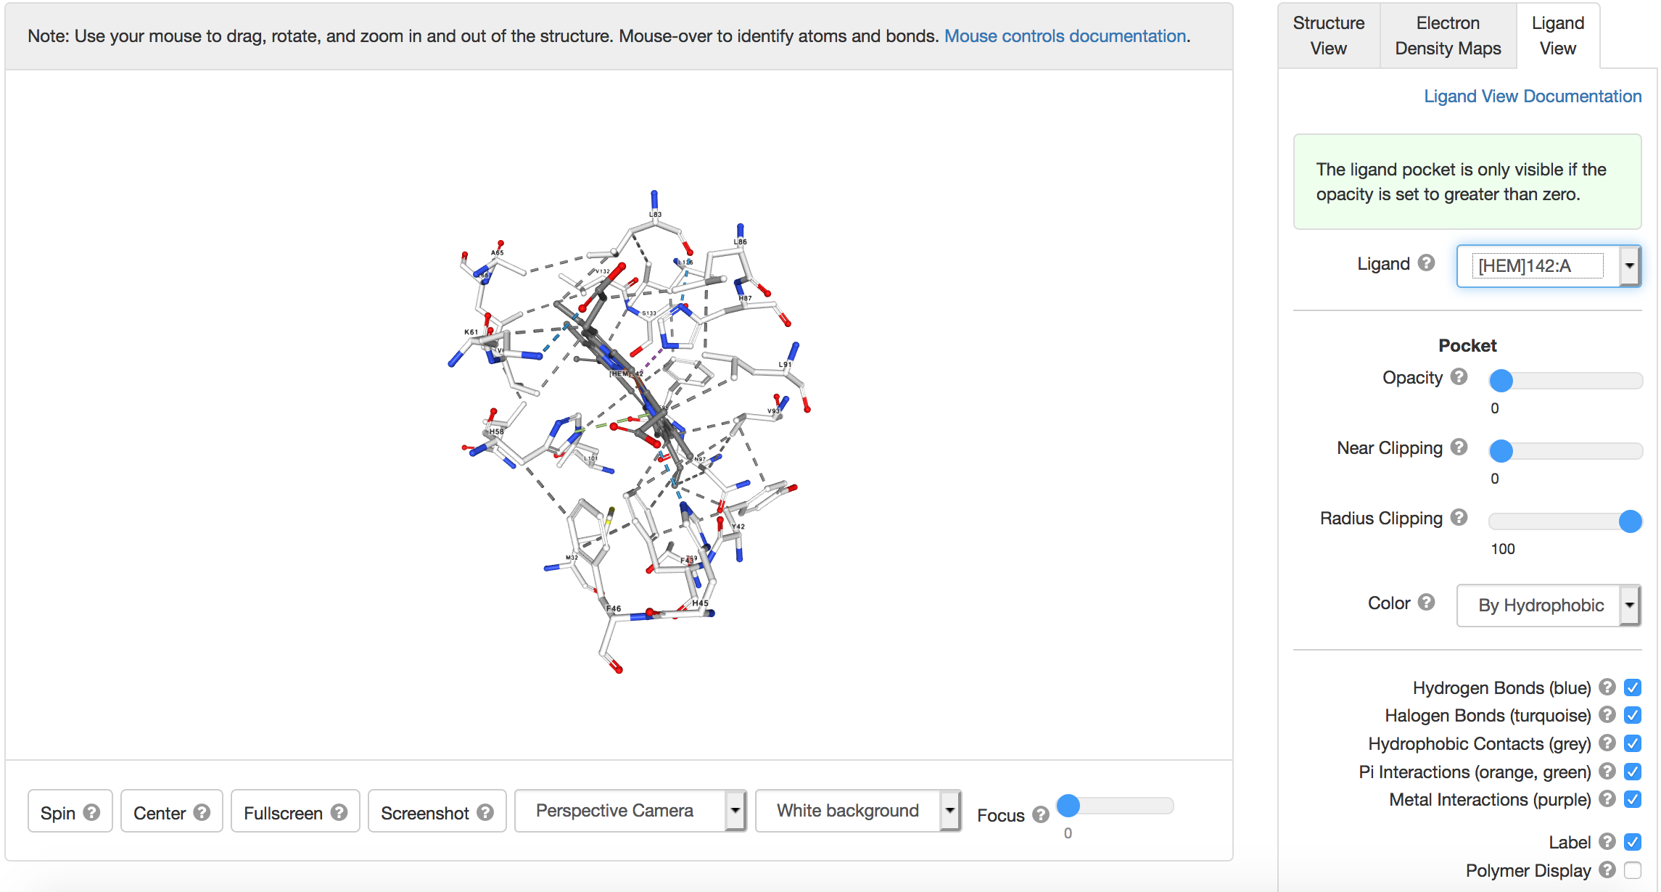

Note, atoms are displayed in using CPK coloring system (in the above diagram). The protein polymer chain is not shown here for clarity. The atoms are color coded so that: Red = oxygen; Blue = nitrogen; Gray = carbon; Yellow = sulfur; Orange = iron. Hydrogen atoms are not typically shown in a protein structure, instead they are assumed to be present.
Rotate the molecular display to examine the interactions. Learn about different kinds of covalent and non-covalent interactions

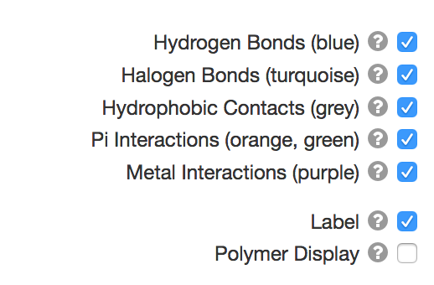

Turn on/off the various types of interactions shown here to explore them closely

Q1. List two different interaction through which the heme group is bound to the hemoglobin molecule? Include screenshots of the interaction(s) to substantiate your answer.

Explore the structure and ligand interactions of the hemoglobin structure in PDB ID 2dn1.

Q2. Where does the oxygen bind and how? Include screenshots of the interaction(s) to substantiate your answer.

- To explore the various kinds of non-covalent interactions stabilizing the hemoglobin molecule, open the NCBI - iCn3D modeling software
(https://www.ncbi.nlm.nih.gov/Structure/icn3d/full.html).
Open the file > Retrieve by ID > type in PDB ID 2dn2
This should open a view as shown below.

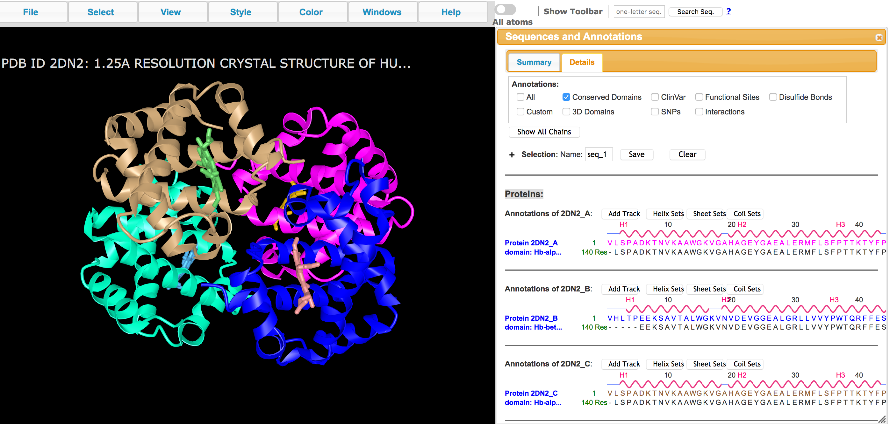

Now open the Windows >> Sequence and Annotations >> Details to see the sequences

You can click on any of the amino acids (shown in one letter code) in the above window and drag the mouse to select it. Note that the same amino acid is highlighted in the graphics window.
You can now show the side chain of the selected amino acid by clicking on Styles >> Side chains >> Stick.
To select other amino acids in the neighborhood of the selected amino acid click on Select >> by Distance >> a new window opens as shown below:
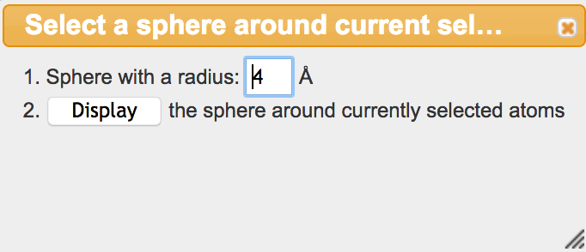
For most cases, 4A is a good distance range to be exploring. If necessary, you can change the distance in the box above.
Once you have selected the neighboring residues, you can use the commands above to display the side chains (i.e., Styles >> Side chains >> Stick)

Q3. List two interactions stabilizing each of the amino acids Val10 and Arg141 in Chain A. Name the type of interactions and include screenshots for each of the interactions to substantiate your answer.

- Explore the physiological impact of the structural changes resulting from the mutation at Glutamate 6 to Valine. Open the NCBI - iCn3D modeling software
(https://www.ncbi.nlm.nih.gov/Structure/icn3d/full.html).
Open the file > Retrieve by ID > type in PDB ID 2hbs
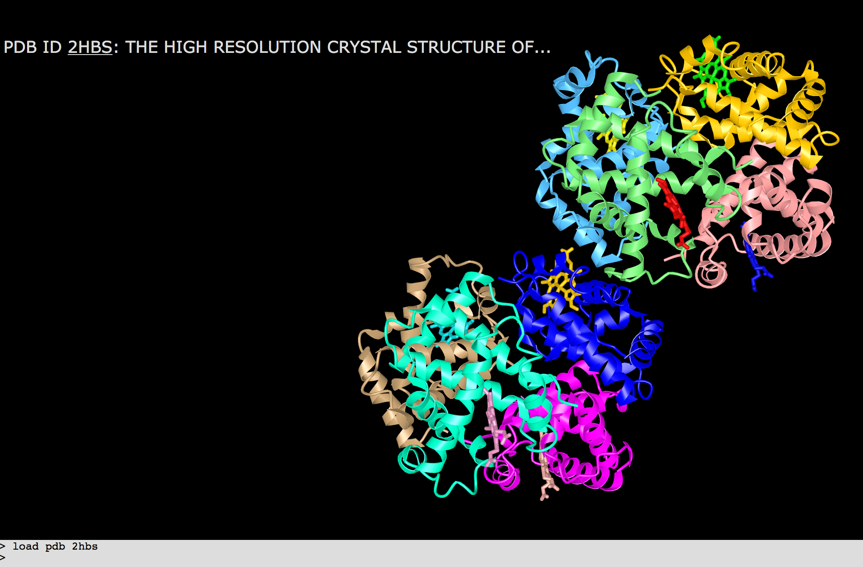

The light and dark blue chains are both hemoglobin beta chains with the Glu6Val mutation. Explore the interactions of the Val6 in the light blue chain (chain H) with amino acid residues of the dark blue chain (chain B) to understand how the hemoglobin molecules interact with each other sequentially to form a fiber. From the top tool bar, click on Windows >> Sequences and Annotations > select the Details tab.

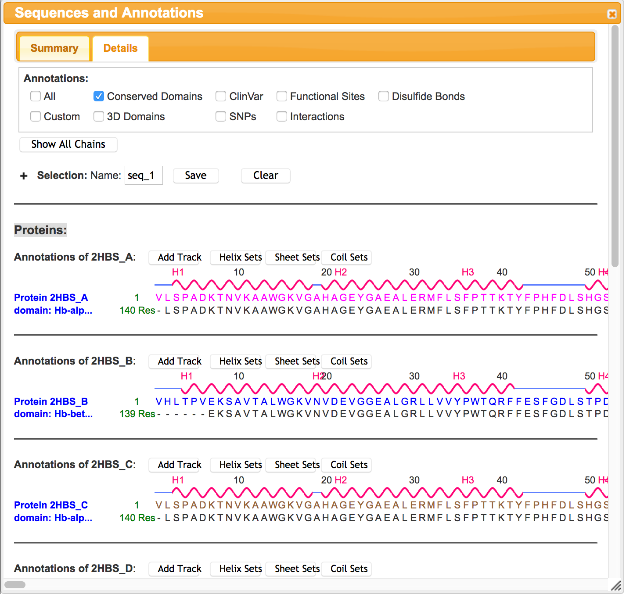

Scroll down to see the sequence of chain H. Select the mutated residue Val 6 by clicking and dragging on the V6

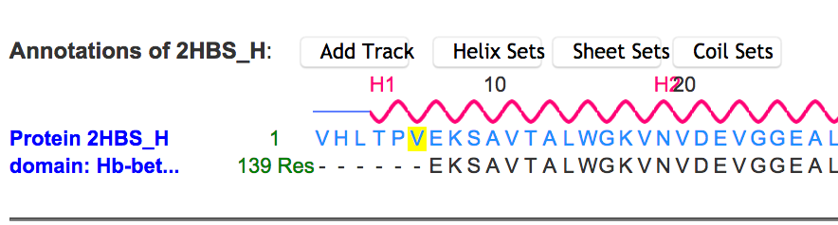

This should highlight the amino acid residue in the graphics window too. From top menu bar, select styles > sidechains > stick. While the residue is still selected (highlighted with a yellow outline) color it by clicking on menu Color >> Atom. Now select all atoms within 5 A to explore the residue’s interactions. Click on Select >> by Distance >> set distance to 5A >> Display

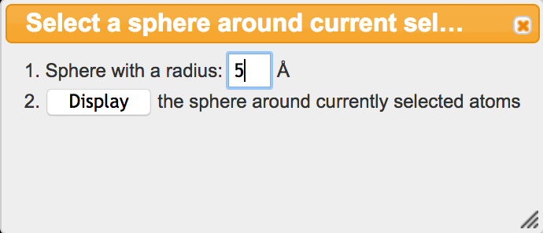

Now show the side chain atoms and color them by Atom colors as above to see the following:

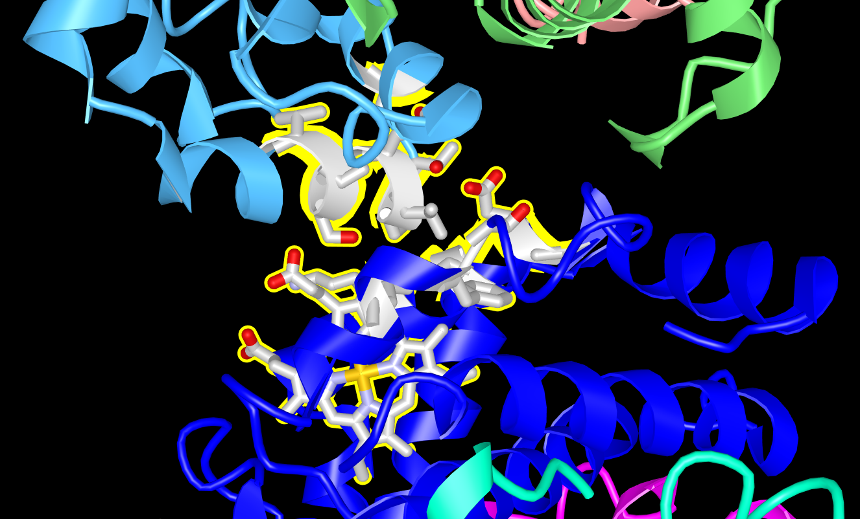

Explore the interactions and answer the following questions:

Q4. Which intermolecular forces (noncovalent interaction) leads to sickle cell hemoglobin (HbS) aggregation?

