Here are some resources to learn about the structure of hemoglobin and the molecular basis of cyanosis seen in the case:
Learning about Hemoglobin
# | Resource Name | Authors (where available) | Link/Detail | Comment
1 | Online Macromolecular Museum  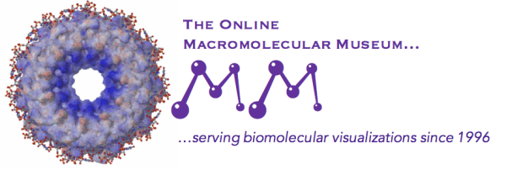 | David Marcey, Stephanie Levi-Blumer, and  Cassidy R. Terrell | https://earth.callutheran.edu/Academic_Programs/Departments/BioDev/omm/jsmolnew/hemo/hemoglobina.html | Hemoglobin A Structure, Sickle Cell Anemia, and Carbon Monoxide Toxicity
2 | PDB-101; Molecule of the Month | Shuchismita Dutta, David Goodsell | http://pdb101.rcsb.org/motm/41 | Hemoglobin
3 | Proteopedia  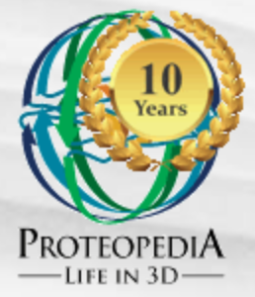 | Eran Hodis, Michal Harel, Joel L. Sussman, Alexander Berchansky, Jaime Prilusky, Eric Martz, Karl Oberholser, Mark Hoelzer, Marc Gillespie, Ann Taylor | https://proteopedia.org/wiki/index.php/Hemoglobin | Hemoglobin
4 | MolviZ.Org | Eric Martz | hemoglobin.molviz.org | Hemoglobin
5 | CBM MSOE | MSOE | http://cbm.msoe.edu/includes/modules/jmolCRESTProteins/hemoglobin.html# | Hemoglobin
Learning about chemical interactions in biological macromolecules
# | Resource Name | Authors (where available) | Link/Detail | Comment
6 | Online Macromolecular Museum | Yasi Mojab and David Marcey | http://earth.callutheran.edu/Academic_Programs/Departments/BioDev/omm/jsmolnew/bonding/chymo.html | An Introduction to Chemical Bonds and Protein Structure
7 | PDB-101 | David Goodsell and Maria Voigt | http://pdb101.rcsb.org/learn/videos/what-is-a-protein-video | What is a Protein?
8 | Internet Course on The Principles of Protein Structure | Organized by Birkbeck College | http://www.cryst.bbk.ac.uk/PPS95/course/3_geometry/index.html | Protein Geometry

