Piwi Matters
By Laurel Lorenz¹ and Shuchismita Dutta^{2*}

¹Department of Molecular Biology, Princeton University, Princeton NJ 08544
²Institute of Quantitative Biomedicine, Rutgers University, Piscataway NJ 08854
*contact author: sdutta@rcsb.rutgers.edu

Preparation:
Prior to the case discussion in class (as a homework assignment), get acquainted to the case.
- Watch the video Piwi Matters (https://youtu.be/5Xr3SlcuEns).
- Review the following concepts and answer these questions in preparation for the case discussion.

In order for Drosophila ovaries to continue producing eggs, they need specialized cells, germline stem cells, that have some unique properties. Stem cells have the ability to 1) divide (a property called self-renewal) and 2) differentiate into other types of cells (e.g., cystoblasts, nurse cells, and oocytes).

Box 1: Concept
Stem cells possess two fundamental properties:
- ability to self-renew and
- ability to produce numerous differentiated progenies.
Stem cells that form gametes (eggs and sperms) are called Germ-line Stem Cells (or GSCs). Sperm and egg production both require a balance between self-renewal and cell differentiation. Self-renewal at the expense of differentiation can cause tumorigenesis, whereas differentiation at the expense of self-renewal can cause germ cell depletion and infertility. Cell division in GSCs are broadly of two types:
- asymmetric – that produce a daughter GSC and a differentiated daughter cell (e.g., in Drosophila ovary), and
- symmetric – that produce two daughter cells each of which has an equal probability of differentiating (e.g., in C. elegans and several Hydra species).

Q1. According to the video that you watched, what happens to flies lacking the Piwi protein?

Q2: What are 3 features of a wild-type ovary?

Box 2: Concept
Analysis of Genetic Mutations
To see whether a specific function of Piwi is required for stem cell self-renewal in Drosophila, scientists delete or replace the wild-type form of Piwi with a mutant form. Every cell in the Piwi mutant fly contains the mutant form of Piwi, which lacks a particular function of Piwi. To test whether this function of piwi is required for stem cell maintenance (self-renewal and differentiation) ovary growth and differentiation is analyzed.

Light microscopy illuminates a specimen with all the visible wavelengths of light. Light microscopy is typically used to observe a specimen’s structural elements.

Fluorescence microscopy uses a specific wavelength of light to detect fluorophores that are covalently bound to a probe. The probe is typically used to detect the location of specific proteins, DNA, or RNA. When the light is absorbed by a fluorophore, the fluorophore is detected by the wavelength.

Q3. If a mutant Piwi Drosophila develops normal ovaries, can we conclude that function of Piwi that is missing in the mutant is required or dispensable (not necessary) for stem cell maintenance? Why or why not?

Q4. If a mutant Piwi Drosophila develops tiny ovaries, can we conclude that the missing function of Piwi is required or dispensable (not necessary) for stem cell self-renewal? Why or why not?

Part 1: Current Research on Piwi

In this section you will learn about some of the research on Piwi that has helped understand the functions of this protein. The next three pages are generated as worksheets for Piwi mutants A, B, and C. Follow your instructor’s directions regarding completing these worksheets. After completing the worksheet(s), the responses will be reviewed in class.

Exploring Piwi “A” Mutant worksheet

When researches compared the ovaries of wild-type Piwi containing flies (panel A) to that of flies with the Piwi A mutant (panel B) they saw the following morphology in the ovarioles. Observe the images included below and answer the following questions.

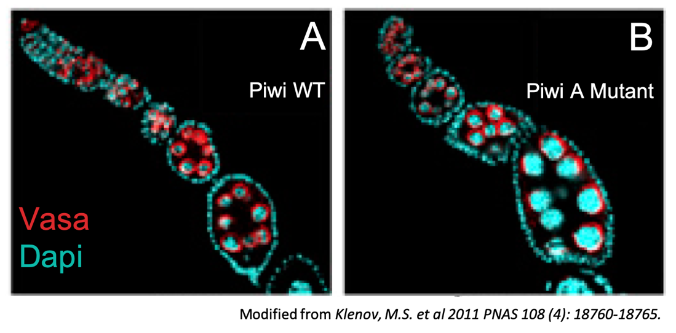

Note: Vasa (colored red) is a protein present in germline cells, but not somatic cells. DAPI (colored cyan) stains DNA of all cells.

Q1. What type of microscopy image (light or fluorescence) are you looking at? From this image, what structures, protein, or DNA are you able to examine?

Q2. What evidence suggests that the wild-type (WT) ovary is normal?

Q3. What evidence suggests that the mutant ovary is normal? Abnormal?

Q4. Based on the results shown, is the role of Piwi that is absent in the Piwi A mutation required or dispensable for stem cell self-renewal? Why or why not?

Exploring Piwi “B” Mutant worksheet

When researches compared the ovaries of wild-type Piwi containing flies (panel A) to that of flies with the Piwi B mutant (panel B) they saw the following morphology in the ovarioles. Observe the images included below and answer the following questions.

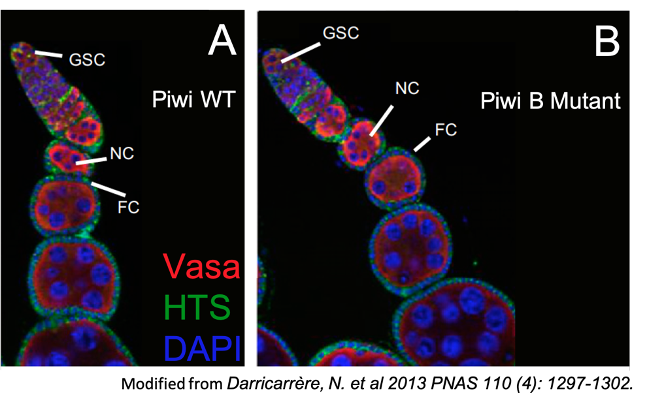
Note: Germline Stem Cells (GSCs), germline nurse cells (NC), and somatic follicle cells (FC) are indicated. Vasa protein (colored red) is present in germline cells, but not somatic cells. HTS (colored green) is a protein found as round spheres in GSCs as well as at the cell membrane of FCs. DAPI stains DNA of all cells (blue color).

Q1. What type of microscopy image (light or fluorescent) are you looking at? From this image, what structures, protein, or DNA are you able to examine?

Q2. What evidence suggests that the wild-type (WT) ovariole is normal?

Q3. What evidence suggests that the mutant ovariole is normal? Abnormal?

Q4. Based on the results shown, is the role of Piwi that is absent in the Piwi B mutation required or dispensable for stem cell self-renewal? Why or why not?

Exploring Piwi “C” Mutant worksheet

When researches compared the ovaries of wild-type Piwi containing flies (panel A) to that of flies with the Piwi C mutant (panel B) they saw the following morphology in the ovarioles. Observe the images included below and answer the following questions.

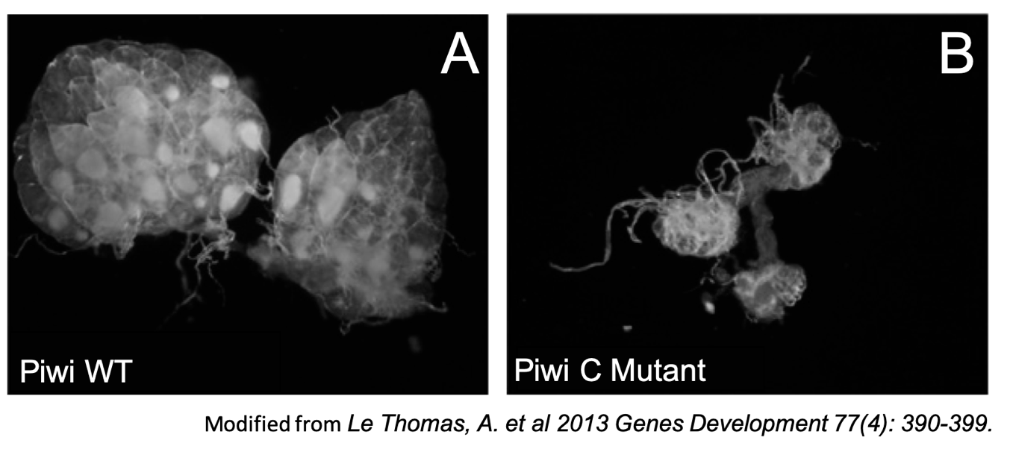
Questions:
Q1. What type of microscopy image (light or fluorescent) are you looking at? From this image, what structures, protein, or DNA are you able to examine?

Q2. What evidence suggests that the wild-type (WT) ovary is normal?

Q3. What evidence suggests that the mutant ovary is normal? Abnormal?

Q4. Based on the results shown, is the role of Piwi that is absent in the Piwi C mutation required or dispensable for stem cell self-renewal? Why or why not?

Part 2: Getting to know Piwi (Function and Sequence)
Piwi appears to be a complex protein that interacts with many specific proteins and RNA to play an important role in gametogenesis. Through a series of bioinformatics explorations students will learn about the domain architecture and interactions of Piwi.
- To learn more about the functions and overall organization of the Piwi protein, we will explore a biological data resource called UniProt.
Box 3: Resource
UniProt (https://www.uniprot.org/) is a bioinformatics data resource that provides comprehensive, high-quality, freely accessible protein sequences, and their functional information. This information comes from research that has been published by others. For eukaryotic proteins it also lists information about specific domains, post-translational processing and modifications, and pathology resulting from mutations in the protein. UniProt provides links to other biological data resources to access other relevant information about the protein, such as gene sequence, protein structures, functional annotations etc.

Search for Piwi in Uniprot by typing the protein name in the top search box. From the results returned, select the entry for Drosophila melanogaster (Fruit fly) Piwi. Open the UniProt page, review and refer to it as you answer the following:

Q1. What is the identifier of the UniProt entry that you have selected? (Hint: this is the set of alpha numerical string, listed at the top of the page, after UniProtKB -, and before the parenthesis.)

Q2. List three types of information that you found out about Piwi from this data resource. (Hint: click on the various tabs in the left hand menu. List the name of the tab and what interesting information you found about the protein).

- Piwi domains: Like many other eukaryotic proteins, the Piwi protein is composed of different domains.
Box 4: Vocab
A domain is a conserved part of a protein that can evolve, function, and exist independently of the rest of the protein chain. It usually has a stably-folded, three dimensional structure.

Explore the primary structure and domain organization of Piwi as listed in the “Family & Domains” section of the UniProt page for Piwi.

Q4. Draw a linear diagram of the Piwi protein and mark all the motifs, regions, and domains.

Q5. To learn more about the functions of the protein domains present in the Piwi protein, explore the Family and domain databases and compare information available from InterPro, Pfam, and PROSITE. For each domain, summarize what you learned in 2-3 sentences.

The Piwi protein functions are quite diverse. Watch the video (https://youtu.be/2LauiT75n2U ) that summarizes key functions of Piwi.
Based on the video and your explorations of the UniProt page on Drosophila Piwi, it appears that the Piwi protein interacts with both proteins and RNA.

Q6. Redraw the linear representation of Piwi (from your Ans 4) and write next to each of the different regions/domains where the protein(s) and RNA are likely to bind.

Part 3: Insights into Piwi’s Structure (Learning from Homologs)

This part of the case focuses on learning about Piwi’s structure in order to understand how it mediates its functions. To find an experimentally determined structure of Piwi, we will explore the Protein Data Bank (PDB) at www.rcsb.org.

Box 5: Resource
RCSB Protein Data Bank (RCSB PDB, www.rcsb.org) provides access to 3D structural data of biological macromolecules (proteins, nucleic acids, carbohydrates and their various complexes). In addition, it provides information about the experiment used to derive the data, details about the molecules included in the experiment, and links to various bioinformatics resources that can provide additional information about the protein/molecule of interest. Each structure in the PDB is identified by a unique identifier (called PDB ID). Atomic coordinates form the PDB can be visualized and analyzed using various visualization software (some available from RCSB PDB).

- Search for Drosophila Piwi structure(s) in the PDB (www.rcsb.org) to see what structure(s) is/are available.

Type the protein name “Piwi” in the top search box and hit on the search button. Once the results are returned, click on Drosophila melanogaster in the left hand menu to view only the structures that contain the fruit fly Piwi protein

Q1. List the PDB identifiers and titles for 2-5 structures that contain Drosophila Piwi.

- The PDB structures may represent a single protein or a complex structure – i.e., the file may contain multiple polymer chains (protein, DNA, and RNA) that form a complex structure and are co-crystalized.
Select one of the PDB entries you listed above and open the structure summary page for this entry to explore the Piwi protein residues, peptides, and chains that are present in these structures.

Box 6: Vocab
Residues: Building blocks of biological macromolecules are sometimes referred to as residues. Depending on the context, this may refer to amino acids (frequent use) or a nucleotide (less common use).
Protein vs Peptide: while both proteins and peptides are composed of covalently linked amino acids, peptides are short (composed of 2-25 amino acids)
Chains: A chain (such as protein/ peptide chain) refers to covalently linked amino acids. To help locate amino acids in a protein structure or complex a chain is given an identifier (called Chain ID) and each amino acid in the chain is assigned a number. Note that large proteins with multiple domains may be cut into smaller pieces – a short peptide or a single domain and included in the experiment. For this experiment the polymer chain formed by the peptide or domain is assigned a chain ID. Nucleic acids or polymers of nucleotide residues (DNA/RNA) may also be referred to as chains and assigned chains IDs.

Q2. In the list of Piwi containing structures, you should find a structure with Piwi and Papi proteins. List the PDB ID you are exploring and answer the following questions.

To identify the polymer chains, present in this structure entry, examine the section titled Macromolecules. What is the Chain ID of Papi? What is the Chain ID of Piwi? What is the region of the Piwi protein that is present in this structure? (Refer back to your diagrams of Piwi as needed)

- We will begin our Piwi structure and function exploration using our knowledge of the relationship between protein sequence, structure, and functions.

Q3. Do you know the relationship between protein sequence, structure, and functions? Describe it in 1-2 sentences.

Box 7: Concept
The foundation for bioinformatics is that protein sequence can be used to predict protein structure, which in turn can be used to predict protein functions. Thus, proteins with similar amino acid sequences tend to fold and have the same overall protein structure and usually perform similar functions. An application of this knowledge is that when experimentally determined structures of a protein (or part of a protein) is not available, the structure of another protein with similar sequences (i.e., a homolog) can be used to provide insights about its structure and function.

- It appears that experimentally determined structures of the complete Drosophila Piwi protein are not available in the PDB (as of October 2019). Therefore, we will need to study similar proteins in other species (orthologues). We will query the PDB for structures of proteins with sequences that are similar to the Drosophila Piwi amino acid sequence.
- Go back to the UniProt page for Piwi. Click on the left hand menu tab called “Sequence”. Click on the tab on top labeled “FASTA” to download the protein sequence in FASTA format and copy the sequence and save it in a text file.
- Go to the RCSB PDB home page (https://www.rcsb.org/) and click on the Search option in the left hand menu >> Sequences. In the “Option B: Paste Sequence”. Paste the FASTA sequence saved above and click on the Run Sequence Search button.
Once the search results are returned look at the matches to answer the following.
Box 8: Concept
How similar do the protein sequences have to be for such analysis?
Analysis of large numbers of protein structures and sequences show that for proteins with ~100 amino acids, a sequence identity >25% is indicative of similar folds and functions (Sander and Schneider 1991*). Finding structures of proteins/domains with >25% identity to the protein of interest, can be used to learn about the structure and function of the protein.
Note that the relationship between protein sequence, structure, and function is complex, and not fully understood yet. For example, there are known protein structures with less than 25% sequence identity that have highly conserved structures, and also there are proteins with high sequence identity that have different structures. Therefore, any predictions or models based on the structures of sequence neighbors should be experimentally tested.
*Sander, C. and Schneider, R. (1991) Proteins: Structure, Function, and Genetics 9, 56-68

Q4. Fill in the following table for the top (best match) structure.

PDB ID
Structure title
length (# of aa) that matches query
percentage of sequence identity

Q5. Do you think that this structure can be used to learn about the structure and function of Piwi? Why or why not?

Open and explore the structure summary page for the top entry in the query results list.

Q6. Complete the following table for the PDB entry reported in Ans4.

PDB ID
Author(s) of entry
Year when the structure was published/ released
Structure determination method
# of macromolecular chains
(# Protein + # nucleic acid)
Names of proteins in these chains (chain ID)
Names of genes of proteins included here
Name of any other macromolecular chain

- In the Macromolecules section of the structure summary page for the PDB entry you are exploring, click on the UniProt ID (orange box) for the protein chain in the structure.

Q7. What is the UniProt Identifier for this chain?

Q8: Examine the “Family & Domains” section of the protein chain listed in Q7 on the UniProt page. Draw a linear diagram of the protein and mark all the motifs, regions, and domains.

- Click on the 3D view tab on the top of the structure summary page on the RCSB PDB website to visualize the molecule. Color the structure by Chain, using the various pull down menu options.

Q9. Take a screen-shot of the graphical window and insert the image here to show the overall shape of the protein complex. Describe in 1-2 sentence what you see.

Box 9: Concept
Missing residues: Due to specific conditions in the structure determination methods, most PDB entries do not have the coordinates of all atoms present in the structure. For example, flexible regions of the structure cannot be “seen” in the experiment, so these coordinates are missing. Also, all H atoms in most structures determined by X-ray crystallography are not included in the coordinate files. To learn more read http://pdb101.rcsb.org/learn/guide-to-understanding-pdb-data/missing-coordinates-and-biological-assemblies.

- In order to visualize and analyze the protein structure(s) in greater detail we will use an online molecular structure visualization tool, called iCn3D.

Box 10: Resource
iCn3D (https://www.ncbi.nlm.nih.gov/Structure/icn3d/full.html) is a web-based visualization tool that allows users to directly open any structure from the Protein Data Bank (PDB) and visualize the structure. Users can interactively rotate the molecule/complex, select specific regions and represent them in different ways, compare structures, analyze interactions and make simple distance measurements.

- Go to iCn3D (https://www.ncbi.nlm.nih.gov/Structure/icn3d/full.html)
- Click on the button called File >> Retrieve by ID >> PDB ID so that a new window opens. Input the PDB ID of the structure you wish to visualize and click on Load.
- The structure opens in a new tab – rotate the molecule and examine the overall structure.

Q10. How many polymer chains do you see? Take and screenshot of the structure and include it below.

- Spend a few minutes playing around with the different pull-down menus to see some of the different ways this protein view can be adjusted.
- Figure out where the Piwi and PAZ domains are located in the 3D structure.
  - Click on the button called Windows >> View Sequences & Annotations.
  - Click on the Details button to see the one letter code sequence of all the protein chains in the structure.
  - Use the residue number limits identified for the Piwi and Paz domains of Siwi (from your answer to Q8 above). Click and drag on these residues in the sequence and annotation window. The residues will be highlighted in yellow, both in the sequence and graphics windows.
  - Click on Color >> Unicolor >> Green (for the PAZ domain). Now click on Select >> Clear Selection.
  - Similarly color the Piwi domain Yellow.

Q11. Save a picture of the Siwi structure after the domain coloring and include it here.

Q12. In relation to the Piwi and PAZ domains, where is the piRNA located in the structure?

- We know that the sequences of Piwi and Siwi are similar. Aligning these sequences will help highlight where the conserved regions are located.
- Go to the Uniprot home page at https://www.uniprot.org/ and click on the Align button in the top left corner. Alternatively, directly go to the alignment page at https://www.uniprot.org/align/. Paste the UniProt identifiers of Piwi (see Part 2, Ans 1) and Siwi (see Part 2, Ans 7), separated by a comma (or in two separate lines) and click on the Align button.
- Examine the sequence alignment of these two sequences. Turn on specific annotations on this sequence alignment by checking on boxes denoting specific criteria.
Q13. Based on the annotations seen on the sequence alignment complete the table:

Annotation | Residue number in Fruit fly (Silk worm)
Active site conserved in both proteins
Mutagenesis studies done in both proteins
Protein domain that shows sequence conservation

- Referring back to the mutational studies discussed in Part -1 of the case the maximum impact on renewal of germline cells was seen in Mutation C or the Piwi-YK mutant had mutations in two amino acids - Y551L and K555E. Locate the corresponding amino acid residues in the Siwi structure to visualize their interactions.
- Locate the corresponding Siwi residues in the aligned sequence window and note down the residue numbers.

Q14. What do the residues Y551 and K555 correspond to in the Siwi structure?

Box 11: Concept
Biomolecular structural stability, interactions and functions are dependent on various non-covalent interactions. Some key interactions in molecular structures are
Hydrogen bonds - formed between two partially negatively charged atoms with a hydrogen atom between and covalently linked to one of them. e.g. in structures look for examples of O/N … H__O/N, where … denotes hydrogen bond and __ denotes a covalent bond
Salt bridges or ionic interactions - formed between oppositely charged amino acid side chains and/or charged ligands/ions. e.g. in structures look for interactions between Lys/Arg/His and Glu/Asp. These interactions may also involve phosphate groups and ions such as K+, Na+, Cl- etc.
Hydrophobic interactions - formed between hydrophobic amino acid side chains positioned away from the aqueous environment. e.g. look for regions with large numbers of carbon and hydrogen atoms in close proximity. Aliphatic amino acids such as Ala, Leu, Val, Ile participate in hydrophobic interactions.
Pi stacking - seen between amino acids with aromatic side chains. Pi clouds of aromatic rings interact with each other in staggered stacks, face to edge interactions. Alternatively they may also interact with positively charged amino acid side chains (pi-cation interaction).
Learn more at https://earth.callutheran.edu/Academic_Programs/Departments/BioDev/omm/jsmolnew/bonding/chymo.html#Topic2

- Go to the iCn3D window and identify these residues in the Sequences and Annotations window by clicking and dragging on them. When you release the mouse button these residues are highlighted in yellow in the graphics window.
- Click on the button Style >> Sidechains >> Stick. This should display the side-chains of the selected amino acids. Color >> Atom (to show the sidechains in CPK coloring scheme)
- Display H-bonding interactions between the selected amino acids and non-selected ones by clicking on View >> H-bonds & interactions. A new window pops-up. Keep the default options (i.e. first set selected and second set non-selected) and click on Display do see green dashed lines show up representing H-bonds.
- Clear all selections and take a screen shot or save images of the displayed structure

Q14. Include the screenshot of the interactions below.

Q15. Examine the structure in iCn3D and describe at least 2 key interactions that stabilize the selected Tyr and Lys residues. (Hint: when you display the interactions using the View >> H-bond and interactions options, remember to select the salt bridges box too!)
Save the image and label relevant interactions.

Note: If you have trouble identifying an amino acid using the mouse over option, hold down option on Mac or alt on PC and simultaneously select the amino acid. The amino residue and number will appear below the 3D structure (in the grey window).

- In the Piwi mutant studies the Y551L and K555E mutant could not rescue the morphological changes caused by the piwi-null mutation.

Q16. Based on the structure explorations above, explain in 2-3 sentences the intermolecular forces that explain why the YK mutant could not perform piwi’s function. (Hint: Review the amino acid properties at https://cdn.rcsb.org/pdb101/learn/resources/what-is-a-protein/what-is-a-protein-pres.pdf. What amino acid properties are changed when Tyrosine (Y) is mutated to Leucine (L) and Lysine (K) is mutated to Glutamic Acid (E)?)

Part 4: Structure Based Hypothesis Development

Exploring the structure of Siwi (Piwi ortholog) allows us to predict additional amino acids that enable Siwi and Piwi to bind to piRNAs.

a. piRNA binding is required for asymmetric stem cell division because when Piwi Y551 and K555 are mutated, piRNA binding is disrupted and the ovaries are rudimentary in size. While these are results for one piRNA binding mutant, it is ideal to test a hypothesis in multiple ways – such as using multiple mutants. Using the Siwi structure, we will identify additional amino acids that are critical for piRNA binding and further hypothesize how to mutate them.

Q1. Where do you think the residues critical to Piwi’s self-renewal function are located in the piwi domain? Explain why.

Q2. Using the rationale, described in the above answer, identify 2 amino acids in Siwi (besides the Y and K discussed in part 3 of the case) that may be critical for its function. List the amino acid residue number and type and explain why you think they are important. Support your answers with figures (using the siwi structure).
(Hint: to make the analysis a little easier, select part of the Siwi or RNA chain and figure out which amino acids interact within 4 angstroms of the selected chain. Use the same steps for selection as used in Part 3: section i)

Q3. What would you mutate these amino acid residues to in order to test if they are functionally important? Predict what phenotype you would observe if you used these to make mutant flies.

Q4. For each of the mutants that you have proposed above, could you mutate the corresponding residues in piwi to affect piwi’s function? Explain your answer. (Hint: remember to consult the sequence alignment that you generated earlier in the case.)

b. To test whether a mutation identified in Q3 and Q4 affects piRNA germline stem cell asymetric division and piRNA binding, the following steps would need to be completed.

- Generate a Piwi mutant DNA sequence by changing the codon for the original amino acid to a codon that will encode the new the new amino acid. This process will lead to an amino acid substitution in the Piwi protein.

- Using the Piwi mutant sequence from step one, use CRISPR technology to create a transgenic fly. The new Piwi mutant fly will have the wild-type Piwi replaced with the mutant Piwi.

- Test whether your Piwi mutant fly has well developed ovaries and egg chambers.

- Test whether the Piwi mutant in the transgenic fly is able to bind to piRNA. To learn more about piRNA binding assays read details at: http://www.genesdev.org/cgi/doi/10.1101/gad.209841.112

Q5. For any 2 mutations that you have proposed in Q3 and Q4, identify a codon sequence for the original and substituted amino acid. You may use a genetic code table as necessary.
Original Amino Acid:
Codon sequence for Original Amino Acid:
Substituted Amino Acid:
Codon sequence for Substituted Amino Acid:

