Piwi Matters
By Laurel Lorenz¹ and Shuchismita Dutta^{2*}

¹Department of Molecular Biology, Princeton University, Princeton NJ 08544
²Institute of Quantitative Biomedicine, Rutgers University, Piscataway NJ 08854
*contact author: sdutta@rcsb.rutgers.edu

Preparation:
Prior to the case discussion in class (as a homework assignment), get acquainted to the case.
- Watch the video Piwi Matters (https://youtu.be/5Xr3SlcuEns).
- Review the following concepts and answer these questions in preparation for the case discussion.

In order for Drosophila ovaries to continue producing eggs, they need specialized cells, germline stem cells, that have some unique properties. Stem cells have the ability to 1) divide (a property called self-renewal) and 2) differentiate into other types of cells (e.g., cystoblasts, nurse cells, and oocytes).

Box 1: Concept
Stem cells possess two fundamental properties:
- ability to self-renew and
- ability to produce numerous differentiated progenies.
Stem cells that form gametes (eggs and sperms) are called Germ-line Stem Cells (or GSCs). Sperm and egg production both require a balance between self-renewal and cell differentiation. Self-renewal at the expense of differentiation can cause tumorigenesis, whereas differentiation at the expense of self-renewal can cause germ cell depletion and infertility. Cell division in GSCs are broadly of two types:
- asymmetric – that produce a daughter GSC and a differentiated daughter cell (e.g., in Drosophila ovary), and
- symmetric – that produce two daughter cells each of which has an equal probability of differentiating (e.g., in C. elegans and several Hydra species).

Q1. According to the video that you watched, what happens to flies lacking the Piwi protein?

Q2: What are 3 features of a wild-type ovary?

Box 2: Concept
Analysis of Genetic Mutations
To see whether a specific function of Piwi is required for stem cell self-renewal in Drosophila, scientists delete or replace the wild-type form of Piwi with a mutant form. Every cell in the Piwi mutant fly contains the mutant form of Piwi, which lacks a particular function of Piwi. To test whether this function of piwi is required for stem cell maintenance (self-renewal and differentiation) ovary growth and differentiation is analyzed.

Light microscopy illuminates a specimen with all the visible wavelengths of light. Light microscopy is typically used to observe a specimen’s structural elements.

Fluorescence microscopy uses a specific wavelength of light to detect fluorophores that are covalently bound to a probe. The probe is typically used to detect the location of specific proteins, DNA, or RNA. When the light is absorbed by a fluorophore, the fluorophore is detected by the wavelength.

Q3. If a mutant Piwi Drosophila develops normal ovaries, can we conclude that function of Piwi that is missing in the mutant is required or dispensable (not necessary) for stem cell maintenance? Why or why not?

Q4. If a mutant Piwi Drosophila develops tiny ovaries, can we conclude that the missing function of Piwi is required or dispensable (not necessary) for stem cell self-renewal? Why or why not?

Part 1: Current Research on Piwi

In this section you will learn about some of the research on Piwi that has helped understand the functions of this protein. The next three pages are generated as worksheets for Piwi mutants A, B, and C. Follow your instructor’s directions regarding completing these worksheets. After completing the worksheet(s), the responses will be reviewed in class.

Exploring Piwi “A” Mutant worksheet

When researches compared the ovaries of wild-type Piwi containing flies (panel A) to that of flies with the Piwi A mutant (panel B) they saw the following morphology in the ovarioles. Observe the images included below and answer the following questions.

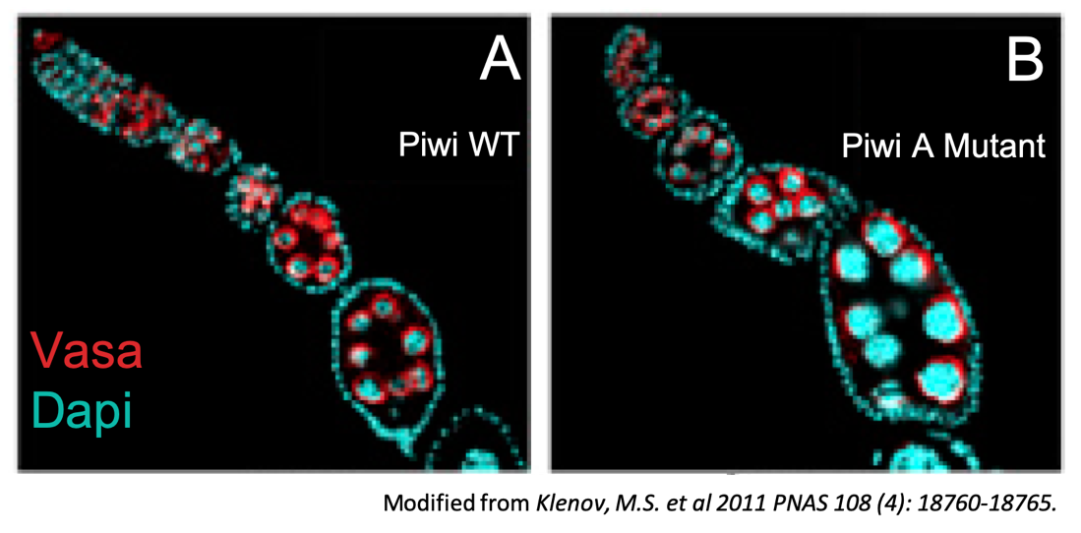

Note: Vasa (colored red) is a protein present in germline cells, but not somatic cells. DAPI (colored cyan) stains DNA of all cells.

Q1. What type of microscopy image (light or fluorescence) are you looking at? From this image, what structures, protein, or DNA are you able to examine?

Q2. What evidence suggests that the wild-type (WT) ovary is normal?

Q3. What evidence suggests that the mutant ovary is normal? Abnormal?

Q4. Based on the results shown, is the role of Piwi that is absent in the Piwi A mutation required or dispensable for stem cell self-renewal? Why or why not?

Exploring Piwi “B” Mutant worksheet

When researches compared the ovaries of wild-type Piwi containing flies (panel A) to that of flies with the Piwi B mutant (panel B) they saw the following morphology in the ovarioles. Observe the images included below and answer the following questions.

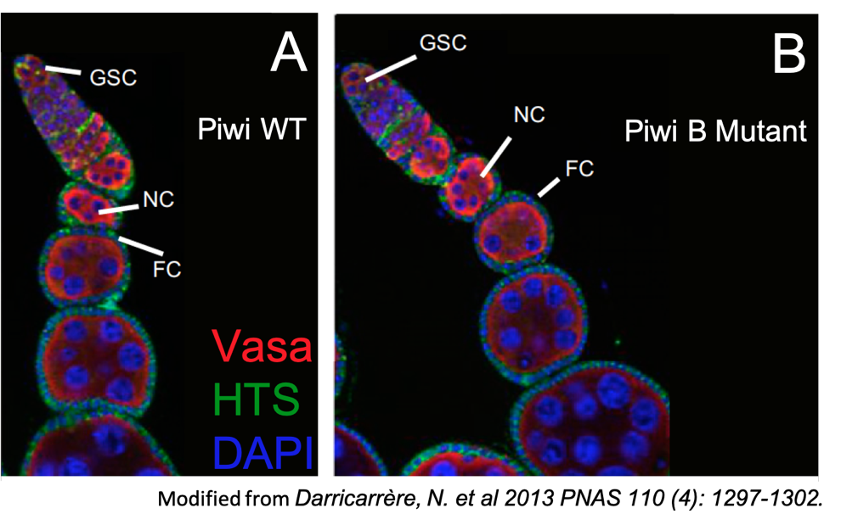
Note: Germline Stem Cells (GSCs), germline nurse cells (NC), and somatic follicle cells (FC) are indicated. Vasa protein (colored red) is present in germline cells, but not somatic cells. HTS (colored green) is a protein found as round spheres in GSCs as well as at the cell membrane of FCs. DAPI stains DNA of all cells (blue color).

Q1. What type of microscopy image (light or fluorescent) are you looking at? From this image, what structures, protein, or DNA are you able to examine?

Q2. What evidence suggests that the wild-type (WT) ovariole is normal?

Q3. What evidence suggests that the mutant ovariole is normal? Abnormal?

Q4. Based on the results shown, is the role of Piwi that is absent in the Piwi B mutation required or dispensable for stem cell self-renewal? Why or why not?

Exploring Piwi “C” Mutant worksheet

When researches compared the ovaries of wild-type Piwi containing flies (panel A) to that of flies with the Piwi C mutant (panel B) they saw the following morphology in the ovarioles. Observe the images included below and answer the following questions.

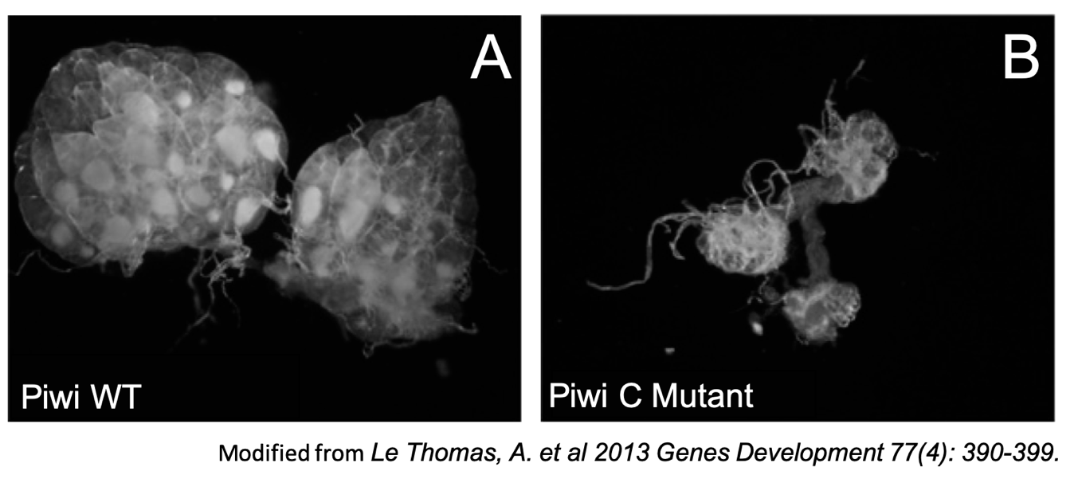
Questions:
Q1. What type of microscopy image (light or fluorescent) are you looking at? From this image, what structures, protein, or DNA are you able to examine?

Q2. What evidence suggests that the wild-type (WT) ovary is normal?

Q3. What evidence suggests that the mutant ovary is normal? Abnormal?

Q4. Based on the results shown, is the role of Piwi that is absent in the Piwi C mutation required or dispensable for stem cell self-renewal? Why or why not?

Part 2: Getting to know Piwi (Function and Sequence)
Piwi appears to be a complex protein that interacts with many specific proteins and RNA to play an important role in gametogenesis. Through a series of bioinformatics explorations students will learn about the domain architecture and interactions of Piwi.
- To learn more about the functions and overall organization of the Piwi protein, we will explore a biological data resource called UniProt.
Box 3: Resource
UniProt (https://www.uniprot.org/) is a bioinformatics data resource that provides comprehensive, high-quality, freely accessible protein sequences, and their functional information. This information comes from research that has been published by others. For eukaryotic proteins it also lists information about specific domains, post-translational processing and modifications, and pathology resulting from mutations in the protein. UniProt provides links to other biological data resources to access other relevant information about the protein, such as gene sequence, protein structures, functional annotations etc.

Search for Piwi in Uniprot by typing the protein name in the top search box. From the results returned, select the entry for Drosophila melanogaster (Fruit fly) Piwi. Open the UniProt page, review and refer to it as you answer the following:

Q1. What is the identifier of the UniProt entry that you have selected? (Hint: this is the set of alpha numerical string, listed at the top of the page, after UniProtKB -, and before the parenthesis.)

Q2. List three types of information that you found out about Piwi from this data resource. (Hint: click on the various tabs in the left hand menu. List the name of the tab and what interesting information you found about the protein).

- Piwi domains: Like many other eukaryotic proteins, the Piwi protein is composed of different domains.
Box 4: Vocab
A domain is a conserved part of a protein that can evolve, function, and exist independently of the rest of the protein chain. It usually has a stably-folded, three dimensional structure.

Explore the primary structure and domain organization of Piwi as listed in the “Family & Domains” section of the UniProt page for Piwi.

Q4. Draw a linear diagram of the Piwi protein and mark all the motifs, regions, and domains.

Q5. To learn more about the functions of the protein domains present in the Piwi protein, explore the Family and domain databases and compare information available from InterPro, Pfam, and PROSITE. For each domain, summarize what you learned in 2-3 sentences.

The Piwi protein functions are quite diverse. Watch the video (https://youtu.be/2LauiT75n2U ) that summarizes key functions of Piwi.
Based on the video and your explorations of the UniProt page on Drosophila Piwi, it appears that the Piwi protein interacts with both proteins and RNA.

Q6. Redraw the linear representation of Piwi (from your Ans 4) and write next to each of the different regions/domains where the protein(s) and RNA are likely to bind.

