Waking Up Anna
By Kate O’Toole¹, and Shuchismita Dutta^{2*}

¹Department of Biology, Emory University, Atlanta, GA 30322
²Institute of Quantitative Biomedicine, Rutgers University, Piscataway NJ 08854
*contact author: sdutta@rcsb.rutgers.edu

Preparation:
Prior to the case discussion in class (as a homework assignment), get acquainted to the case.
- Watch a video (https://www.youtube.com/watch?v=V9gnvWtta4M) to hear Anna’s personal account and how doctors at the Emory Sleep Center in Atlanta, GA found a treatment that finally helped her feel awake.
- Read the Emory news article, “An antidote for hypersomnia”, by Baker and Eastman, published on Nov. 21, 2012 describing this treatment (http://news.emory.edu/stories/2012/11/antidote_for_hypersomnia/).
- Read the abstract of the peer reviewed scientific article describing this work at https://stm.sciencemag.org/content/scitransmed/4/161/161ra151.full.pdf

Part 1: Can’t Get Enough Sleep
We have all been sleep deprived at some point in time and can relate to how difficult it becomes to focus or carry out simple routine tasks. For Anna Sumner, it was different – she craved sleep. This case will focus on understanding the molecular basis for signaling in the Nervous System and the cause and treatment of Anna’s sleep crises.

Based on the video you watched and articles you have read about this case answer the following questions.

Q1. Describe in 1-2 sentences the main difference between the popular news report and the peer-reviewed scientific article.

Q2. For the three sources of information that you viewed/read for this case list one benefit and one drawback in the table below.
Source | Benefit | Drawback
Video
News report
Journal article

Q3. Define the prefixes Hypo- and Hyper- used in the description of this case in the peer-reviewed manuscript. Find at least one example where this meaning is used

Cellular communication in the brain occurs when neurotransmitters released from one cell activate receptors on the surface of another cell. This chemical signal changes the physiology of the second cell to elicit a response, as shown in figure 1.

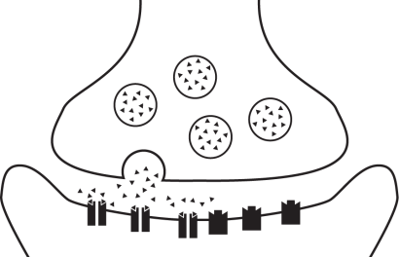

Figure 1: Neuronal synapse showing a. presynaptic cell, b. post synaptic cell, c. neurotransmitters, d. synaptic vesicles, e. receptors

Q4. Can you redraw the above neuronal synapse shown above and label the diagram with the 5 labels a. presynaptic cell – e. receptors, listed in the figure legend.

Box 1: Vocab
Neurotransmitters are small molecules derived from basic building blocks of life, e.g., amino acids. For example, gamma amino butyric acid (or GABA) is derived from the amino acid Glutamate by a decarboxylation reaction. They bind to proteins (such as receptors) and affect their functions. They are also referred to as ligands and may include naturally occurring molecules or man-made drugs.
Receptors are large transmembrane proteins that change shape when they bind to small molecules. Many clinically important drugs also bind to receptors in the brain to change our behavior, to treat diseases, and in special situations like inducing anesthesia for surgery.
There are many different combinations of neurotransmitters and receptors in the nervous system that add together to control the types of physiological and behavioral responses that we can see in ourselves. Two main types of neurotransmitter receptors are listed here:
- Metabotropic receptors control metabolic pathways inside the cell, which can change the activity and expression of proteins.
- Ionotropic receptors open pores, or channels, to allow specific ions to cross the cell membrane. These “ion channels” alter the electrical properties of the membrane to increase or decrease the likelihood that the cell will continue the chain of communication by firing an action potential.
Some neurotransmitters (e.g. glutamate) are excitatory (i.e., make it easier to fire action potentials while others (e.g., GABA) are inhibitory (i.e., make it harder to fire action potentials).

Q5. Review Figure 1 again and examine the rectangles closely - do you see anything special about the receptors and their interaction with the neurotransmitters?

- Here we will focus on the γ-aminobutyric acid (GABA) neurotransmitter system. There are two main types of GABA receptors. GABA type A (GABA-A) receptors are ionotropic and GABA type B (GABA-B) receptors are metabotropic, but the overall response of both types of receptors is to inhibit the activity of the cell.
- GABA-A receptors are pentameric, composed of 5 transmembrane protein subunits that together form a chloride ion-selective channel. This channel is open when the neurotransmitter GABA binds to the receptor. The GABA-A receptor also responds to a wide variety of drugs, e.g. benzodiazepines (a sedative), anesthetics and depressants. A simple cartoon of the GABA-A receptor is shown in Figure 2 along with the binding sites of various ligands.
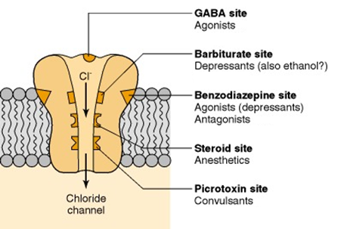
Figure 2: GABA-A receptor, chloride (Cl⁻) ionophore complex. The cut-away view demonstrates binding sites for a variety of compounds that influence the function of the receptor complex. (Adapted from Olsen, R.W. and DeLorey, T.M., (1996), GABA Receptor Physiology and Pharmacology, Basic Neurochemistry: Molecular, Cellular and Medical Aspects. 6th edition.)

Let’s review the GABA neurotransmitter system.

Q6. What is the main role of GABA in the nervous system?

Q7. The GABA-A receptor is a transmembrane protein. Where would you expect a chemical signal (GABA, Benzodiazepine etc.) to bind this receptor? Circle ONE and explain your choice.

- extracellular side
- transmembrane domain
- intracellular side
- in the central channel

- Binding of neurotransmitters triggers ion channels to open. When GABA binds to the GABA-A receptor, the ion channel is open and chloride ions can cross the cell membrane. Other ligands, including clinically important drugs, can also bind to the GABA-A receptor to alter its function by opening or closing the Cl⁻ channel.

Box 2: Vocab
Agonists: These are drugs or molecules that turn on the function of a protein. The natural ligand usually acts as an agonist.

Antagonists: These are drugs or molecules that decrease or inhibit the function of a protein.

Allosteric modulators: The word root “allo” means “other”. These are drugs or molecules that bind at a location other than the natural ligand’s binding site. Modulators could be positive (increase activity of the protein) or negative (decrease its activity).

Q8. Predict the effect of an AGONIST binding to the GABA-A receptor. Will the Cl⁻ channel open, close, or remain unaffected by this drug? Can you list some examples of GABA-A receptor agonists?

Q9. Predict the effect of a POSITIVE ALLOSTERIC MODULATOR binding to the GABA-A receptor. Will the Cl⁻ channel open, close, or remain unaffected by this drug? Can you list some examples of GABA-A receptor positive allosteric modulators?

Q10. Predict the effect of an ANTAGONIST binding to the GABA-A receptor if it occupies the same site that GABA would normally bind. Will the Cl⁻ channel open, close, or remain unaffected by this drug?

Q11. Challenge question: What would happen if you increase the concentration of GABA and keep the concentration of the antagonist the same?

Part 2: A Clue in the Spinal Fluid
After excluding known causes of sleepiness doctors collected a sample of Anna’s cerebrospinal fluid (CSF) to look for clues about the unique pharmacology within her sleepy brain. Researcher scientists analyzed her sample along with 31 other hypersomnolent patients and found that it contained a substance that increased GABA-A receptor function in cultured cells!

Let’s explore the evidence that scientists gathered and discover how this observation can help understand Anna’s case.

Box 3: Experimental techniques
GABA-A receptor. GABA-A receptors are pentameric. Although there are many different isoforms of the protein, the most common type of GABA-A receptors found in the human brain are composed of 2 alpha (α), 2 beta (β), and 1 gamma (γ) subunit.
Cultured cells express the receptor: These GABA-A receptor protein subunits can be recombinantly expressed in a cultured cell line (e.g. HEK293 cells) that form functional receptors for laboratory study.
Patch clamp is an experimental technique used to measure the changes in the electrical properties of cell membranes. Important ions, like Na⁺, K⁺, Ca²⁺, and Cl⁻, are present in different concentrations inside and outside neuronal cells leading to a membrane potential difference in charge. When channels are open, ions can move across cellular membranes leading to rapid and transient changes in the distribution of these charged particles. The movement of ions is recorded as current. These electrical signals are transmitted through neurons to trigger physiological changes. These cells can be examined by a technique called “patch clamping” to determine whether or not the channels in these receptors are open or closes in the presence of different ligands.
In these experiments, when the GABA-A receptor channels are closed there is a baseline reading. GABA and/or other GABA-A receptor agonists open the chloride channels to let negative ions (Cl⁻) into the cells. The patch clamp records this entry of Cl⁻ ions as a downward deflection from the baseline. The larger the deflection (or dip) in the recording the more the Cl⁻ ions have entered, inhibiting the neuron.

Scientists used patch clamp electrical recordings on HEK293 cells expressing the human α1, β2, and γ2 subunits of the GABA_{A} receptor to test CSF effects on inhibitory chloride currents. First, they measured currents triggered by 10 μM GABA alone (control, trace a) to establish a baseline. Next, hypersomnolent patient CSF was applied alone and they observed a negligible chloride current (trace b). This response was equal to what would be expected from normal GABA concentrations in typical CSF. Next, hypersomnolent patient CSF was applied together with 10 μM GABA (trace c). Researchers were astonished to find that the current was doubled. They would only expect to see that kind of increase in the presence of a positive allosteric modulator like a benzodiazepine! Luckily, they had a pharmacological tool to determine if something was binding to the benzodiazepine site. Flumazenil is a competitive antagonist that blocks benzodiazepine binding. When flumazenil was applied together with 10 μM GABA and the hypersomnolent patient CSF sample (trace d) they saw that the effect was reversed! Finally, to make sure that everything was working correctly, they verified that flumazenil does not change GABA-A receptor activity with GABA alone (trace e) and that currents evoked by 10 μM GABA alone returned to baseline levels (trace f) after all other pharmacological agents were washed away. The data for these experiments is shown in Figure 3. Vertical calibration bars equal 200 pA (picoAmps) and horizontal calibration bars equal 5 s.

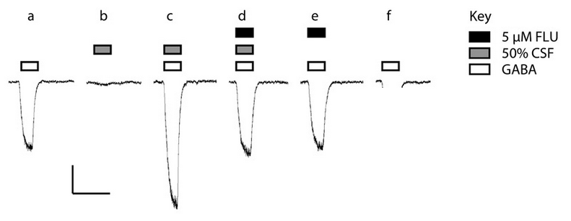

Figure 3. Chloride currents recorded from HEK293 cells expressing human GABA-A receptor.

Q1: Label the calibration bars with proper units and scale. Choose one word to describe what is being depicted in each direction.

Q2. Compare the chloride current traces shown in b. and c. and explain the conclusion that can be drawn from your observation.

Q3. Compare the chloride current traces shown in c. and d. and explain the conclusion that can be drawn from your observation.

Q4. Complete the figure. Draw the current trace that would be elicited by application of 10 μM GABA after washout of pharmacological agents that had been co-applied throughout the experiment in “trace f” as described above. What are traces e and f showing about the experimental design?

Q5. Based on the traces above, which of the following statements is correct?
- Only in trace c. the GABA-A receptor is open and Cl⁻ ions are flowing into the cell
- The substance in Anna’s CSF can bind to GABA-A receptor and open the Cl⁻ channel
- The substance in Anna’s CSF needs GABA in order to open the Cl⁻channel
- Flumazenil can close the GABA-A receptor Cl⁻ channels
- When the GABA-A receptor is open K⁺ ions are flowing out of the cell

