A Case of Severe Insulin Resistance
By Melanie Lenahan¹, Shuchismita Dutta²*

¹Science and Engineering, Raritan Valley Community College, Branchburg, NJ
²Institute for Quantitative Biomedicine, Rutgers University, Piscataway NJ
*contact author: sdutta@rcsb.rutgers.edu

Introduction
Read the following story titled “Megan, Jade, and Joanna” to get started on this case.
------------------------------------
Jade and Megan have been best friends since second grade. While in school they spent a lot of time in each other’s homes. Jade’s older sister, Joanna, was their favorite go-to person – for help with school projects, personal advice, teenage troubles, and so much more. A few years ago, Joanna got married and now lives with her husband and little baby girl.
Currently the three of them live in different cities – Megan is in Boston, majoring in Biochemistry at Boston College; Jade is in Los Angeles studying to become a pianist; and Joanna is a nurse practitioner in Texas. Last month, Jade called Megan on a Sunday afternoon and anxiously said – “Do you know Joanna told me that she was recently diagnosed with Diabetes, something about insulin resistance or something?” “She is just 32, not obese, you know, and is very particular about what she eats and stuff”. Megan sensed that Jade was worried. She knew Jade’s mom and grandma had been diagnosed with diabetes in their thirties too, so she wondered if Jade was worrying about developing diabetes herself. That afternoon they talked on the phone for an hour about family history, food, obesity, and diabetes. By the time Jade hung up, Megan was seriously thinking about Jade’s chances of getting diabetes, and for that matter, Joanna’s baby girl too.
The next morning Megan started searching online to see if I could learn about diabetes running in families. She wanted to understand if diabetes could indeed be inherited. Searching through PubMed Megan read about Maturity Onset Diabetes of the Young (MODY) but brushed it aside. She also believed that since Joanna is in the healthcare field, she must have thought about this and looked into getting tested. Megan wanted to learn more about insulin resistance. One particular paper that really caught her attention was titled “A Family with Severe Insulin Resistance and Diabetes Due to a Mutation in AKT2”. The family tree shown in the paper seemed very much like Jade’s family, so she became curious and opened the paper to read it in detail.
------------------------------------
Box 1: Resource
PubMed: a free online search engine for scientific literature on biological and biomedical topics with links to access their abstracts and full articles.

Read the abstract of the paper that Megan found and let us join her in understanding what the paper described.

Part 1: The Familial Connection

Box 2: Vocab
Proband is the individual/subject who brings a case to attention – e.g., the patient, or person who is being studied.

- The pedigree tree included in the paper shows the inheritance patterns of hyperinsulinemia and diabetes in the proband’s family. Examine the figure 1D in the George et al., 2004 paper (also shown below for your convenience) and answer the following questions.

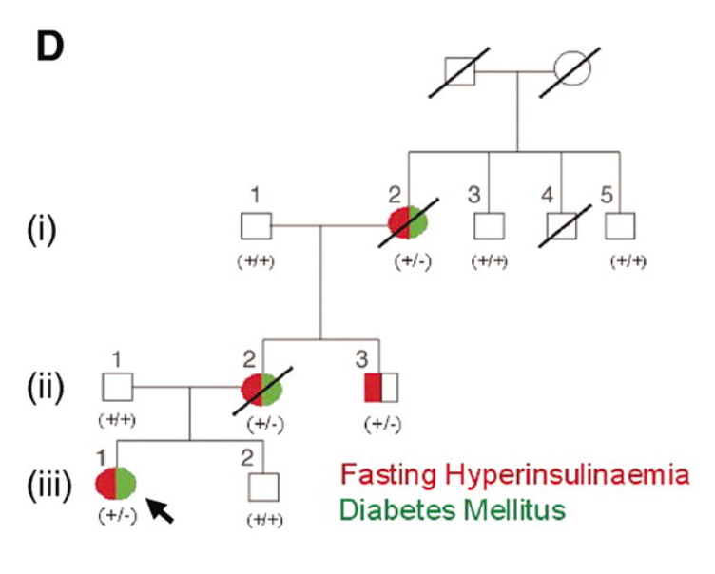
Figure 1D from George et al., 2004.

Q1. What is the relationship between hyperinsulinemia and diabetes mellitus in the three numbered generations [(i), (ii), (iii)] in the family tree shown above?

- DNA sequencing of the proband’s genome and selected family members revealed a G-to-A mutation in the Akt-2 gene compared to control (see * in the DNA sequencing trace below. This mutation changes the Arg (codon CGC) at position 274 to His (codon CAC).

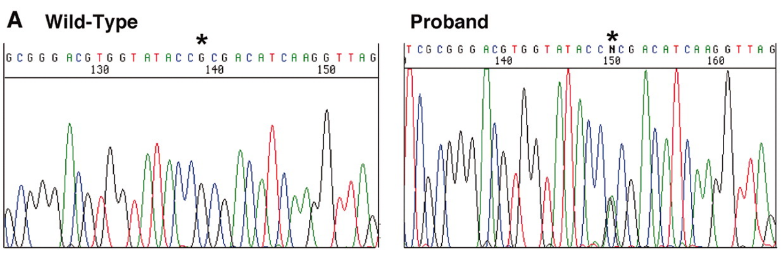
Fig 1A from George et al., 2004.

Q2. List one difference in the properties of the side chains of Arg and His.

Part 2: Understanding Insulin Resistance

- The supplementary sections of the paper provide details on how members of the family (described here) with the Akt-2 mutation had hyperinsulinemia. Even when no or very little glucose was consumed these individuals produced higher amounts of insulin compared to control subjects from the population. Yet, many of these individuals developed diabetes. To understand this scenario let us learn a little more about insulin signaling and the role of Akt-2 using a resource called KEGG.

Box 3: Resource
Kyoto Encyclopedia of Genes and Genomes (KEGG, https://www.genome.jp/kegg/) has aggregated information about various types of biological interactions at the molecular, cellular, organismal, and ecosystem levels. KEGG Pathway (https://www.genome.jp/kegg/pathway.html) is a collection of metabolic and signaling pathways in health and disease. This can be consulted to explore the names and interactions of key players in these pathways.

Go to the KEGG Pathway website and search for insulin resistance (either typing it in the top search box or by looking through the Human Disease pathways.

Box 4: Concept
Insulin binding to Insulin receptors on the cell surface of a muscle cell initiates a series of signaling steps involving various players that eventually signal vesicles containing the Glucose transporter (GLUT4) to move to the cell membrane where they open to let in glucose from the blood into the cells.

Follow the pathway(s) from Insulin (INS) binding to Insulin Receptor (INSR) on the left of the page to GLUT4 vesicles being moved to the membrane for glucose uptake.

Q1. Examine the KEGG PATHWAY to identify all the key players in the shortest path that connects Insulin to GLUT4 and list them in sequential order. Does this involve Akt2?

- The paper Megan was reading (George et al., 2004) showed that the mutant Akt-2 enzyme’s activity is altered. The AKT2 gene with and without the mutation was introduced into a mammalian cell line and the protein was expressed. Results of a kinase assay (Figure 2B) shows enzyme activity for both the wild type and mutant proteins, with (Ins) and without adding Insulin (Bas). Examine the figure (also shown below for your convenience) and answer the following questions.
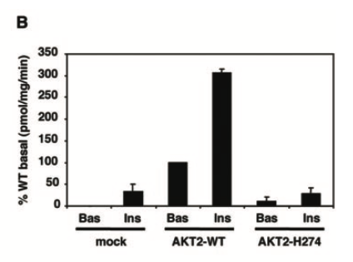
Figure 2B from George et al., 2004.

Q2. In the kinase assay results, the activity of the wild type protein changes significantly in the presence of insulin. Describe the change and explain why this change is observed in the presence of insulin? (Hint: examine the KEGG pathway and consider the insulin signaling steps in writing this answer).

Q3. What does the kinase assay results tell you about the activity of the H274 mutant in comparison with the wild type Akt-2 enzyme?

Q4. Examine the KEGG pathway and explain the impact of inactivating the Akt-2 enzyme. Why and how does this lead to insulin resistance?

