Here are some resources to learn about the structure of proteins in general:
Learning about chemical interactions in biological macromolecules
# | Resource Name | Authors (where available) | Link/Detail | Comment
1 | Online Macromolecular Museum  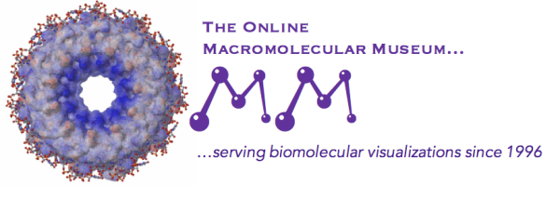 | Yasi Mojab and David Marcey | http://earth.callutheran.edu/Academic_Programs/Departments/BioDev/omm/jsmolnew/bonding/chymo.html | An Introduction to Chemical Bonds and Protein Structure
2 | PDB-101  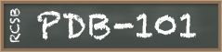 | David Goodsell and Maria Voigt | http://pdb101.rcsb.org/learn/videos/what-is-a-protein-video | What is a Protein?
3 | Internet Course on The Principles of Protein Structure | Organized by Birkbeck College | http://www.cryst.bbk.ac.uk/PPS95/course/3_geometry/index.html | Protein Geometry
4 | PDB-101 | Shuchismita Dutta, Rachel Kramer Green, and Catherine L. Lawson | http://pdb101.rcsb.org/learn/guide-to-understanding-pdb-data/biological-assemblies | asymmetric units and biological assemblies
5 | PDB-101 | David Goodsell | http://pdb101.rcsb.org/learn/guide-to-understanding-pdb-data/introduction | Introduction to PDB Data

To learn more about the Caffeine biosynthetic enzymes and more:
  - For XMT and DXMT structures see paper
http://www.plantphysiol.org/content/144/2/879
  - For chitinase CrChi1 in complex with the inhibitor caffeine
https://www.microbiologyresearch.org/content/journal/micro/10.1099/mic.0.043653-0.

