Caffeine Evolution
By Brian Sullivan¹, Shuchismita Dutta²*

¹Department of Plant and Microbial Biology, North Carolina State University, Raleigh NJ 27695
²Institute of Quantitative Biomedicine, Rutgers University, Piscataway NJ 08854
*contact author: sdutta@rcsb.rutgers.edu

Preparation:
Prior to the case discussion in class (as a homework assignment), get acquainted to the case.
- Read the New York Times Science article from Sep 2014, authored by Carl Zimmer (https://www.nytimes.com/2014/09/04/science/how-caffeine-evolved-to-help-plants-survive-and-help-people-wake-up.html)
- Also read the abstract of the peer-reviewed scientific article mentioned in the newspaper article above (Science, 2014, 345, 1181-1184; doi:10.1126/science.1255274)
- List 3 interesting things you learned after reading these articles and capture the source where you learned this from (NYT article, Science article, elsewhere). Write this on a sheet of paper and post it on a physical Classroom “Parking Lot” or post these electronically on a shared class page.

Part 0: Understanding sources
- Begin the class with a general discussion about the newspaper and peer-reviewed scientific articles you read in preparation for this case. Based on your readings, answer the following.

Q1. What is the main difference between the news report and peer-reviewed scientific article?

Q2. What kinds of information did you learn from the NYT article vs the Science article abstract?

Part 1: What is caffeine?
Motivation 1: When you think about foods and drinks that contain caffeine perhaps you think about coffee, tea, and cocoa or chocolate. Here we will learn the chemical nature of Caffeine.

- The newspaper article describes caffeine as a drug that is “toxic at high doses but enhancing our brains at low doses.” To learn a little more about its chemical structure, search for Caffeine in DrugBank (a curated resource that provides a wide variety of information of drugs and drug-like molecules). Look for information about this molecule in DrugBank (https://www.drugbank.ca/drugs/DB00201), then refer to it to answer the following questions?

Q1. What is the chemical structure of caffeine? Draw or paste a picture of this molecule below.

Q2. Describe the function(s) of Caffeine (as listed in DrugBank).

Part 2: Why do Plants make Caffeine? and How?
Motivation 2a: Worldwide humans commonly use caffeine as a stimulant. In this case study we will think about the value of caffeine from the plants’ perspective. However, have you ever thought about why plants (e.g. the Coffee, tea, cocoa, mate plants) make caffeine?

- Let us watch a mini lesson video (https://youtu.be/mFo1Qzm0Q_M) to learn about plant growth strategies and allelopathy; review the Box-1 contents and then answer the following questions.
Box 1: Vocabulary
Allelopathy is a biological phenomenon in which plants produces biochemicals to influence germination, growth, survival, and reproduction of another plant or organism.
Allelochemicals are often secondary metabolites and not required for its growth, development, and reproduction.

Caffeine has been described as a germination and growth inhibitor based on various experiments.

Q1. How would you design an experiment to test this function of caffeine? Describe the experiment and expected results in 2-4 sentences.

In the early 1900s Fred Ransom published the results of an experiment in Biochem J. 1912, 6: 156–161; doi: 10.1042/bj0060156, where he compared the germination of a large number of different seeds in tap water and when pre-treated with caffeine. A small portion of the results are included below.

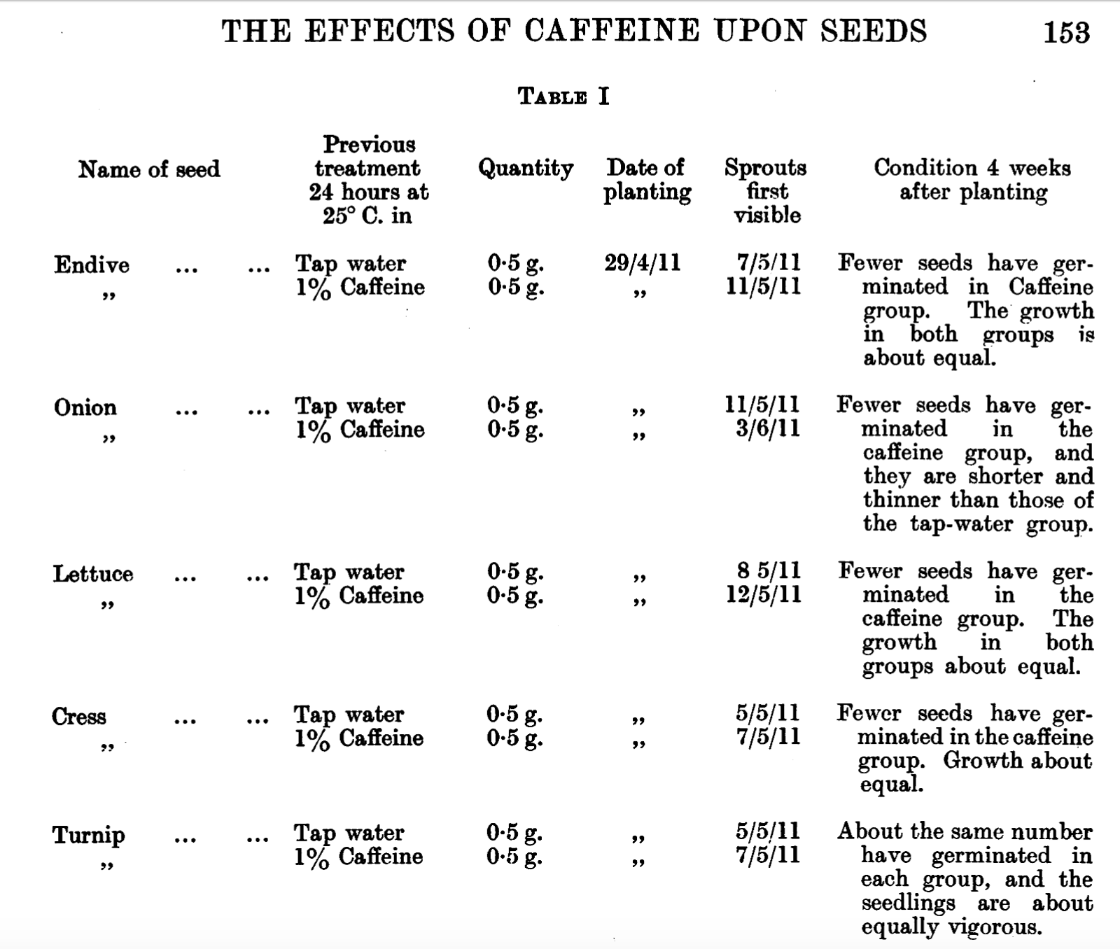

Note that in the above table the date is listed using the convention DDMMYY

Q2. Based on the data shown fill in the table below and describe the impact of caffeine treatment on the germination of the seeds. Does this confirm or disprove the claim that caffeine is an allelochemical?

Name of Seed | # days for germination
 | Tap water | pre-treated with Caffeine
Endive
Onion
Lettuce
Cress
Turnip

Motivation 2b: Coffee, tea, cocoa, and other caffeine producers make caffeine (1,3,7-trimethixanthine) from the nucleoside metabolite xanthosine through a series of enzymatic reactions. Here we will learn what these enzymes are and how they facilitate caffeine biosynthesis.

The Denoeud et al., 2014 (Science paper) explains that coffee plants have a set of 3 enzymes that convert a xanthosine into caffeine. All three enzymes [xanthosine methyltransferase (XMT); 7-methylxanthine methyltransferase (MXMT); and 3,7-dimethylxanthine methyltransferase (DXMT)] are N-methyl transferases that use the cofactor S-adenosylmethionine (SAM).

Review the chemical structures of xanthosine, caffeine, and various intermediates in the biosynthetic pathway.
Adapted from Figure 2 of Science (2014): Vol. 345, Issue 6201, pp. 1181-1184

Q3. The cofactor/co-substrate SAM is used by all the enzymes (XMT, MXMT, and DXMT). In each case at the end of the enzyme reaction SAM is converted to SAH. Can you figure out what SAH is?

Box 2: Concept
Enzymes undergo conformational changes in order to catalyze a reaction. Sometimes these changes include movement of loops and also interacting with other molecules (such as cofactors, ions). Apoenzymes – i.e. the enzyme without any substrate, cofactor etc. bound to it, is often inactive. Binding to substrate(s) and cofactor(s) can activate the enzyme and prepare it to perform the enzyme reaction.

Q4. If you had to assemble an active complex of the XMT enzyme, that is about to perform the catalysis, what molecule(s) would you include in this complex?

