A Constitutively Active Enzyme

After completing the “Bypassing the Roadblock” section of the case, read the following abstract and answer the questions.
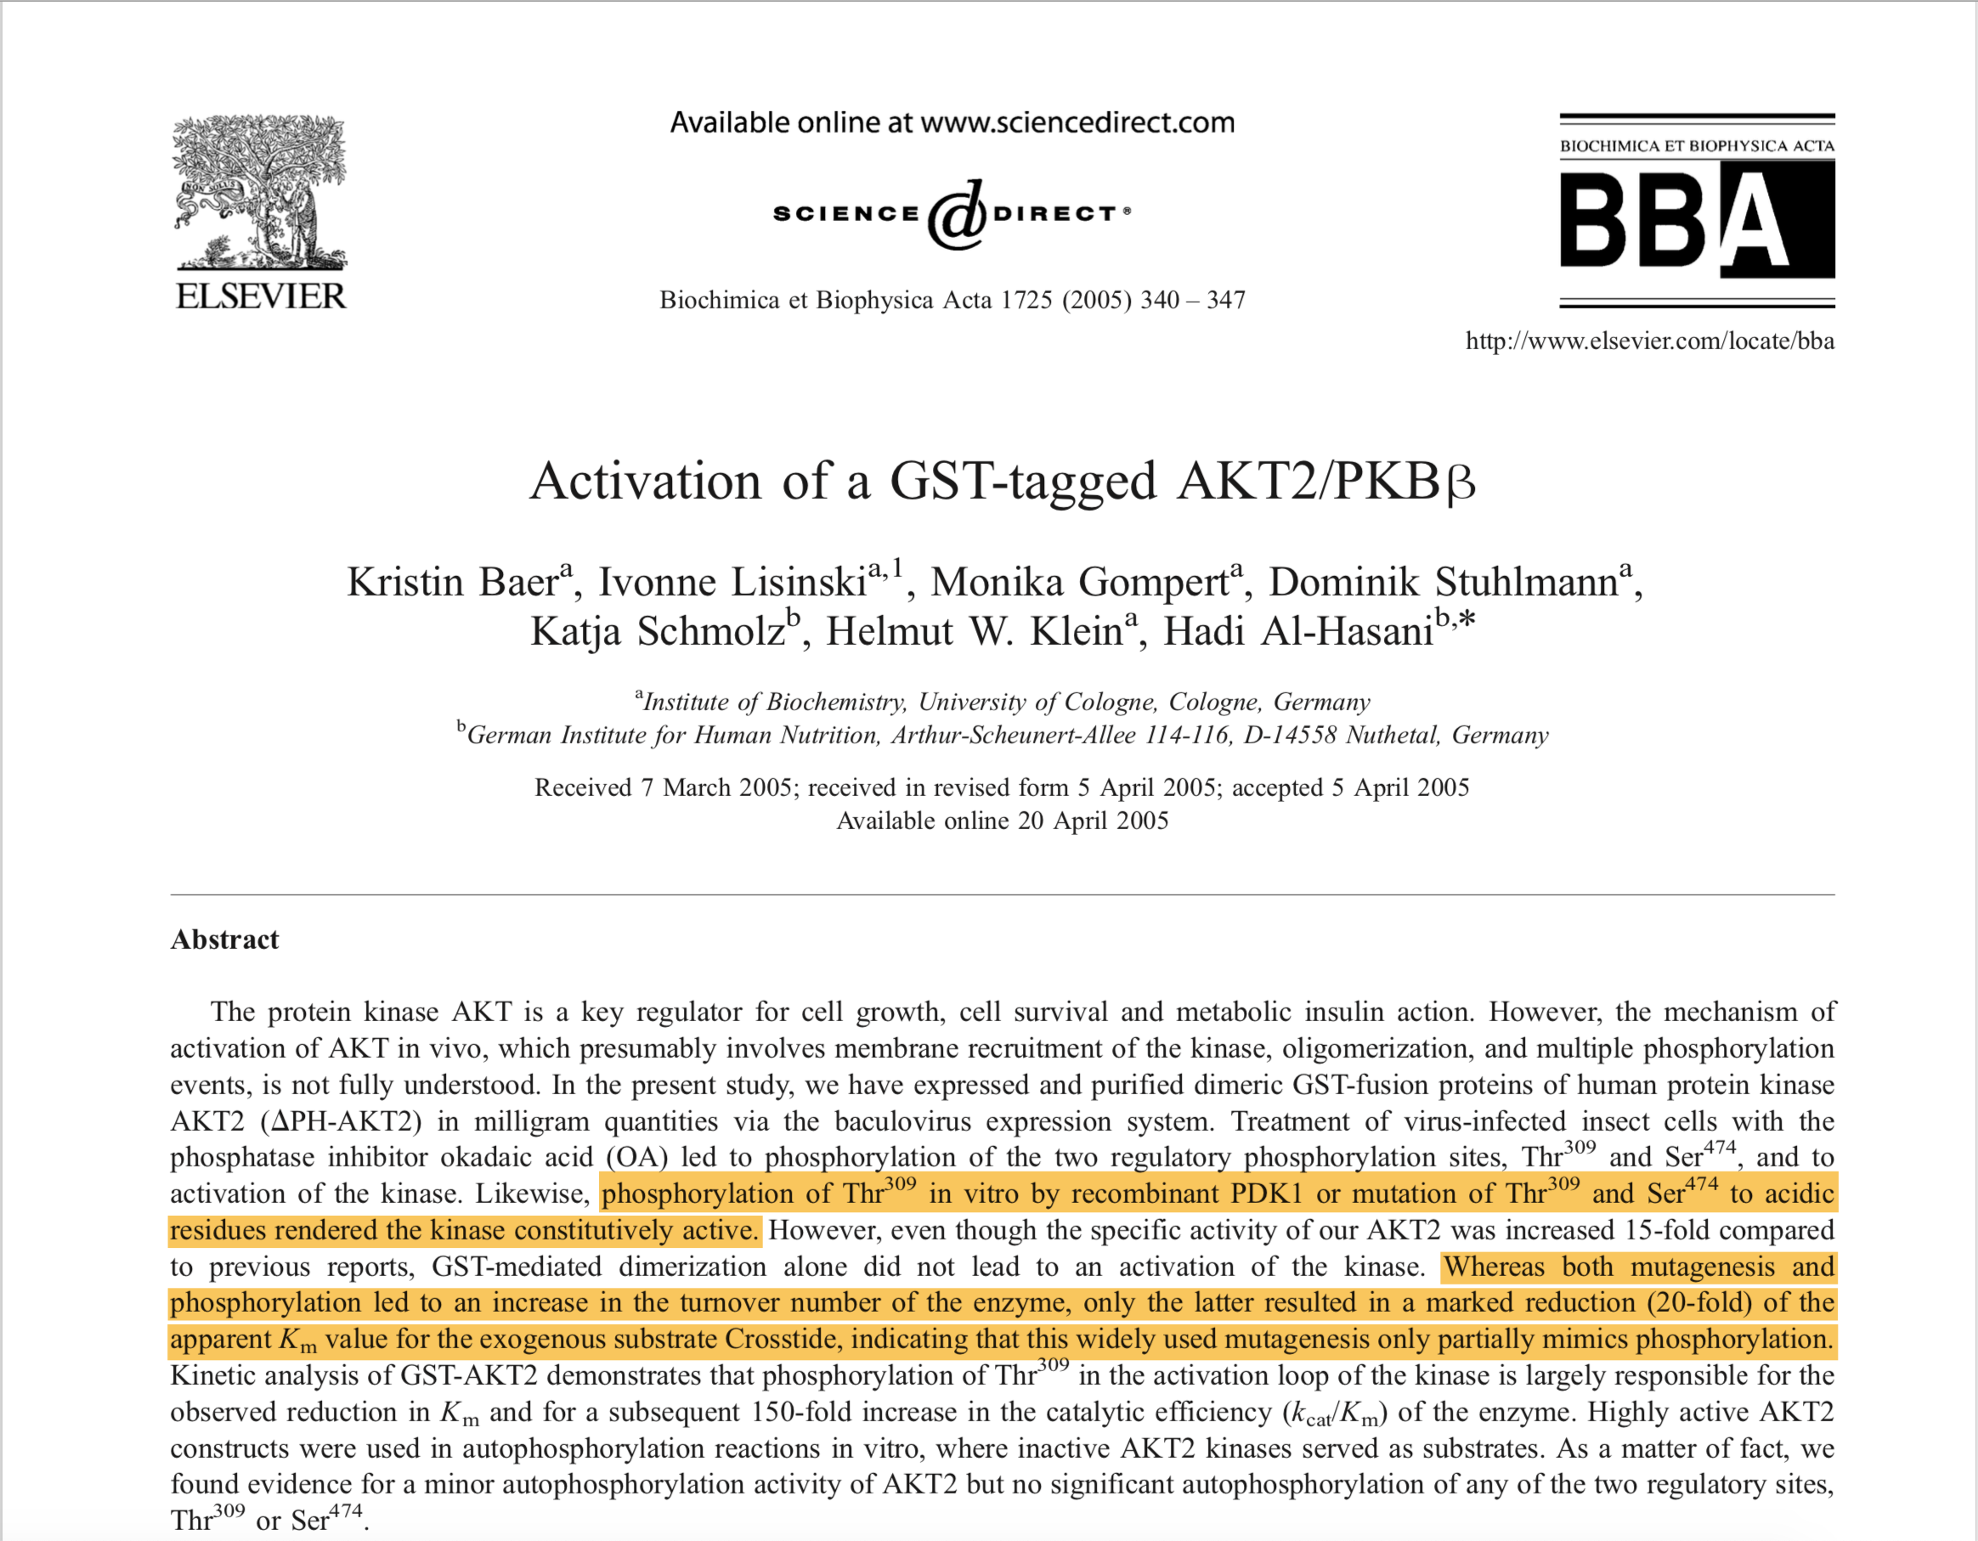

Read the yellow highlighted sections carefully and go back to the Akt-2 structure that you were exploring (PDB ID 1o6k).

Q1. Explore the structure summary page for this structure and list which of the 2 key residues (T309 or S474) is mutated to an acidic residue? What is the residue mutated to?

Q2. What is the role of ANP in this complex? Where is it bound – include an image to illustrate your answer.

Q3. Locate the mutated residue you identified in Ans 1. Examine its interactions with its neighboring residues. List any two interactions that its side chain is involved in and describe the nature of its interactions. Support your answer with an illustration.

Q4. Based on your analysis above, can you explain why the mutation can only partially mimics the phosphorylation? (Hint: if the residue was phosphorylated would its interactions be any different?)

