Nicholas’ Story
Kimberly Cortes¹, Shuchismita Dutta^{2*}, Henry Jakubowski³, Melanie Lenahan⁴, David Marcey⁵, Patricia Marsteller⁶, Cassidy R. Terrell⁷

¹ Kennesaw State University, GA; ² Rutgers University, NJ; ³ College of Saint Benedict, St John’s University, MN; ⁴ Raritan Valley Community College, NJ; ⁵ California Lutheran University, CA; ⁶ Emory College of Arts and Sciences, GA; ⁷ University of Minnesota, Rochester, MN
*contact author: sdutta@rcsb.rutgers.edu

Part 2: Fetal and Adult Hemoglobin
Box 11: Storyline
Since hydroxyurea is able to increase production of the fetal hemoglobin (HbF), here we will explore the structure of HbF and compare it with that of the sickle cell hemoglobin (HbS). These comparisons may help understand how Hydroxyurea changed Nicholas’ life.
Note: both adult and fetal hemoglobin chains undergo conformational changes upon binding oxygen so when comparing these structures take care that they are in the same conformational state – e.g., both deoxy hemoglobin.

a. We will begin our discussion of fetal and adult/sickle cell hemoglobin by learning about the composition of these molecules.
Box 12: Concept
Adult hemoglobin is a tetramer made up of two α-globin and two β-globin protein chains, while the fetal hemoglobin tetramer has two γ-globin chains instead of the β-globin chains.
Although the β- and γ-globin chains are similar in structure and function, subtle differences between these proteins allow the adult and fetal hemoglobin molecules to bind oxygen.
The sickle cell mutation is in the β-globin protein so the fetal Hb is unaffected by this mutation.

b. Query the PDB archive to find any human fetal hemoglobin structures in the PDB archive. Go to the RCSB Protein Data Bank (https://www.rcsb.org/) and type fetal hemoglobin in the top search box and run a search.

Q1. Did you find any structure of fetal deoxy-hemoglobin in the PDB? What is/are the PDB ID(s)? List all that you think may be relevant.

c. Explore and compare the structures using web-based visualization tools (NCBI’s iCn3D)

- Open the NCBI - iCn3D modeling software
(https://www.ncbi.nlm.nih.gov/Structure/icn3d/full.html).
- Open the File > Align > Structure to Structure.
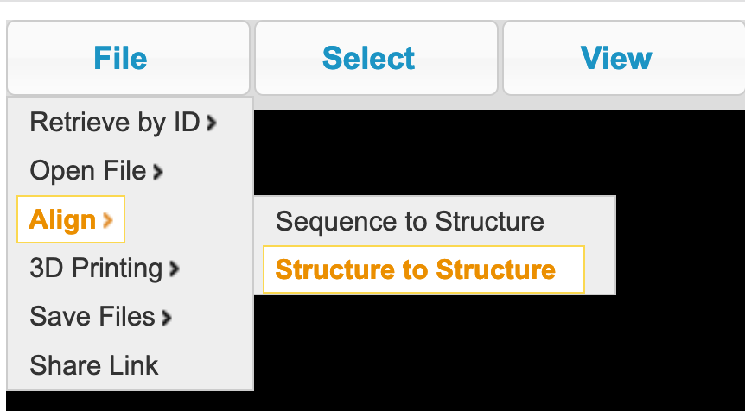

- This should open a window >> type in the IDs of the 2 PDB entries that you wish to compare. Type them in as shown below.
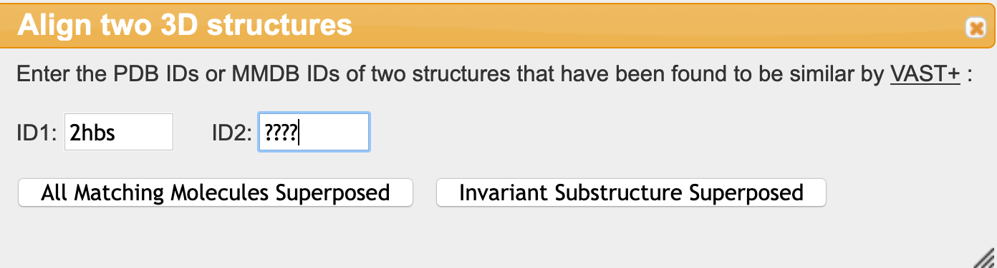

- Click on the button “All Matching Molecules Superposed” to see the HbS and HbF structures aligned.
  - Note the identical amino acids are shown in red – both in the sequence and graphical windows. Amino acids that vary in the β and γ globin proteins are shown in blue.

For your reference, the windows should appear as shown below:
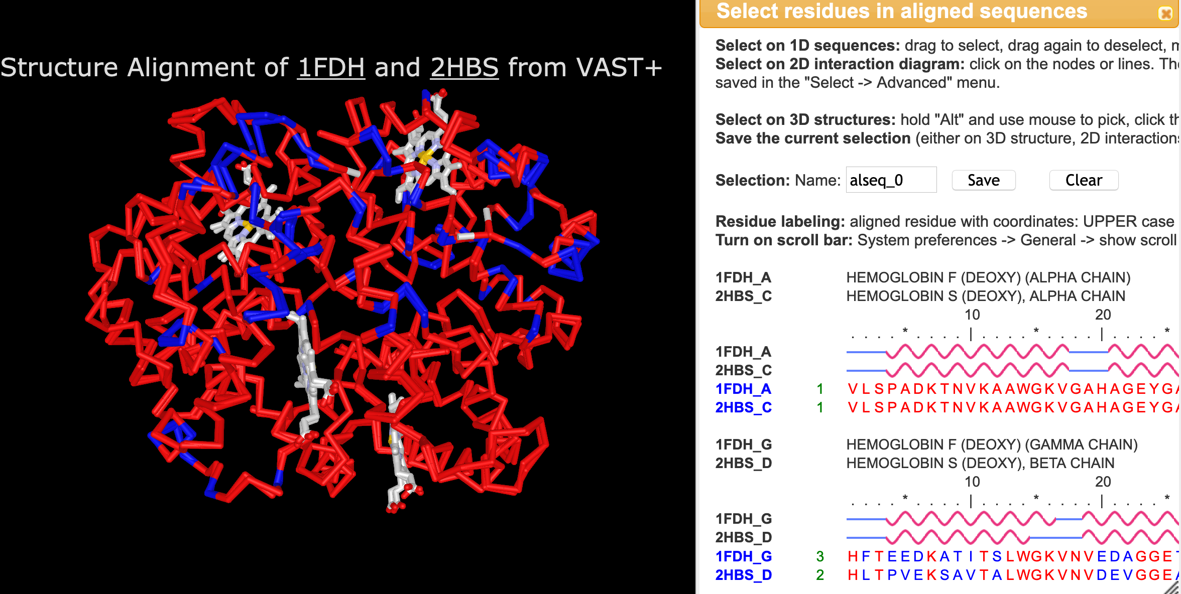

Q2. In which chains and where in these chains are the residues that are different in the two structures located? Support your answer with an image of the superimposed structures

Q3. How well aligned are the structures in these regions? Support your answer with an image of the superimposed structures.

Q4. The hydrophobic patch where the V6 side chain binds in low oxygen conditions includes residues between amino acids 80 and 90. From the Sequence alignment window can you find any one amino acid that is different in the β and γ globin proteins.

- Display the different residue(s) identified above.
  - Select residues that you identified above by clicking and dragging on the amino acid one letter code in the sequence alignment window.
  - Show side chain of these amino acid by clicking on Styles >> Side chains >> Ball and Stick.
  - Zoom in on these amino acids click on View >> Zoom in Selection.
  - Color the amino acid side chains by CPK colors by clicking on Colors >> Atom.

Q5. Which of these amino acids can form hydrogen bonds? Compare the size of these side chains – which one is larger? Support your answer with an image.

Keep the differences between these residues in mind. It will come in handy for discussing the scenario presented in the assessment.
Part 3: Changing Nicholas’ life
Box 13: Storyline
The structural explorations reveal that the HbF structure is similar to the HbS structure barring a few minor differences. However, what is the benefit of increasing HbF concentration in Nicholas’ blood? Here we will explore how this changed Nicholas’ life.

Q1. How does having a higher amount of HbF benefit Nicholas?

Q2. Based on what you know about what hydroxyurea does, why do you think that Nicholas could be more active now?

