Nicholas’ Story
Kimberly Cortes¹, Shuchismita Dutta^{2*}, Henry Jakubowski³, Melanie Lenahan⁴, David Marcey⁵, Patricia Marsteller⁶, Cassidy R. Terrell⁷

¹ Kennesaw State University, GA; ² Rutgers University, NJ; ³ College of Saint Benedict, St John’s University, MN; ⁴ Raritan Valley Community College, NJ; ⁵ California Lutheran University, CA; ⁶ Emory College of Arts and Sciences, GA; ⁷ University of Minnesota, Rochester, MN
*contact author: sdutta@rcsb.rutgers.edu

Section I: Nichola’s Pain Crises
Box 2: Question
In the video Nicholas describes his pain crisis as “it feels like someone is squeezing you, thumping – ba boom, ba boom”. Nicholas’ mom also talks about how he would have to be hospitalized frequently to treat his pain crisis. The first question that we will ask in this case is “What is the molecular basis of Nicholas’ pain crisis?” In this section we will explore the molecular basis for SCD pain crisis and some ways to reduce it.

Part 1: The Sickle Cell Mutant
In class, review the answers to questions in Part 0 then begin the molecular exploration.
Box 3: Storyline
Since we know that the pain is related to SCD, let us begin by exploring the molecule that was introduced in Part 0 as the cause of SCD.
To understand the significance of the sickle cell mutation, let us explore available molecular structures as follows:
- Where are the heme groups located in hemoglobin?
- Where does the oxygen bind?
- Where is the mutation located? How does it impact the structure of mutant protein?

Explorations using web-based visualization tools (from RCSB PDB and NCBI)

a. Go to the RCSB Protein Data Bank (https://www.rcsb.org/) and examine the structure of the human hemoglobin deoxy form ( PDB ID 2dn2, https://www.rcsb.org/structure/2DN2). Let us explore the structure summary pages of these structures to learn a little more about the structure.

Box 4: What can you find on the structure summary page?
1. Title - that tells you what the structure is about
2. Snapshot - of what the structure of the molecule/complex looks like.
3. Authors – who solved the structure
4. Literature – for access the article that describes the structure.
5. Macromolecules – All proteins and nucleic acids present in the structure are listed here. Each unique type of macromolecule or molecular chains is listed as a separate entity. There may be multiple copies of a molecule in the structure.
6. Small molecules – All ligands, ions, cofactors, inhibitors that are present in the structure are listed here.
7. Experimental details – describe details about the structure determination
8. Structure quality – shows a slider that provides insights about the quality of the structure and its agreement with the experimental data and geometric standards.
See http://pdb101.rcsb.org/learn/guide-to-understanding-pdb-data/introduction for details

Q1. Use information from the structure summary page to complete the following table.
Ans:
Structure Title
Authors of entry
Macromolecules (#, Name, and chain ID)
Small molecule (# and Name)

b. Click on the 3D view tab on the top of the RCSB PDB structure summary page to see a ribbon model of the structure. Explore the structure interactively by rotating it, changing the colors, representations etc. using the various pull-down menus on the right hand side of the page. Remember to select the asymmetric unit option in the Assembly pulldown menu. This shows you the actual coordinates submitted to the PDB.

Q2. What is the overall shape of the protein(s) in the structure? Take a screen shot or save an image of the structure and mark where you see the heme groups?

c. To visualize and explore the structure in detail, open the NCBI - iCn3D modeling software
Box 5: Resource
iCn3D is a web-based visualization tool that allows users to directly open any structure from the Protein Data Bank (PDB) and visualize the structure. Users can interactively rotate the molecule/complex, select specific regions and represent them in different ways, compare structures, analyze interactions and make simple distance measurements.

- Open the file:
  - Go to iCn3D (https://www.ncbi.nlm.nih.gov/Structure/icn3d/full.html)
  - Click on the button called File >> Retrieve by ID >> PDB ID so that a new window opens. Input the PDB ID of the structure you wish to visualize and click on Load.
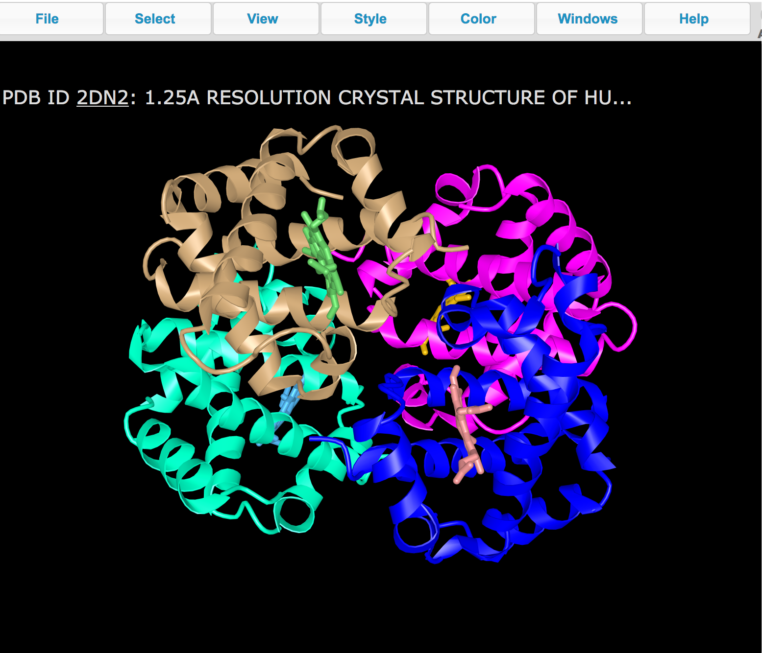
Spend a few minutes playing around with the different pull-down menus to see some of the different ways this protein view can be adjusted.
- Display one copy of the enzyme and molecules (cofactors/substrates) bound to it
  - Since more than one chain is present, visualize the chain of interest (e.g. chain A)
    - Click on Select >> Defined Sets.
    - In the new window that opens on the right select chains keep the chain A untouched by click to select chains B, C, D simultaneously. In the graphics window all these chains should be highlighted with a yellow halo.
    - Click on Style >> Proteins >> Hide
    - Click on any atom in the heme groups bound to the chains B, C, and D, with the option button pressed. Now click on Style >> Chemicals >> Hide to hide these chains.
  - Color the visible chain (chain A) by the rainbow color scheme.
    - Select chain A
    - Click on the menu Color >> Spectrum
- Orient molecule so that you can clearly see the hemoglobin protein chain and the heme group.
- Save an image by clicking on File >> Save files >> iCn3D PNG image.
- Import the image saved above to power point or any other graphics software and label in the image appropriately.

Q3. Which of the helices (N-terminal or C-terminal) is positioned closer to the heme group bound to this protein chain? Support your answer with a suitably labeled figure.

d. To carefully explore the neighborhood of the heme bound to this protein chain.
- Display the amino acid side chains in the neighborhood of the heme:
  - Select the Heme - Click on Windows >> View Sequence and Annotations >> scroll down to select the first HEM listed (e.g. bound to chain A)
  - Select the neighborhood - Click on Select >> by Distance >> use the default options and click on Display
  - Display amino acids in the neighborhood - In the graphics window click on Style >> Side chains >> Sticks. This shows the amino acid side chains selected near the substrate molecule.
  - Focus on selected residues - Click on View >> Zoom in selection to see a closeup of these residues and visualize the nature of interactions.

Q4. Identify the proximal His that holds the heme in place. What is the amino acid residue number for this His? Illustrate your answer with a suitably labeled figure. Hint: this His is located closest to the Heme iron and forms a coordinate link (see crosslink in iCn3D).

e. Let us now look at the structure of a human oxy-hemoglobin structure (PDB ID 2dn1) to see where the oxygen binds.
- In a fresh iCn3D session upload the PDB entry 2dn1 for visualization
- Select the residues neighboring the oxygen (OXY) bound to chain A (use the same steps as before). Display the side chains.
- Select the OXY bound to chain A and view its interactions (H-bonds, salt bridges, and crosslinks).

Q5. List two interaction that stabilize the OXY molecule in chain A. Support your answer with a suitably labeled illustration.

f. Examine the structure of a hemoglobin with the sickle cell mutation (Glutamate 6 to Valine mutation in the beta chains, PDB ID 2hbs).
- Open the structure summary page for this entry and examine the contents of the entry.

Q6. What is/are the chain ID(s) for the hemoglobin beta chain(s) in this structure?

g. In a fresh iCn3D session upload the PDB entry 2hbs for visualization. You should see something like the following:
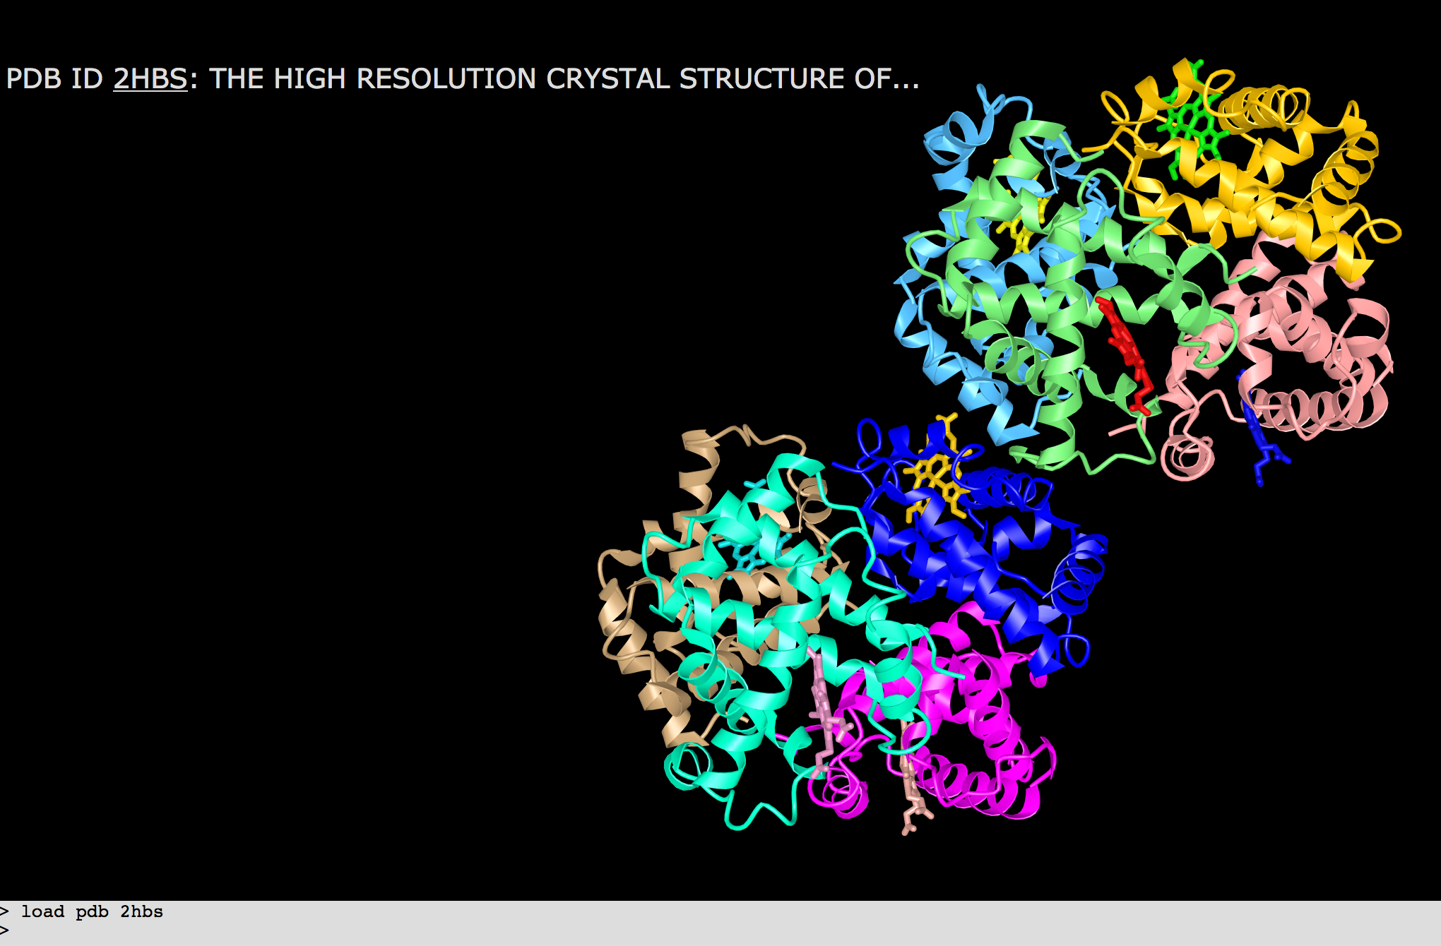

- From the top menus, click on Windows >> Sequences and Annotations > select the Details tab.
- Scroll through this window and identify the chains that represent the hemoglobin beta chains. These are the Glu6Val mutant proteins.

Q7. Label the above figure with the chain IDs of the beta chains.

h. Explore the interactions of the Val6 in chain H to understand how the hemoglobin molecules interact with each other sequentially to form a fiber.
- In the Sequences and Annotations window and scroll down to chain H
- Select the mutated residue Val 6 by
  - Click and drag on the V6 residue in chain H to highlight it in the sequence window and graphics window too.
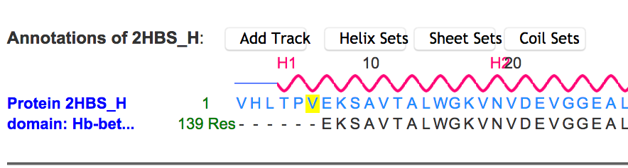
  - Display the side chain by clicking on menu bar, select styles >> sidechains >> stick.
  - Color this amino acid by clicking on menu Color >> Atom.
- Select the neighborhood of the residue by
  - Click on Select >> by Distance >> use the default options and click on Display
  - Display amino acids in the neighborhood - In the graphics window click on Style >> Side chains >> Sticks.
  - Focus on selected residues - Click on View >> Zoom in selection to see a closeup of these residues.
- Examine interactions stabilizing the mutated residue
  - Clear all selections - Click on Select >> Clear Selections
  - Now select the Val 6 in chain H (as before) and click on View >> H-bonds and interactions >> Display to see H-bonds and/or Salt bridge interactions.
  - Examine the structure to see if you can identify any other interactions stabilizing the substrate (e.g. hydrophobic interactions, pi stacking.)
  - Display the Val6 and any residues participating in hydrophobic interactions bby clicking on Style >> Side Chains >> Spheres.
  - Save an image and import to power point or any other graphics program to label the figure.

Read the box below to review some of the interactions in you may see in the structure:
Box 6: Concept
Biomolecular structural stability, interactions and functions are dependent on various non-covalent interactions. Some key interactions in molecular structures are
Hydrogen bonds - formed between two partially negatively charged atoms with a hydrogen atom between and covalently linked to one of them. e.g. in structures look for examples of O/N … H__O/N, where … denotes hydrogen bond and __ denotes a covalent bond
Salt bridges or ionic interactions - formed between oppositely charged amino acid side chains and/or charged ligands/ions. e.g. in structures look for interactions between Lys/Arg/His and Glu/Asp. These interactions may also involve phosphate groups and ions such as K+, Na+, Cl- etc.
Hydrophobic interactions - formed between hydrophobic amino acid side chains positioned away from the aqueous environment. e.g. look for regions with large numbers of carbon and hydrogen atoms in close proximity. Aliphatic amino acids such as Ala, Leu, Val, Ile participate in hydrophobic interactions.
Pi stacking - seen between amino acids with aromatic side chains. Pi clouds of aromatic rings interact with each other in staggered stacks, face to edge interactions. Alternatively, they may also interact with positively charged amino acid side chains (pi-cation interaction).
Learn more at https://earth.callutheran.edu/Academic_Programs/Departments/BioDev/omm/jsmolnew/bonding/chymo.html#Topic2

Q8. Which intermolecular forces (noncovalent interaction) leads to sickle cell hemoglobin (HbS) aggregation? Illustrate your answer with a suitably labeled figure.

Part 2: Nicholas’ Pain Crises
Box 7: Storyline
The structural explorations reveal how hemoglobin with the sickle cell mutation can aggregate.
A review article (Hematology Am Soc Hematol Educ Program. 2017 Dec 8; 2017(1): 546–555.), explains “A unique feature of SCD is vaso-occlusive crises (VOCs) characterized by episodic, recurrent, and unpredictable episodes of acute pain. Microvascular obstruction during a VOC leads to impaired oxygen supply to the periphery and ischemia reperfusion injury, inflammation, oxidative stress, and endothelial dysfunction, all of which may perpetuate a noxious microenvironment leading to pain.”
Here we will explore the relationship between aggregation of mutant hemoglobin to pain.

A glossary for some of the key words/phrases used in the explanation above is included below:
- Microvascular obstruction – small blood vessels are obstructed
- ischemia reperfusion injury - tissue damage caused when blood supply returns to tissue after a period of lack of oxygen
- inflammation - a localized physical condition in which part of the body becomes reddened, swollen, hot, and often painful, especially as a reaction to injury or infection.
- oxidative stress - a state where oxidative forces exceed the antioxidant systems due to loss of the balance between them
- endothelial dysfunction – condition when the inner lining of blood vessels fail to perform their normal functions.
- noxious microenvironment – poisonous local environment

Q1. Explain in a few sentences and with a suitable drawing how the HbS aggregation is connected to pain.

Q2. Based on your understanding of the structural basis of pain, can you suggest two approaches that can avoid the pain crises?

Q5. If you had to develop a new treatment for sickle cell disease how would you approach the problem. (Hint: use the deoxy HbS structure for inspiration).

