A Case of Severe Insulin Resistance
By Melanie Lenahan¹, Shuchismita Dutta²*

¹Science and Engineering, Raritan Valley Community College, Branchburg, NJ
²Institute for Quantitative Biomedicine, Rutgers University, Piscataway NJ
*contact author: sdutta@rcsb.rutgers.edu

Part 1: Understanding Insulin Resistance

The supplementary sections of the paper provide details on how members of the proband’s family with the AKT2 mutation had hyperinsulinemia – i.e., even when no or very little glucose was consumed these individuals produced higher amounts of insulin compared to control subjects from the population. Yet, many of these individuals developed diabetes.
Box 1: Concept
Insulin binding to Insulin receptors on the cell surface of a muscle cell initiates a series of signaling steps involving various players that eventually signal vesicles containing the Glucose transporter (GLUT4) to move to the cell membrane where they open to let in glucose from the blood into the cells.
If any of the signaling steps are missing or not functioning properly the signal to move GLUT4 transporters to the cell membrane can be disrupted as seen in insulin resistance.

To better understand Insulin resistance let us learn a little more about insulin signaling and the role of AKT2 using a resource called KEGG.

Box 2: Resource
Kyoto Encyclopedia of Genes and Genomes (KEGG, https://www.genome.jp/kegg/) has aggregated information about various types of biological interactions at the molecular, cellular, organismal, and ecosystem levels.
KEGG Pathway (https://www.genome.jp/kegg/pathway.html) is a collection of metabolic and signaling pathways in health and disease. This can be consulted to explore the names and interactions of key players in these pathways.

Go to the KEGG Pathway website and search for insulin resistance (either by typing it in the top search box or by looking through the Human Disease pathways). Save an image below.

Follow the pathway(s) from Insulin (INS) binding to Insulin Receptor (INSR) on the left of the page to GLUT4 vesicles being moved to the membrane for glucose uptake.

Q1. Identify all the key players in the shortest path that connects Insulin to GLUT4 and list them in sequential order. Does this involve Akt2?

The George et al., 2004 paper that Megan was reading showed that the mutant AKT2 enzyme’s activity is altered. The AKT2 gene with and without the mutation was introduced into a mammalian cell line and the protein was expressed. Results of a kinase assay (Figure 2B) shows enzyme activity for both the wild type and mutant proteins, with (Ins) and without adding Insulin (Bas). Examine the figure (also shown below for your convenience) and answer the following questions.
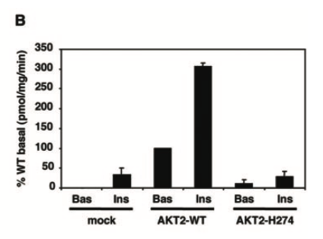
Figure 2B from George et al., 2004.

Q2. In the kinase assay results, the activity of the wild type protein changes significantly in the presence of insulin. Describe the change and explain why this change is observed in the presence of insulin? (Hint: examine the KEGG pathway and consider the insulin signaling steps in writing this answer).

Q3. What does the kinase assay results tell you about the activity of the H274 mutant in comparison with the wild type AKT2 enzyme?

Q4. Examine the KEGG pathway and explain the impact of inactivating the AKT2 enzyme. Why and how does this lead to insulin resistance?

