A Case of Severe Insulin Resistance
By Melanie Lenahan¹, Shuchismita Dutta²*

¹Science and Engineering, Raritan Valley Community College, Branchburg, NJ
²Institute for Quantitative Biomedicine, Rutgers University, Piscataway NJ
*contact author: sdutta@rcsb.rutgers.edu

Part 3: Bypassing the Roadblock

Two weeks ago, when Megan was walking by the departmental notice board, she stopped as she read the title – “Insulin Resistance and Improvements in Signal Transduction”. Wow! She thought this is exactly what she had been wondering about since she had read the George et al., 2004 paper. She decided to attend that seminar. The speaker, Dr. Laurie Goodyear, was a researcher at Joslin Diabetes Center, Boston, and spoke about the role of physical exercise in reducing blood glucose levels in type 2 diabetes. In this lecture Megan learned about insulin-independent glucose uptake!
------------------------------------------------------------------------
Examine the following simple figure from Dr. Goodyear’s seminar and notice the crosstalk between insulin dependent and insulin independent glucose uptake in skeletal muscle cells.

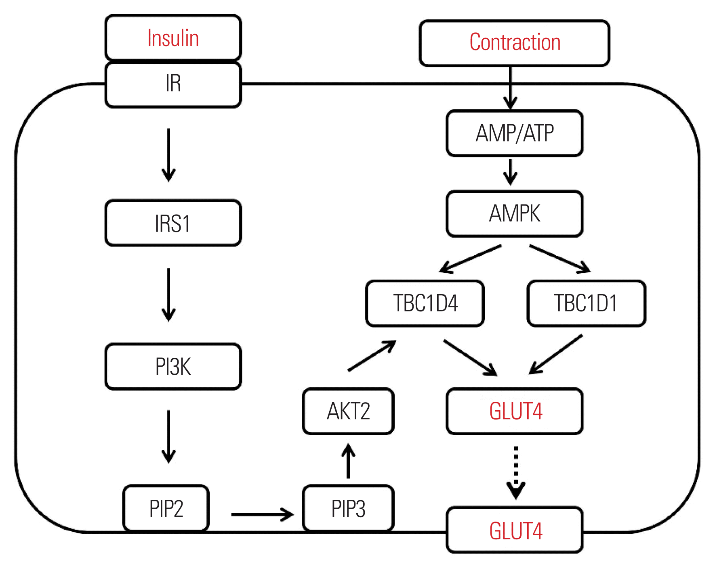
Figure 1. Journal of Obesity & Metabolic Syndrome 2018; 27(3): 150-157. doi: 10.7570/jomes.2018.27.3.150.

In the above figure do you notice that exercise uses up cellular ATP, activates AMP kinase, which in turn acts on TBC1D1 and TBC1D4 to facilitate the transport of GLUT4 receptors to the cell membrane for glucose uptake? So now even when the insulin signaling fails this pathway can be activated!

Megan was really excited and wants to write an email to Jade to explain all the things that she has found out about insulin resistance, its cause, and treatment approaches.

Q1. Help Megan write 1-2 paragraphs (5-10 sentences) to explain insulin resistance and possible ways to manage it. Feel free to add an image to help explain your point(s).

