A Case of Severe Insulin Resistance
By Melanie Lenahan¹, Shuchismita Dutta²*

¹Science and Engineering, Raritan Valley Community College, Branchburg, NJ
²Institute for Quantitative Biomedicine, Rutgers University, Piscataway NJ
*contact author: sdutta@rcsb.rutgers.edu

Preparation: “Megan, Jade, and Joanna”
As homework and prior to the case discussion in class, get acquainted with the case.
- Read the following story as an introduction to the context and to get started on this case.
------------------------------------
Jade and Megan have been best friends since second grade. While in school they spent a lot of time in each other’s homes. Jade’s older sister, Joanna or Jo, was their favorite go-to person – for help with school projects, personal advice, teenage troubles, and so much more. A few years ago, Jo got married and now lives with her husband and little baby girl in Texas. Currently the three of them live in different cities – Megan is in Massachusetts, studying in Boston College, majoring in Biochemistry; Jade is in California studying in Los Angeles College of Music to become a pianist; and Jo is a nurse practitioner in Austin. Even though they live over 2600 miles away from each other Megan and Jade still keep in touch.
Last month, Jade called Megan on a Sunday afternoon and anxiously said – “Do you know Jo told me that she was recently diagnosed with Diabetes, something about insulin resistance or something?” “She is just 32, not obese, you know, and is very particular about what she eats and stuff”. Megan sensed that Jade was worried. She knew Jade’s mom and maternal grandma had been diagnosed with diabetes in their thirties too, so she wondered if Jade was worrying about developing diabetes herself. A little later Jade mentioned ““Jo even said that she got tested and confirmed that it is not a MODY, do you know what that is?” Megan didn’t know but said she would find out. That afternoon they talked on the phone for an hour about family history, food, obesity, and diabetes. By the time Jade hung up, Megan was seriously thinking about Jade’s chances of getting diabetes, and for that matter, Joanna’s baby girl too.
The next morning Megan decided she wanted to learn more about diabetes and MODY. During her “Intro to Research” course Megan had learned about PubMed, a free online search engine for scientific literature on biological and biomedical topics with links to access their abstracts and full articles. She started searching online to see if I could find anything that could help her understand if and how diabetes could indeed be inherited. Megan found out that Maturity Onset Diabetes of the Young (MODY) was caused by mutations in specific genes that can lead to diabetes. Then she remembered that Jo’s test results for MODYs was negative. Megan wanted to learn more about insulin resistance. One particular paper that really caught her attention was titled “A Family with Severe Insulin Resistance and Diabetes Due to a Mutation in AKT2”. The family tree shown in the paper seemed very much like Jade’s family, so she became curious and opened the paper to read it in detail.
------------------------------------

The Familial Connection

Q1. Draw a pedigree tree for Jade and Joanna’s family with currently known information about diabetes in the family.

- Read the abstract of the paper (https://doi.org/10.1126/science.1096706) that Megan found and let us join her in understanding what the paper described.

The paper describes the case of a nonobese 34-year-old female who developed diabetes at 30 years of age. The proband, her nonobese mother, her maternal grandmother, and a maternal uncle were all affected. The pedigree tree included in the paper shows the inheritance patterns of hyperinsulinemia and diabetes in the proband’s family. Here Proband is the individual/subject who brings a case to attention – e.g., the patient, or person who is being studied. Examine the figure 1D in the George et al., 2004 paper (also shown below for your convenience) and answer the following questions.

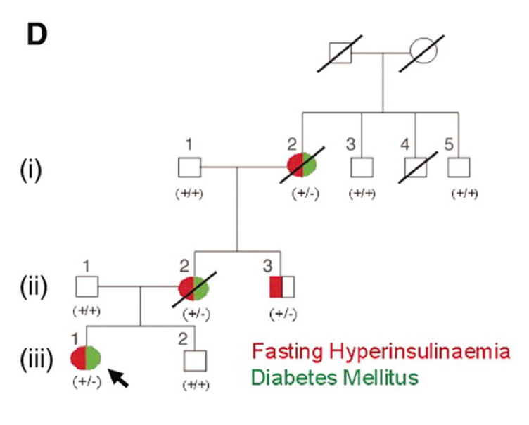
Figure 1D from George et al., 2004.

Q2. What is the relationship between hyperinsulinemia and diabetes mellitus in the three numbered generations [(i), (ii), (iii)] in the family tree shown above?

Q3. DNA sequencing of the proband’s genome and selected family members revealed a G-to-A mutation in the AKT2 gene, changing the codon for amino acid 274 from CGC to CAC. Consult the genetic code (https://www.genome.gov/genetics-glossary/Genetic-Code) and list what mutation was seen in the proband.

Q4. Is the mutated residue side chain similar to or different from that found in the native protein? Draw the chemical structure of the side chains of these amino acids and explain in terms of the size and physicochemical properties.

