Here are some resources to learn about the structure of proteins in general:
Learning about chemical interactions in biological macromolecules
# | Resource Name | Authors (where available) | Link/Detail | Comment
1 | Online Macromolecular Museum  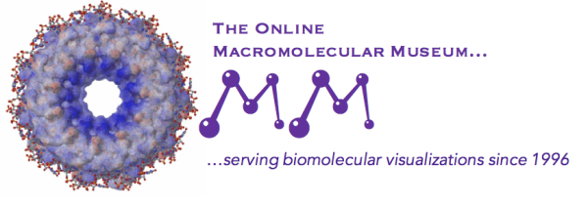 | Yasi Mojab and David Marcey | http://earth.callutheran.edu/Academic_Programs/Departments/BioDev/omm/jsmolnew/bonding/chymo.html | An Introduction to Chemical Bonds and Protein Structure
2 | PDB-101  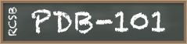 | David Goodsell and Maria Voigt | http://pdb101.rcsb.org/learn/videos/what-is-a-protein-video | What is a Protein?
3 | Internet Course on The Principles of Protein Structure | Organized by Birkbeck College | http://www.cryst.bbk.ac.uk/PPS95/course/3_geometry/index.html | Protein Geometry
4 | PDB-101 | Shuchismita Dutta, Rachel Kramer Green, and Catherine L. Lawson | http://pdb101.rcsb.org/learn/guide-to-understanding-pdb-data/biological-assemblies | asymmetric units and biological assemblies
5 | PDB-101 | David Goodsell | http://pdb101.rcsb.org/learn/guide-to-understanding-pdb-data/introduction | Introduction to PDB Data

To learn more about:
1. The SARS-CoV-2 life cycle - https://viralzone.expasy.org/9096
2. Coronavirus infection: https://www.nature.com/articles/nrmicro775.pdf
3. SARS-CoV-2 vaccine design see
https://media.nature.com/original/magazine-assets/d41586-020-01221-y/d41586-020-01221-y.pdf

