COVID-19: Molecular Basis of Infection

Didem Vardar-Ulu¹ and Shuchismita Dutta^{2*}
¹Biological Chemistry, Boston University, Boston MA
²Institute of Quantitative Biomedicine, Rutgers University, Piscataway NJ 08854
*contact: sdutta@rcsb.rutgers.edu)

Part 1: Life Cycle of SARS-CoV-2

Like any other virus the SARS-CoV-2 virus does not have its own machinery to produce biological macromolecules (e.g., nucleic acids and proteins). It must infect a host cell and hijack its cellular machinery for replication. Examine Figure 2 illustrating key steps in the coronavirus life cycle.
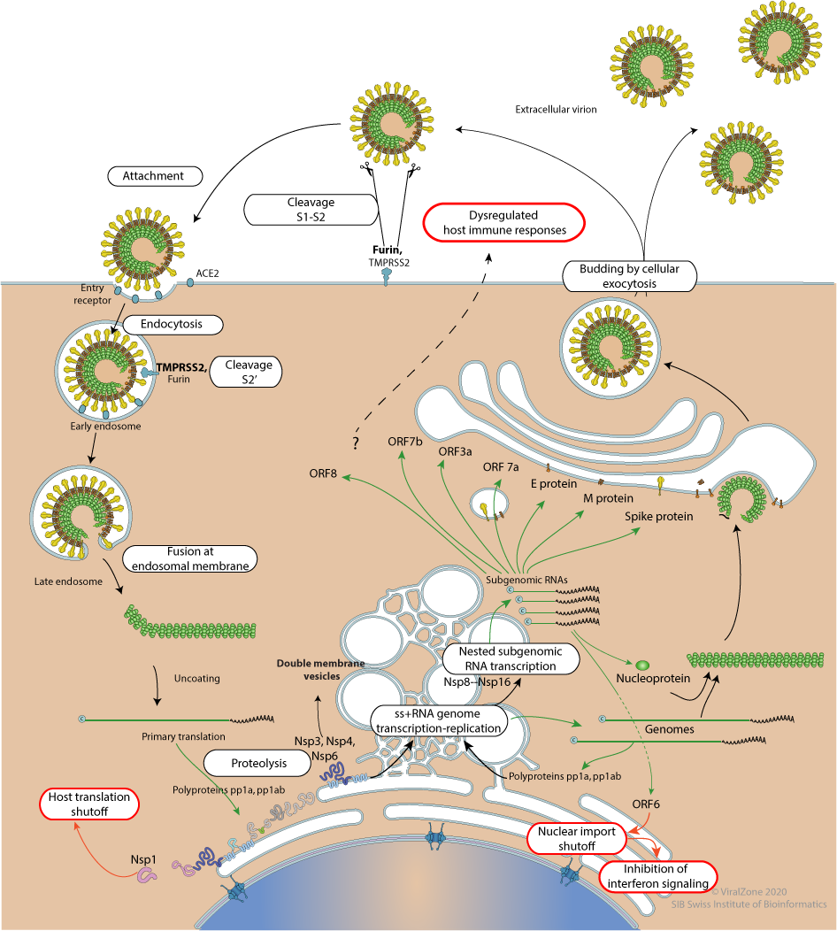
Figure 2. Life cycle of a virus from infection (entry into host cells) to release of new viral particles. (See https://viralzone.expasy.org/resources/Coronavirus_cycle.png).

Q1. Based on what you learned from studying the figure above, complete the following table about key steps in the SARS-CoV-2 life cycle and identify the key players at each step.

Life Cycle Step | Viral protein/ process | Host protein/ processes | Comment/ Description
Viral attachment and infection
Replication of viral genome
Viral assembly and release

The Central Dogma in biology describes the flow of genetic information from DNA to RNA (via transcription) to protein (via translation), while the DNA itself is maintained through generation via replication. The genetic material of Coronavirus is a +ive single stranded RNA.

Q2. Since there is no DNA stage in the life cycle of this virus, what special abilities does this virus have to replicate its genetic material?

