COVID-19: Molecular Basis of Infection

Didem Vardar-Ulu¹ and Shuchismita Dutta^{2*}
¹Biological Chemistry, Boston University, Boston MA
²Institute of Quantitative Biomedicine, Rutgers University, Piscataway NJ 08854
*contact: sdutta@rcsb.rutgers.edu)

Preparation:
As homework and prior to the case discussion in class, get acquainted with the case
- Read the following sections A-D and explore the articles/ links included
- Answer the questions 1-3 in preparation for the case discussion.

Quarantine, Social Distancing, and Stay Home Orders …

A. The COVID-19 Pandemic
On December 31, 2019, China reported a cluster of pneumonia cases in Wuhan, Hubei Province, caused by a novel coronavirus, later named SARS-CoV-2, (World Health Organization, WHO). Within two weeks, reports of infection and resulting mortalities began coming in from Thailand, US, Japan, South Korea, Iran, and Italy. Concerned by the alarming levels of spread and severity of this infection, WHO declared this outbreak as the COVID-19 pandemic on March 11, 2020. In the first three months after COVID-19 emerged, nearly 1 million people were infected and 50,000 died.
Data from China, where the epidemic began, showed that quarantine, social distancing, and isolation of infected individuals can help contain the spread. So, governments of various countries around the globe started promoting social distancing, issuing stay home orders, and ordering lockdowns. By the end of March, most countries in the world had implemented travel bans and its citizens were in some form of lockdown. The goal of these community based measures was to mitigate the epidemic by “flattening the curve”, i.e., delay the epidemic peak, reduce the number of infected individuals, and allow time for treatments and prevention strategies to be developed.
Optional: For a more detailed introduction read “Features, Evaluation and Treatment Coronavirus (COVID-19)” (https://www.ncbi.nlm.nih.gov/books/NBK554776/#article-52171.s15)

B. Anatomy of SARS-CoV-2
Examine David Goodsell’s painting of the anatomy of the Coronavirus below and read a description of the virus.
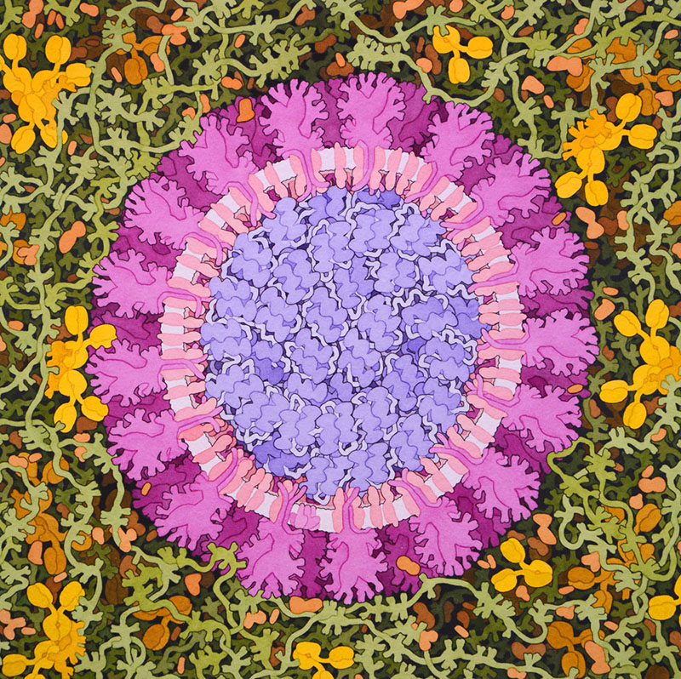
Figure 1: Painting of SARS-CoV-2 by David Goodsell, 2020 (https://pdb101.rcsb.org/sci-art/goodsell-gallery/coronavirus)

Coronavirus is so named because it has an outer corona or crown formed by the Spike protein. The SARS-CoV-2, was named after a similar virus that caused the Severe Acute Respiratory Syndrome (SARS) in 2002. The SARS-CoV-2 is an enveloped virus, and its genetic material is a single positive-stranded RNA (Figure 1). The viral genome codes for (a) structural proteins such as the spike, matrix, envelope, and nucleocapsid proteins; (b) enzymes such as proteases, and RNA-dependent-RNA polymerase; and (c) 16 non-structural proteins that play different roles in infection, and evasion of host immune surveillance.

Q1. In the Figure 1 (above) label the following:
- Spike protein (S) proteins,
- Viral envelope (E), and
- any two other viral proteins
Describe the main functions of the proteins that you labeled within the virus.

C. Washing Hands with Soap
Watch the video https://pdb101.rcsb.org/learn/videos/fighting-coronavirus-with-soap.

Q2. How does soap impact virus structure to provide an effective prevention against coronavirus infection? Highlight the structure function relationship and chemical properties of the key molecules involved.
Ans. Hydrophobic interactions of the soap molecule’s lipid tails with the membrane phospholipids and viral spike protein disrupt the viral envelope and destroy the virus.

D. Viral Replication
Learn about the viral life cycle by watching the video “How does a virus replicate in a cell”

Q3. What is the role of infection in the viral life cycle? Why do you think viruses infect only specific cells in specific organisms?

