**Biosynthesis of A Medicinal Alkaloid**

Here are some suggestions for assessing student knowledge and skills in biology class.

Through the answer of this question you may be able to assess your students’:

1. knowledge about amino acid side chain properties and IMF
2. understanding that different ligands (chemical compounds) can bind to proteins in different locations to change its shape/properties and function(s)
3. skill in generating an image that clearly illustrates the point(s) being made
4. ability to explain in words the key ideas about molecular interactions to answer the question

After completing the “Evolution of Caffeine Biosynthesis Enzymes” section of the case, read the following abstract and answer the questions.

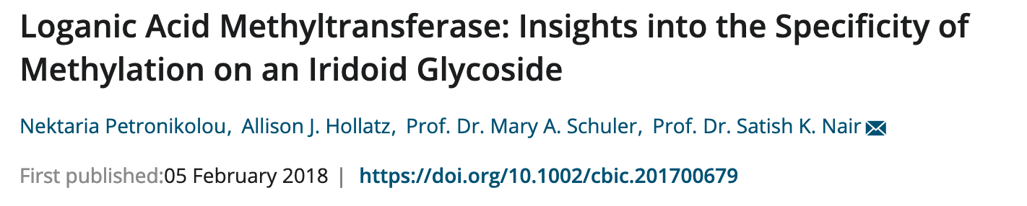

Monoterpenoid indole alkaloids (MIAs) are a group of plant natural products with a number of medicinal uses including chemotherapeutics (vinca alkaloids), antihypertensives (ajmalicine and serpentine), and antidiabetics (vindolicine). The enzyme loganic acid methyltransferase (LAMT), in the Madagascar periwinkle plant, uses S-Adenosyl methionine as a cofactor. Here we explore the structure of the enzyme (PDB ID 6c8r).

The following figure shows the main steps in the biosynthesis of caffeine and strictosidine.



Q1. Based on the information provided above list one feature that is common and one that is different between the XMT and LAMT enzymes.

Q2. Explore the structure of the LAMT enzyme (PDB ID 6c8r) and explain where in the structure does the S-Adenosyl methionine (seen in the structure as the reaction product SAH) bind? Where is the substrate Loganic acid bound in relation to SAH? Include an image to illustrate your answer.

Q3. Explore the neighborhood of SAH in the LAMT (PDB ID 6c8r) and XMT (PDB ID 2eg5) structures. Identify any two residues surrounding the SAH in these structures that non-covalently interact with it. Support your answer with a suitably labeled illustration.

Hint: Use chain ID B in PDB ID 6c8r (the chain that has both SAH and loganic acid bound) and chain C in PDB ID 2eg5.

Q4. Are there any common interactions in the SAH binding seen above?

Q5. Compare the sequences of the 2 enzyme LAMT and XMT (taken from the 2 PDB entries you were exploring above). Save the FASTA format sequences using the download button on the top right of the structure summary pages. Upload the sequences to BLAST (<https://blast.ncbi.nlm.nih.gov/Blast.cgi?PROGRAM=blastp&PAGE_TYPE=BlastSearch&BLAST_SPEC=blast2seq&LINK_LOC=blasttab>). Paste the sequences of 6c8r in the top box and that of 2eg5 in bottom box. Run the search.

What is the % sequence identity in these sequences? List any one region where 3 or more consecutive residues are identical in both proteins.

Q6. Compare the structures of the LAMT and XMT proteins. Are they related? Is any part of the structure conserved? Support your answer with a suitably labeled illustration.

Q7. Based on the explorations above what can you say about the evolutionary relationship between these enzymes (LAMT and XMT)?