Evolution of Caffeine Biosynthesis Enzymes
By Brian Sullivan¹, Shuchismita Dutta²*

¹Department of Plant and Microbial Biology, North Carolina State University, Raleigh NJ 27695
²Institute for Quantitative Biomedicine, Rutgers University, Piscataway NJ 08854
*contact author: sdutta@rcsb.rutgers.edu

Part 3: Evolution of Caffeine Biosynthesis

In this part we explore if the same enzymes that make caffeine in coffee plants are also involved in producing caffeine in tea and cocoa plants too.

Other plants that make caffeine (e.g., Tea and Cocoa) also use Xanthosine as a starting metabolite. Currently there are no structures of these enzymes in the PDB archive. To determine if the tea and cocoa enzymes are related to each other and/or to the coffee plants, we will do some sequence comparisons and draw phylogenetic trees using the interface and tools available from UniProt.
Box 7: Resource
UniProt (https://www.uniprot.org/) is a bioinformatics data resource that provides comprehensive, high-quality, freely accessible protein sequences, and their functional information. This information comes from research that has been published by others. For eukaryotic proteins it also lists information about specific domains, post-translational processing and modifications, and pathology resulting from mutations in the protein. UniProt provides links to other biological data resources to access other relevant information about the protein, such as gene sequence, protein structures, functional annotations etc.

- Find and download protein sequences
  - Go to UniProt (https://www.uniprot.org/), search for the following protein sequences and download the FASTA sequences.
    - In tea (organism: Camellia sinensis) UniProt ID TCS1_CAMSI
    - In cocoa (organism: Theobroma cacao) UniProt ID Q2HXL8_THECC
  - Go to the UniProt Align tool (https://www.uniprot.org/align/) to compare the sequences of the 2 Coffee N-methyltransferases and the 2 caffeine synthase enzymes from tea and cocoa.
(If your previous alignment result page is still open add the 2 FASTA sequences to the box called Add and align and rerun the alignment.
  - Save the sequence alignment (by clicking on Download alignment, then copying and pasting the alignment to this document using Courier font size 8)
  - Also take a screen shot of the phylogenetic tree.

Q1. Based on the sequence comparison results, are the tea, coffee, and cocoa enzymes related?

Q2. What does the phylogenetic tree tell you about the evolution of the caffeine biosynthetic enzymes?

An overview of the Caffeine Metabolism in the KEGG pathways shows how multiple enzymes and combinations of enzymes that can lead to caffeine synthesis (https://www.genome.jp/kegg-bin/show_pathway?map00232).

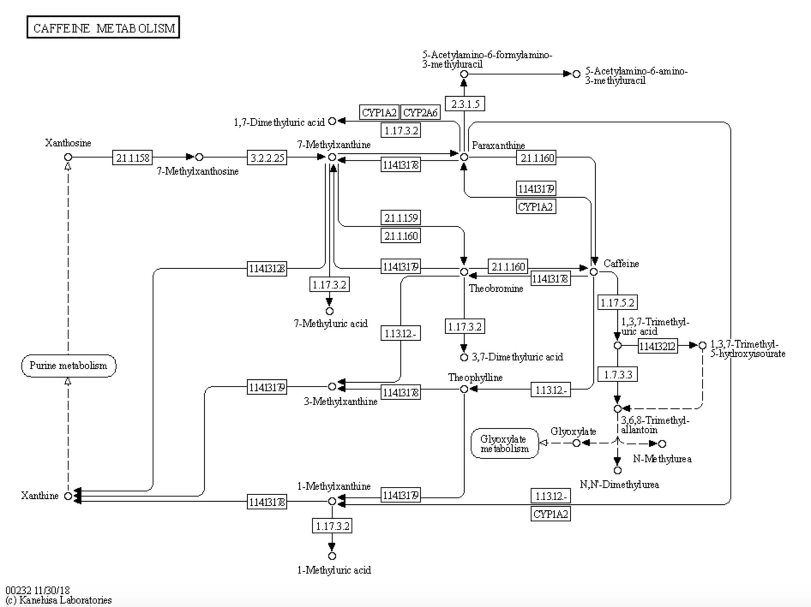

Based on all the things that you learned in your explorations answer the questions asked.

The Molecular Case Study Question:
How do plants make caffeine? Do they all make it the same way?

