Evolution of Caffeine Biosynthesis Enzymes
By Brian Sullivan¹, Shuchismita Dutta²*

¹Department of Plant and Microbial Biology, North Carolina State University, Raleigh NJ 27695
²Institute for Quantitative Biomedicine, Rutgers University, Piscataway NJ 08854
*contact author: sdutta@rcsb.rutgers.edu

Preparation: The Coffee Genome
As homework and prior to the case discussion in class, get acquainted with the case.
- Read the New York Times Science article from Sep 2014, authored by Carl Zimmer (https://www.nytimes.com/2014/09/04/science/how-caffeine-evolved-to-help-plants-survive-and-help-people-wake-up.html)
- Also read the abstract of the peer-reviewed scientific article mentioned in the newspaper article above (Science, 2014, 345, 1181-1184; doi:10.1126/science.1255274)

These articles set the stage for the case. The first part of this section focuses on understanding information sources, the second introduces you a biological data resource to learn about the chemical nature and use of caffeine (for humans), and finally the third section discusses why plants make caffeine.
- Review these sections and answer the questions in each of the sections.

A. Understanding sources

Both the NY Times and Science articles report sequencing of the coffee genome. Here is an opportunity to reflection on what can be learned from reading these articles. Answer the following questions.

Q1. What kinds of information did you learn from the NYT article vs the Science article abstract?

Q2. What is the main difference between the news report and peer-reviewed scientific article?

B. What is caffeine?

When you think about foods and drinks that contain caffeine perhaps you think about coffee, tea, and cocoa or chocolate. Here we will learn the chemical nature of Caffeine.

- The newspaper article describes caffeine as a drug that is “toxic at high doses but enhancing our brains at low doses.” To learn a little more about its chemical structure, search for Caffeine in DrugBank (a curated resource that provides a wide variety of information of drugs and drug-like molecules). Look for information about this molecule in DrugBank (https://www.drugbank.ca/drugs/DB00201), then refer to it to answer the following questions?

Q3. What is the chemical structure of caffeine? Draw or paste a picture of this molecule below.

Q4. Describe the function(s) of Caffeine (as listed in DrugBank).

C. Why do Plants make Caffeine?

Worldwide humans commonly use caffeine as a stimulant. In this case study we will think about the value of caffeine from the plants’ perspective. However, have you ever thought about why plants (e.g. the Coffee, tea, cocoa, mate plants) make caffeine?

Watch a short video (https://youtu.be/ohhMF1UlqR4) to learn about plant growth strategies and allelopathy; review the Box-1 contents and then answer the following questions.
Box 1: Vocabulary
Allelopathy is a biological phenomenon in which plants produces biochemicals to influence germination, growth, survival, and reproduction of another plant or organism.
Allelochemicals are often secondary metabolites and not required for its growth, development, and reproduction.

Caffeine has been described as a germination and growth inhibitor based on various experiments.

Q5. How would you design an experiment to test this function of caffeine? Describe the experiment and expected results in 2-4 sentences.

In the early 1900s Fred Ransom published the results of an experiment in Biochem J. 1912, 6: 156–161; doi: 10.1042/bj0060156, where he compared the germination of a large number of different seeds in tap water and when pre-treated with caffeine. A small portion of the results are included below.

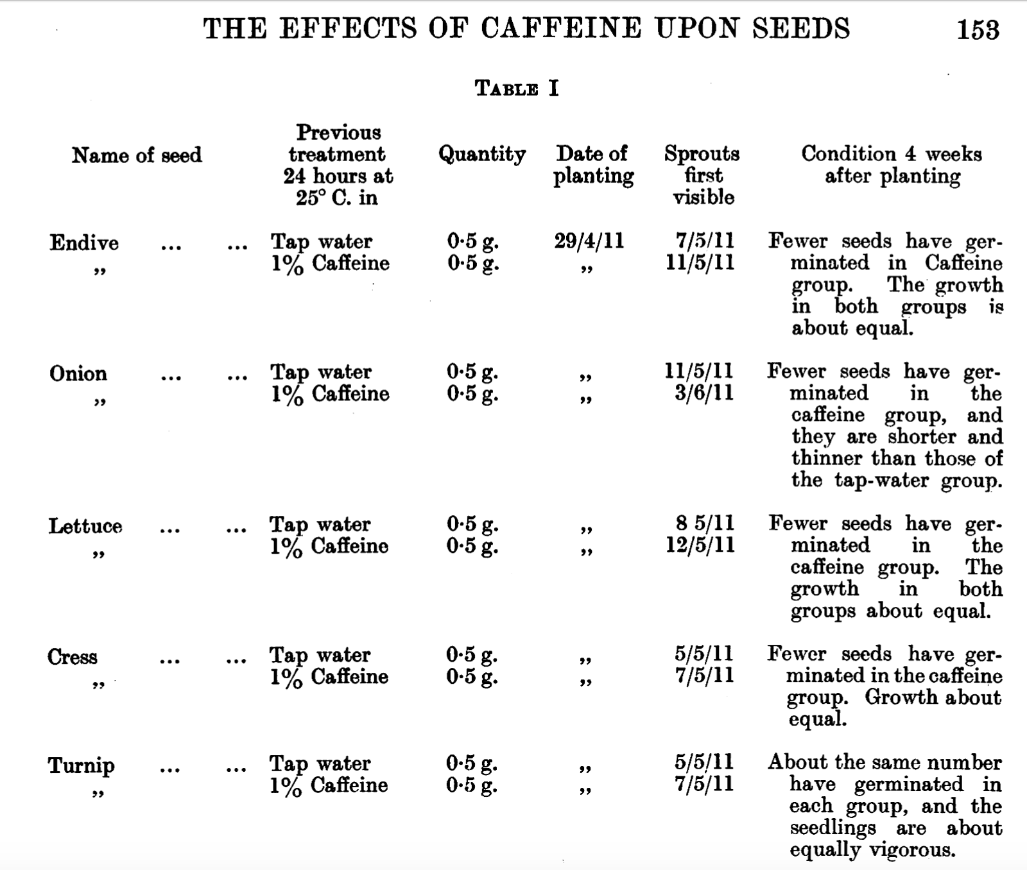

Note that in the above table the date is listed using the convention DDMMYY

Q6. Based on the data shown fill in the table below and describe the impact of caffeine treatment on the germination of the seeds. Does this confirm or disprove the claim that caffeine is an allelochemical?

Name of Seed | # days for germination
 | Tap water | pre-treated with Caffeine
Endive
Onion
Lettuce
Cress
Turnip

