Happy Blue Baby
Shuchismita Dutta (contact: sdutta@rcsb.rutgers.edu)
Institute for Quantitative Biomedicine, Rutgers University, Piscataway NJ 08854

Part 5: Binding and Release
The authors engineered the V67M mutation in the hemoglobin F gamma chain and used it for structural studies. In addition, they examined the biochemical consequences of the hemoglobin Toms River mutation. They expressed the recombinant hemoglobin F (α₂γ₂) protein in an Escherichia coli expression system. Here are some things they noted:
- The mutant hemoglobin F was produced at yields similar to those for wild-type hemoglobin F.
- Initial studies indicated that the oxygenated hemoglobin tetramer (α₂γV67M₂) was not excessively prone to oxidation, heme loss, or denaturation, as compared with wild-type hemoglobin F.

The authors used partial laser photolysis and rapid mixing methods to measure the association (k′o2) and dissociation (ko2) rate constants for the last step of oxygen binding to individual globin subunits in wild-type and V67M γ-hemoglobin F. Data from the experiments are included in the table below:
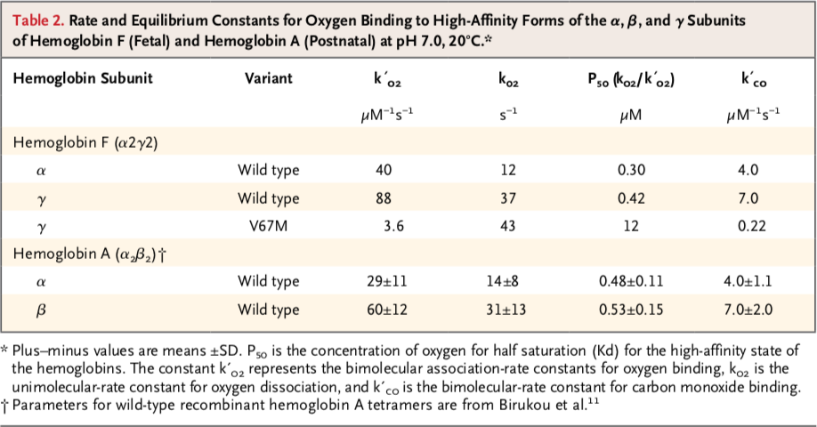

Q1. From the data provided above what can you say about the binding and dissociation of oxygen to the Hemoglobin γ chain in the native and mutation proteins?

Q2. What does the data in the table suggest about the protein folding of the mutant protein?

Q3. Relate the oxygen binding behavior reported in the table above to your structural explorations of the Toms River mutant. Explain in 2-3 sentences the structural bases of the binding properties.

