Piwi Matters
By Laurel Lorenz¹ and Shuchismita Dutta^{2*}

¹Department of Molecular Biology, Princeton University, Princeton NJ 08544
²Institute of Quantitative Biomedicine, Rutgers University, Piscataway NJ 08854
*contact author: sdutta@rcsb.rutgers.edu

Part 2: Exploring Piwi’s Structure and Function

Learning about Piwi’s structure can help in understanding how it mediates its various functions.

To find an experimentally determined structure of Piwi, we will explore the Protein Data Bank (PDB) at www.rcsb.org.
Box 4: Resource
RCSB Protein Data Bank (RCSB PDB, www.rcsb.org) provides access to 3D structural data of biological macromolecules (proteins, nucleic acids, carbohydrates and their various complexes). In addition, it provides information about the experiment used to derive the data, details about the molecules included in the experiment, and links to various bioinformatics resources that can provide additional information about the protein/molecule of interest. Each structure in the PDB is identified by a unique identifier (called PDB ID). Atomic coordinates form the PDB can be visualized and analyzed using various visualization software (some available from RCSB PDB).

Search for Drosophila Piwi structure(s) in the PDB (www.rcsb.org) to see what structure(s) is/are available.
- Type the protein name “Piwi” in the top search box and hit on the search button.
- Once the results are returned, click on Drosophila melanogaster in the left hand menu to view only the structures that contain the fruit fly Piwi protein

Q1. List the PDB identifiers and titles for 2-5 structures that contain Drosophila Piwi.

The PDB structures may represent a single protein or a complex structure – i.e., the file may contain multiple polymer chains (protein, DNA, and RNA) that form a complex structure and are co-crystalized. In the list of Piwi containing structures, you should find a structure of Piwi-piRNA complex.

Select the PDB structure of Piwi-piRNA complex from the above list and open the structure summary page for this entry to explore the Piwi protein residues, peptides, and chains that are present in these structures.

Box 5: Vocab
Residues: Building blocks of biological macromolecules are sometimes referred to as residues. Depending on the context, this may refer to amino acids (frequent use) or a nucleotide (less common use).
Protein vs Peptide: while both proteins and peptides are composed of covalently linked amino acids, peptides are short (composed of 2-25 amino acids)
Chains: A chain (such as protein/ peptide chain) refers to covalently linked amino acids. To help locate amino acids in a protein structure or complex a chain is given an identifier (called Chain ID) and each amino acid in the chain is assigned a number. Note that large proteins with multiple domains may be cut into smaller pieces – a short peptide or a single domain and included in the experiment. For this experiment the polymer chain formed by the peptide or domain is assigned a chain ID. Nucleic acids or polymers of nucleotide residues (DNA/RNA) may also be referred to as chains and assigned chains IDs.

Q2. Fill in the following table for the PDB structure.
Ans:
PDB ID
Author(s) of entry
Year when the structure was published/ released
Structure determination method
# of macromolecular chains
(# Protein + # nucleic acid)
Names of proteins in these chains (chain ID)
Name of any other macromolecular chain

Click on the 3D view tab on the top of the structure summary page on the RCSB PDB website to visualize the molecule. Take a screen-shot of the graphical window and insert the image here to show the overall shape of the protein complex.

Q3. What color is the RNA chain in this structure?

Box 6: Concept
Missing residues: Due to specific conditions in the structure determination methods, most PDB entries do not have the coordinates of all atoms present in the structure. For example, flexible regions of the structure cannot be “seen” in the experiment, so these coordinates are missing. Also, all H atoms in most structures determined by X-ray crystallography are not included in the coordinate files. To learn more read http://pdb101.rcsb.org/learn/guide-to-understanding-pdb-data/missing-coordinates-and-biological-assemblies.

In order to visualize and analyze the protein structure(s) in greater detail we will use an online molecular structure visualization tool, called iCn3D.

Box 7: Resource
iCn3D is a web-based visualization tool that allows users to directly open any structure from the Protein Data Bank (PDB) and visualize the structure. Users can interactively rotate the molecule/complex, select specific regions and represent them in different ways, compare structures, analyze interactions and make simple distance measurements.

- Go to iCn3D (https://www.ncbi.nlm.nih.gov/Structure/icn3d/full.html)
- Click on the button called File >> Retrieve by ID >> PDB ID so that a new window opens. Input the PDB ID of the structure you wish to visualize and click on Load.
- The structure opens in a new tab – rotate the molecule and examine the overall structure.
- Spend a few minutes playing around with the different pull-down menus to see some of the different ways this protein view can be adjusted.
- Save an image of the structure by clicking on Files >> Save Files >> iCn3D png image and upload it in the space provided below.
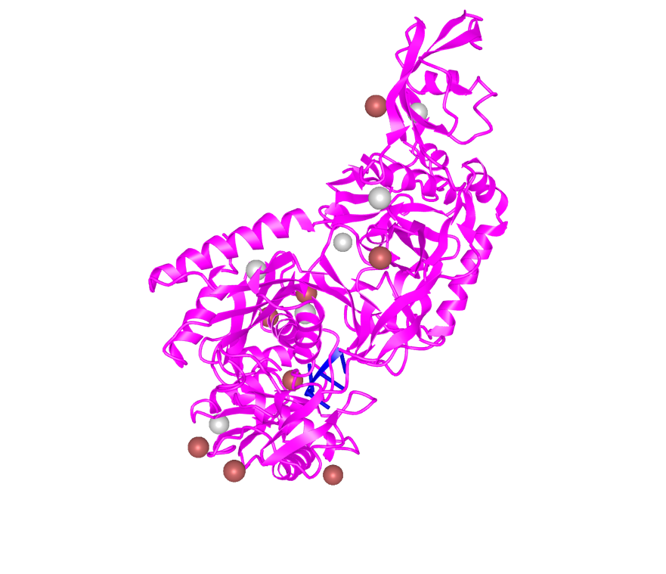
Figure out where the Piwi and PAZ domains are located in the 3D structure.
- Click on the button called Windows >> View Sequences & Annotations.
- Click on the Details button to see the one letter code sequence of all the protein chains in the structure.
- Use the residue number limits identified for the Piwi and Paz domains of Piwi (from your explorations in Part 1, Q3, above). Click and drag on these residues in the sequence and annotation window. The residues will be highlighted in yellow, both in the sequence and graphics windows.
- Click on Color >> Unicolor >> Green (for the PAZ domain). Now click on Select >> Clear Selection.
- Similarly color the Piwi domain Yellow.

Q4. Save a picture of the Piwi structure after the domain coloring and include it here.

Q5. In relation to the Piwi and PAZ domains, where is the piRNA located in the structure?

Examine the structure and explore the amino acids that interact with and stabilize the piRNA binding. In a fresh iCn3D session upload the PDB ID 6kr6.
- Select the RNA chain by clicking on Select >> Defined sets >> in the new window that opens >> click on 6KRK_B (the blue chain should now be highlighted in yellow)
- Show all atoms in the RNA in stick representation by clicking on Style >> Nucleotide >> Stick
- Now select residues within 4 angstroms of the RNA by clicking on View >> H-bonds & Interactions; Turn off the Contacts/Interactions selection and then click on 3D Display interactions.
- Show the side chains of all the residues selected by clicking on Style >> Side chains >> Stick
- Focus on selected residues by clicking on View >> Zoom in Selection
- Color the selected side chains by CPK color scheme by clicking on Color >> Atom
- Now select the RNA chain and re color it blue for contrast (Select >> Defined sets >> in the new window that opens >> click on 6KRK_B and Color >> Unicolor >> Blue

Examine the interactions through which pi-RNA is bound to the Piwi protein. Review the various types of non-covalent interactions in Box 8 and note the types of interactions between the piRNA fragment and Piwi.

Box 8: Concept
Biomolecular structural stability, interactions and functions are dependent on various non-covalent interactions. Some key interactions in molecular structures are
Hydrogen bonds - formed between two partially negatively charged atoms with a hydrogen atom between and covalently linked to one of them. e.g. in structures look for examples of O/N … H__O/N, where … denotes hydrogen bond and __ denotes a covalent bond
Salt bridges or ionic interactions - formed between oppositely charged amino acid side chains and/or charged ligands/ions. e.g. in structures look for interactions between Lys/Arg/His and Glu/Asp. These interactions may also involve phosphate groups and ions such as K+, Na+, Cl- etc.
Hydrophobic interactions - formed between hydrophobic amino acid side chains positioned away from the aqueous environment. e.g. look for regions with large numbers of carbon and hydrogen atoms in close proximity. Aliphatic amino acids such as Ala, Leu, Val, Ile participate in hydrophobic interactions.
Pi stacking - seen between amino acids with aromatic side chains. Pi clouds of aromatic rings interact with each other in staggered stacks, face to edge interactions. Alternatively, they may also interact with positively charged amino acid side chains (pi-cation interaction).
Learn more at https://earth.callutheran.edu/Academic_Programs/Departments/BioDev/omm/jsmolnew/bonding/chymo.html#Topic2

Q6. List any 3 amino acid residues with charged side chains that facilitate Piwi-piRNA binding. Support your answer with suitable images.
(Note: Mouse over any residue in the graphics window to see the residue number. Convert that NCBI reference number to the PDB/UniProt number by reading off the corresponding number from the Sequences and Annotations window).

