From Poison to Medicine

Introduction

Chemical weapons are arguably some of the cruelest forms of attack. Organophosphate nerve agents are a family of phosphoric acid ester compounds that are commonly used in this type of warfare. Read the New York Times article below and focus on the symptoms felt and observed by the survivor of the Syrian chemical attack.

<https://www.nytimes.com/2017/04/07/opinion/what-its-like-to-survive-a-sarin-gas-attack.html>

The story above mentions one landmark usage of sarin, a type of organophosphate nerve agent. Sarin is a clear, odorless, lethal liquid. Apart from the attack in Syria, a subway attack in Tokyo also utilized the nerve agent. These important cases have led to significant research into sarin, and especially into its interaction with its biological target, the enzyme acetylcholinesterase (AChE). Throughout this exercise, the interactions of sarin and AChE will be explored.

Sarin inhibits AChE, resulting in the host of symptoms described in the article. AChE is an enzyme that is present in synapses found in the central and peripheral nervous system (commonly at the neuromuscular junction) that hydrolyzes the neurotransmitter acetylcholine.

**Synaptic Neurotransmission and AchE Introduction**

Synaptic transmission is the process by which neurons communicate with other cells. After an electrical signal in the form of an **action potential** is passed, or **transduced***,* down the nerve fiber, or **axon**, of a neuron (Figure 1), it reaches the axon terminal and the signal must be transmitted, often to another neuron. Chemicals called **neurotransmitters** pass along this message via excitatory or inhibitory postsynaptic potentials, which are essentially electrical changes in the membrane potential of the postsynaptic membrane. Inhibitory signals work to hyperpolarize the membrane (make the voltage more negative), while excitatory signals work to depolarize the membrane (make the voltage more positive). A resting neuron is typically at around -70 mV. These inhibitory and excitatory signals will sum up together depending on how close together the signals are brought onto a neuron both in space and time, and if the signals add up to a sufficient excitatory stimulation, it can induce another action potential in the **axon hillock** that will then travel down the neuron’s axon and the process will repeat.

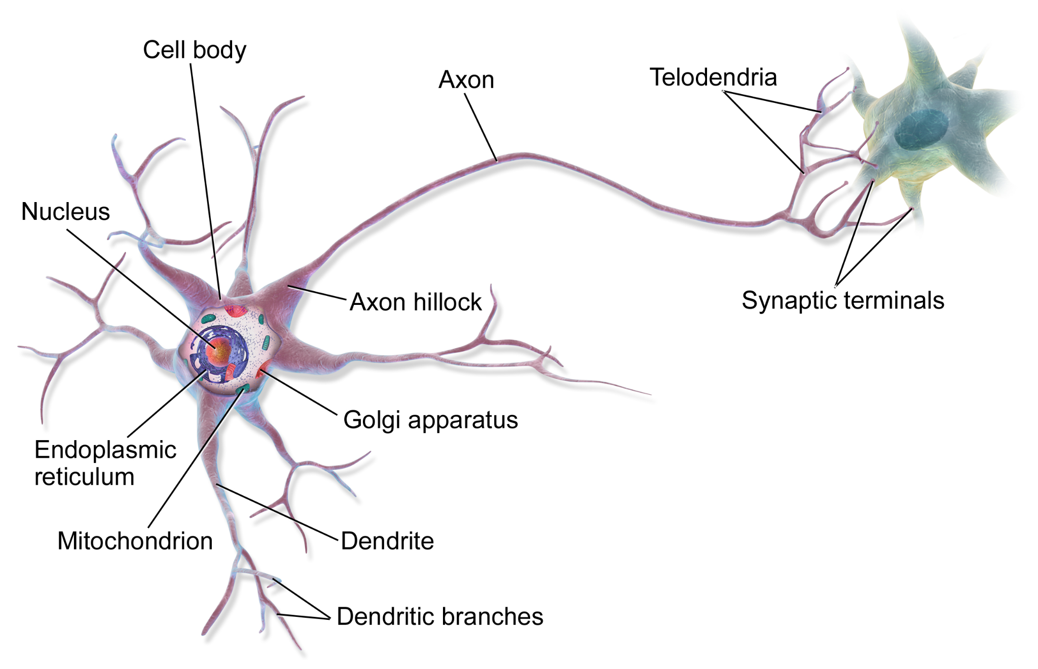

**Figure 1:** Diagram of a neuron (Wikimedia Commons)

In this lesson we will focus on the mechanisms of neurotransmitter release at the synapse during synaptic transmission of acetylcholine. The steps of synaptic transmission are:

1. Presynaptic terminal depolarizes as an action potential reaches an axon terminal.
2. Depolarization opens voltage gated calcium channels, causing an influx of Ca2+ ions at the axon terminal.
3. Calcium influx at the axon terminal triggers vesicles filled with neurotransmitters to fuse with the presynaptic membrane, leading to the release of neurotransmitters into the synapse via exocytosis.
4. Neurotransmitters diffuse across the synapse and bind to receptors present on the postsynaptic membrane (some also bind to autoreceptors on the presynaptic membrane to attenuate further neurotransmitter release).
5. Neurotransmitters eventually leave the synapse, either by diffusion away from the synapse, or enzyme degradation which is often followed by reuptake, depending on the type of neurotransmitter.

Step 5 in this process is crucial to stop the signal once it is no longer needed. As shown in Figure 2, enzymes are present in the synapse to break down the neurotransmitter and prevent overstimulation of the postsynaptic cell. One example of an enzyme present at synapses is acetylcholinesterase (AchE), which is often found at the neuromuscular junction in animals. AchE hydrolyzes the neurotransmitter acetylcholine into choline and acetic acid in the synapse. Once acetylcholine is hydrolyzed, the presynaptic membrane can reuptake the choline, which is used to re-synthesize acetylcholine for future release during transmission.



**Figure 2**: Diagram of a synapse. Acetyl coenzyme A and choline react to form acetylcholine (ACh). ACh is transported to a vesicle. The vesicle fuses with the membrane, releasing ACh into the synapse. ACh stimulates the receptor, until the action of acetylcholinesterase hydrolyzes ACh, forming acetate and choline. Choline undergoes reuptake and is reused in the formation of ACh.

**Introductory Questions**

Question 1: What symptoms were consistently observed in victims of the sarin chemical attacks?

Question 2: Where does the acetyl-CoA present in the axon terminal that is used in acetylcholine synthesis originate from? Which biochemical pathway gives rise to it, and in which cellular compartment(s) is it formed?

Question 3: Acetylcholine is important for nerve transmission, but it’s also critical that it gets broken down. What would be the result on nerve stimulation if AChE were to be inhibited?

Question 4: How might acetylcholinesterase inhibition lead to the symptom of difficulty breathing that was observed in the victims of the nerve agent attack?