From Poison to Medicine
Modeling the Active Site in PyMOL

The neurotransmitter acetylcholine is an ester of acetic acid and choline, which is rapidly hydrolyzed at cholinergic synapses by acetylcholinesterase (AChE), thereby playing a critical role in nerve signal transmission. The overall enzyme catalyzed hydrolysis of acetylcholine into acetic acid and choline is shown in Figure 1.

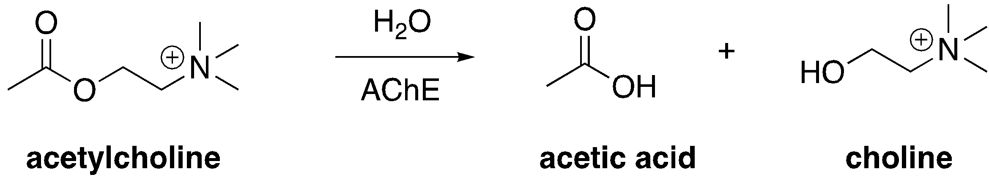

Figure 1: Overall enzyme-catalyzed reaction

The active site of AChE contains two subsites, the esteratic subsite and the anionic subsite. Catalysis occurs in the esteratic subsite, which contains a catalytic triad (Figure 2). This triad is similar in function to others found in serine proteases such as chymotrypsin. The anionic site is important for binding and specificity.

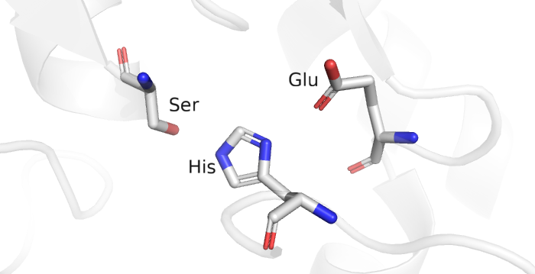

Figure 2: Catalytic triad in the active site of acetylcholinesterase

Exploring the RCSB PDB:

We’ll take a closer look at the enzyme by modeling it in the molecular visualization program PyMOL. The active site of AChE is highly conserved because of its critical role in neurological function across species. The electric eel Torpedo californica acetylcholinesterase is a model system for AChE. The electric organs contain an abundance of nervous system proteins, thus providing an early source of AChE for study in the 1970s. The high homology of the eel and human AChE allows for parallels to be drawn from the study of the eel enzyme.

Box 1: Resource
RCSB Protein Data Bank (RCSB PDB, www.rcsb.org) provides access to 3D structural data of biological macromolecules (proteins, nucleic acids, carbohydrates and their various complexes). In addition, it provides information about the experiment used to derive the data, details about the molecules included in the experiment, and links to various bioinformatics resources that can provide additional information about the protein/molecule of interest. Each structure in the PDB is identified by a unique identifier (called PDB ID). Atomic coordinates form the PDB can be visualized and analyzed using various visualization software (some available from RCSB PDB).

Search the Protein Data Bank (www.rcsb.org) for AChE by entering PDB ID 2ACE into the search bar in the top right. Open the structure summary page. Look over Box 2 and fill in the table below for 2ACE.

Box 2: Navigating the Structure Summary Page
1. Title - that tells you what the structure is about
2. Snapshot - of what the structure of the molecule/complex looks like.
3. Authors – who solved the structure
4. Literature –access the article that describes the structure. This section also includes links to the PubMed page and the abstract of the article describing this structure, when available.
5. Macromolecules – All proteins and nucleic acids present in the structure are listed here. Each unique type of macromolecule or molecular chain is listed as a separate entity. There may be multiple copies of each molecule in the structure.
6. Small molecules – All ligands, ions, cofactors, inhibitors that are present in the structure are listed here. You can find links here to explore the interaction of this ligand with the target protein.
7. Experimental details – describe details about how the structure was determined
8. Structure quality – shows a slider that provides insights about the quality of the structure and its agreement with the experimental data and geometric standards.
See http://pdb101.rcsb.org/learn/guide-to-understanding-pdb-data/introduction for details

Copy and paste this table into your working document, then fill in your responses in blue or green.

PDB ID
Author(s) of Entry
Date Structure was Published/released
Structure Determination Method
Organism
Resolution
Small Molecules/Ligands
How Many Protein Chains are Present?
Are There Any Mutations?

Now, let’s model the protein in PyMOL.

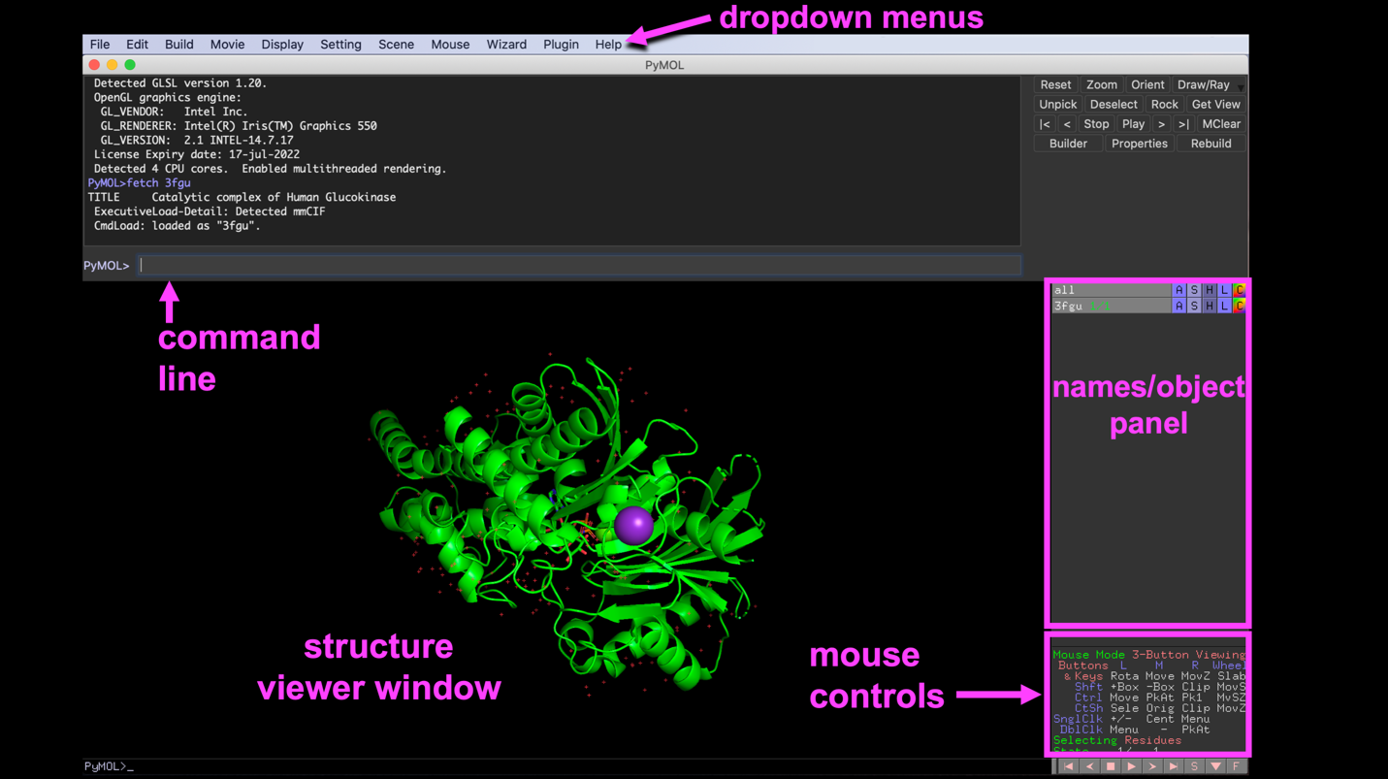
Figure 3: The PyMOL GUI with parts of the interface labeled
Modeling:

STEP 1: Load the structure in PyMOL and set up your workspace.

Open PyMOL and fetch 2ACE by entering the scripts in the box below into the command line. This will retrieve the structure from the Protein Data Bank. Then, hide the waters.

fetch 2ace
hide nonbonded

Now, display the sequence by using the dropdown menu:
Display → Sequence

STEP 2: Use the Graphical User Interface (GUI) and command line to select the ligand in the active site. Color the ligand in a way that contrasts the protein and apply CPK coloring.

Select the ligand using the command line, by typing:
select ACH, resn ACH

Box 3: PyMOL GUI Controls
There are four buttons in the names/object panel:

A - Actions: Rename, duplicate, remove, apply preset representations (e.g. "ball-and-stick" or "publication")
S - Show: Change the way objects appear: for example, stick or cartoon representation
H - Hide: Representations that are shown using S accumulate or layer. H is the opposite of S and hides representations.
L - Label: Label atoms, residues, etc.
C - Color: Recolor atoms and groups.

Color the ligand by element with the carbons a bright color (pink or orange) to contrast the rest of the protein. In the names/object panel next to the ACH object, click:
C → by element → choose one of the color schemes in sets 1–5

STEP 3: Duplicate the ligand object and modify it to select the active site.

In the names/object panel:
ACH → A → duplicate

A new object called sel01 will appear. Rename it and use it to select the residues 5Å from the ligand. In the names/object panel:
sel01 → A → rename

The rename menu will appear in the upper left-hand side of the structure viewer; the existing name needs to be deleted before you enter the new name. Underscores are automatically inserted when a space is entered. Delete sel01 and type: binding_site

Modify the new binding site selection using the actions button. In the names/object panel:
binding_site → A → modify → around → residues within 5A

STEP 4: Display the active site as sticks and label them.

In the names/object panel:
binding_site → S → sticks

Notice that the residues are the same color as the protein. You may wish to recolor them using the C button. Make sure the ACH ligand and the binding site residues are different colors so they are easy to distinguish.

In the names/object panel:
binding_site → L → residues

Question 1: Which residue is making the strongest bond to the acetylcholine? What type of bond is this?

Question 2: Earlier we mentioned the importance of the catalytic triad, aside from the residue found in question 1, which other two residues are part of the catalytic triad? Give the residue three letter codes and numbers.

Check your work! In the RCSB literature box for 2ACE, click on the DOI of the paper to access it. If you are unable to access the paper, ask your instructor for help.

Question 3: In the RCSB literature box for 2ACE, click on the DOI of the paper to access it. Do the amino acids you chose for the catalytic triad match up with the residues in the actual catalytic triad shown in Figure 5 of the journal article?

If any residues that are part of the catalytic triad were not selected, select them by clicking on the residue numbers in the sequence at the top of the structure viewer window. Rename the object “triad” and show the amino acids as sticks.

Question 4: Based on your observation of the structure, draw the arrow pushing for the first step of ACh hydrolysis in the esteratic site. Be sure to show the roles of each residue of the catalytic triad, and show how serine forms a bond with ACh.

Correct orientation of ACH in the active site is required for the catalytic reaction to occur. This is made possible by interactions with two other parts of the active site: 1. the oxyanion hole and 2. the anionic subsite.

STEP 5: Explore interactions of the oxyanion hole.

Hydrogen bonds measured in modeling programs are typically 2.6-3.2 Å (measured from the center of the two heteroatoms involved in the bond, since hydrogen atoms are not shown).

Focusing on acetylcholine, find hydrogen bond interactions from the oxygen that started off as a carbonyl. In the names/object panel:
ACH → A → find → polar contacts → to any excluding solvent

A new object will be created (ACH_polar_contacts), select S and show the labels. Save an image of three possible hydrogen bond sites.

STEP 6: Explore the the anionic site, another region that is important for acetylcholine binding. The anionic site is composed of electron rich residues like aromatic amino acids.

Box 4: Cation-π interactions
Aromatic compounds, for example, benzene and the side chains of aromatic amino acids, have alternating single and double bonds in their rings. The π electrons of these rings are delocalized above and below the ring, creating an area of electron density, and therefore negative charge. This partial negative charge can interact with cations, binding via a cation-π interaction.
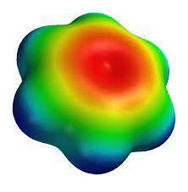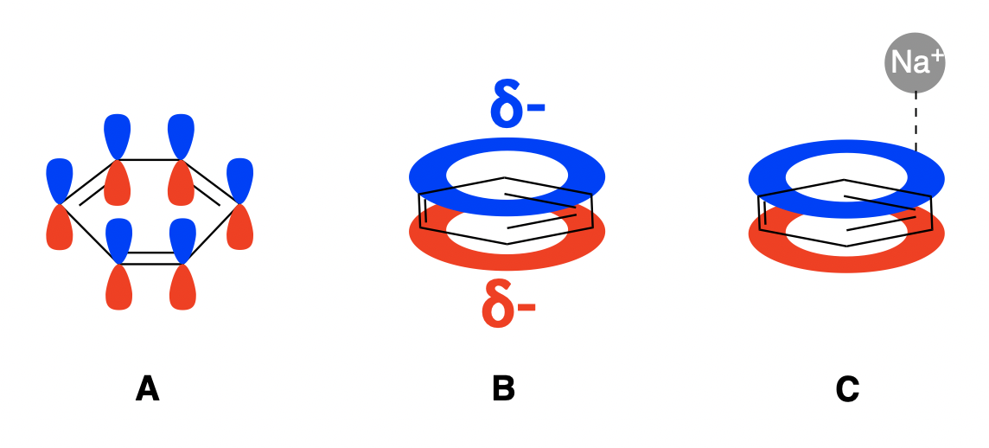

Images: (Left) Electron density map of benzene. Red indicates the area of highest electron density, blue the lowest. (Right, A) The π system of benzene (B) delocalization of the π electrons in benzene creates regions of negative charge above and below the ring (C) a cation-π interaction between a sodium ion and the π electron cloud of benzene.

Distances for electrostatic interactions from induced dipoles are a bit more challenging to describe than those of hydrogen bonds. These interactions take into account the van der Waals radii of the atoms, plus some additional distance before the atoms are too far apart to be electrostatically attracted. These interactions usually measure in the low 4Å range (~4–4.4Å).
STEP 7: Create manual measurements to find potential cation-π binding interactions.

To visualize the anionic site, use the wizard tool to find hydrophobic interactions in the anionic site. In the dropdown menu:
Wizard → Measurement

The bottom right of the screen should now show measurement controls. The structure viewer should also display green text, reading: “Please click on the first atom…”

The first atom you select will be one base for the measurement, while the second selected atom will represent the other end. After selecting two atoms, a dashed line will appear between the two atoms and the distance between them will be labeled. If the measured distance was too long to be a van der Waals interaction, select “delete the last object” and continue measuring for hydrophobic interactions in the anionic site. Measure from a carbon atom of the ammonium to the aromatic ring to see if you can find any van der Waals interactions.

When you are finished, click done in the measurement controls to exit the measurement wizard tool.

Question 5: Which aromatic residues have interactions with acetylcholine? Are these cation-π interactions? Explain your reasoning.
Question 6: Propose a function of the anionic site if it doesn’t directly engage in ACH hydrolysis.

Question 7: Why would the cation-π interaction be measured from a carbon attached to the acetylcholine ammonium ion, and not from the nitrogen atom?

Take a final image zoomed in on the binding site and save your session file.

Submit the answers to Questions 1–7, along with the 2 screenshots of the model, one clearly showing the esteratic site interactions and one showing the anionic site interactions.

You have finished analyzing and modeling multiple parts of the acetylcholinesterase active site using PyMOL. At this point, you should be familiar with the functional parts of the enzyme and have a better understanding of the various interactions that occur within them.

