From Poison to Medicine
Mechanisms and an Antidote

The overall reaction catalyzed by acetylcholinesterase is the hydrolysis of acetylcholine to acetic acid and choline. This is a two-stage process involving hydrolysis (Figure 1).

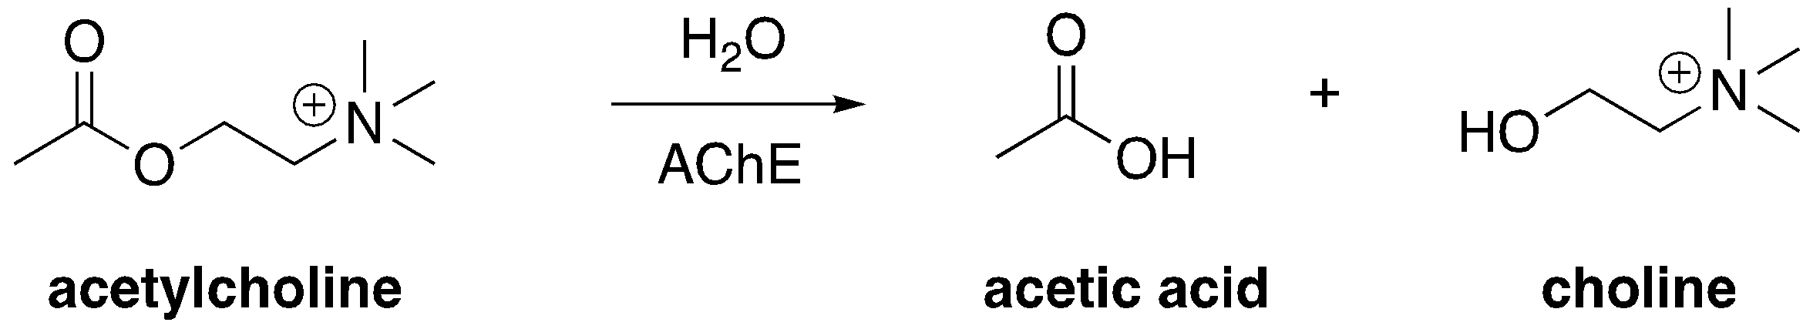

Figure 1: Acetylcholinesterase Overall Reaction

The first step forms the intermediate that can be seen in the structure given by the PDB ID: 2ACE (Figure 2). This covalent adduct is called a tetrahedral intermediate, because it’s going from a trigonal planar carbonyl group to a tetrahedral oxyanion.
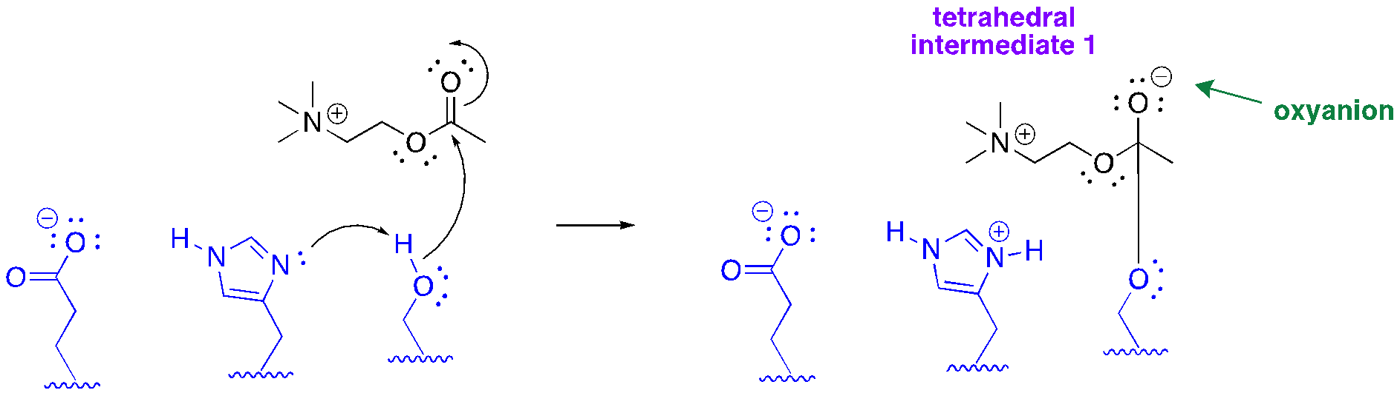
Figure 2: Formation of the first tetrahedral intermediate in the AChE mechanism

Question 1: What is the role of serine and histidine in the mechanistic step shown in Figure 1? Propose a purpose for the glutamate residue that is also part of the catalytic triad.

The tetrahedral intermediate is fleeting. These electrons from the oxyanion push back down, reforming a double bond and releasing choline from the active site (Figure 3).
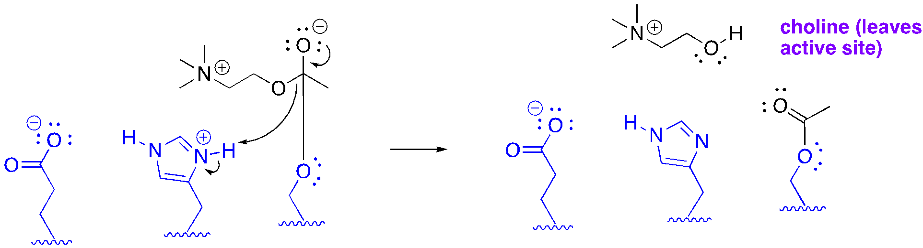
Figure 3: Release of choline in the AChE mechanism

An enzyme needs to return to its original state to catalyze another reaction. To perform this step, a molecule of water in the active site attacks the covalently bound acetate, forming a second tetrahedral intermediate (Figure 4). Like the first tetrahedral intermediate, this collapses, this time releasing the product, acetate.
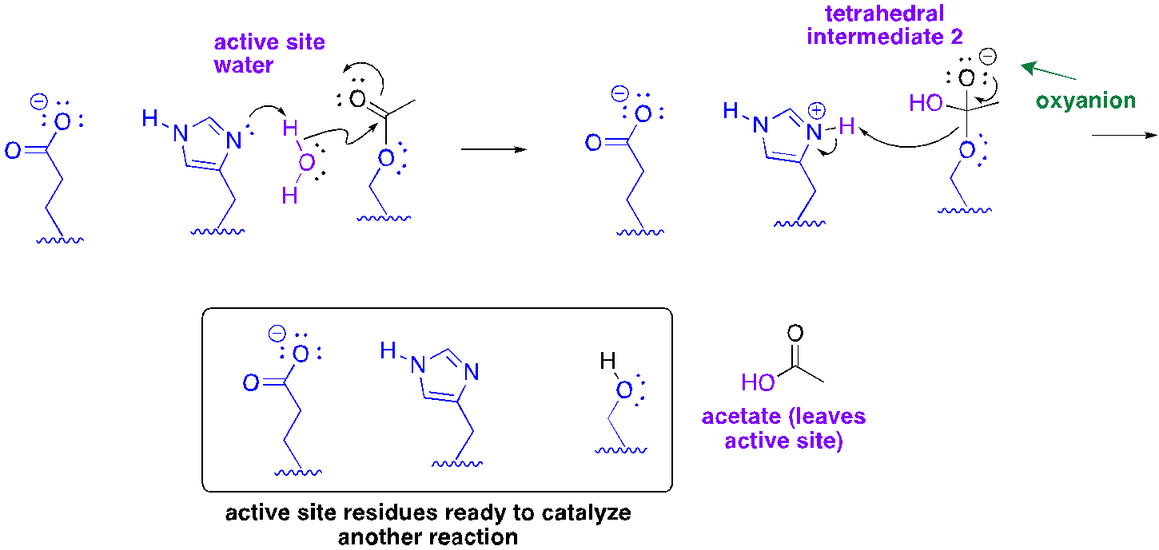
Figure 4: Formation of the second tetrahedral intermediate and acetate release

Question 2: Why is the hydrolysis step necessary? If water couldn’t get into the active site for this hydrolysis step, what do you predict the outcome would be?

Sarin is a powerful inhibitor of AChE. The structure of this poison is shown in Figure 5.

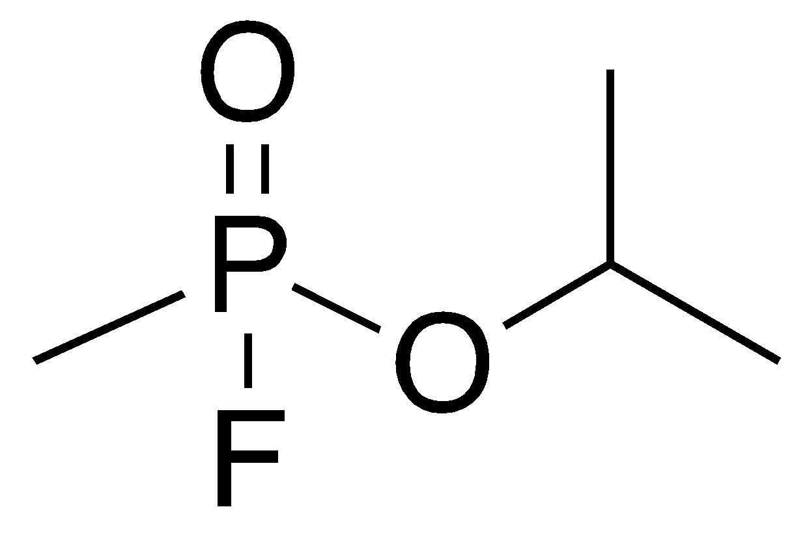
Figure 5: Sarin, powerful a nerve agent

An image of the active site residues interacting with sarin is provided in Figure 6. Examine the figure and answer the following questions.

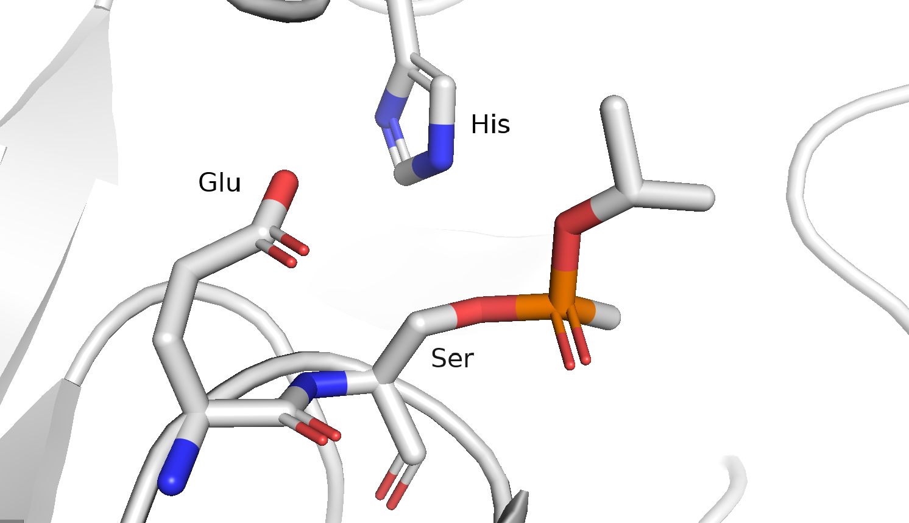
Figure 6: Sarin bound to AChE

Question 3: Draw a chemical structure that shows the way serine interacts with the nerve agent.

Question 4: What type of inhibition is this? How does this lead to the symptoms you read about in the first part of the case study?

There are some chemicals that show promise as antidotes to sarin poisoning. HI-6 (Figure 7) is one such agent.

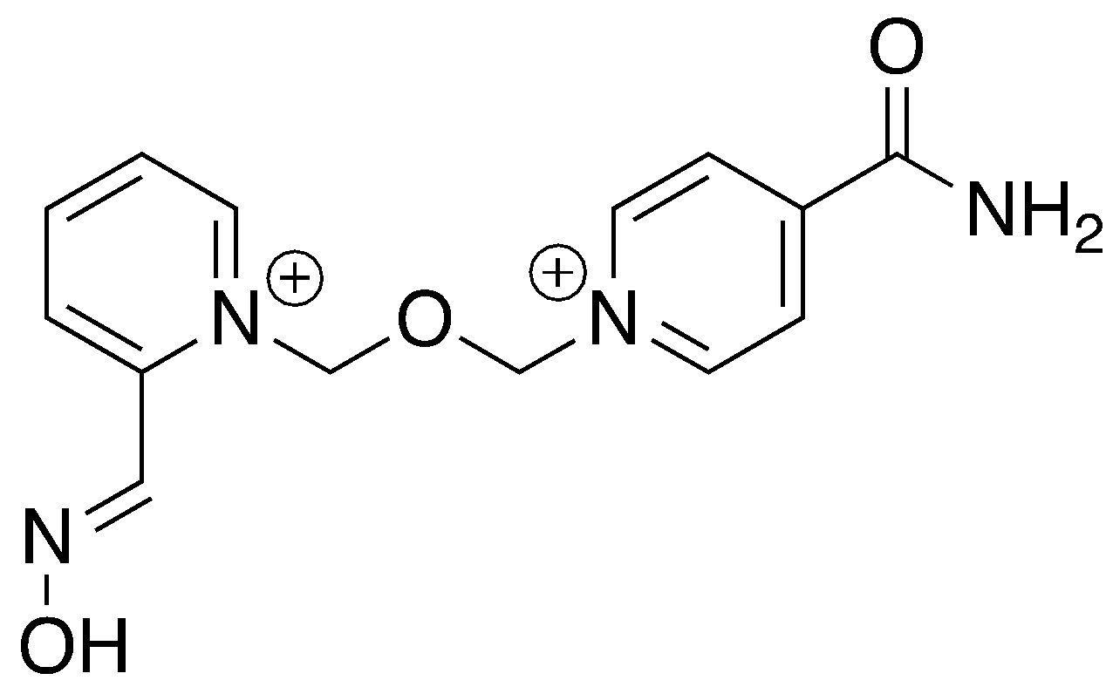
Figure 7: HI-6, a potential sarin antidote

If administered quickly, this compound can reverse the effects of sarin poisoning. Figure 8 shows HI-6 bound to sarin-deactivated acetylcholinesterase.
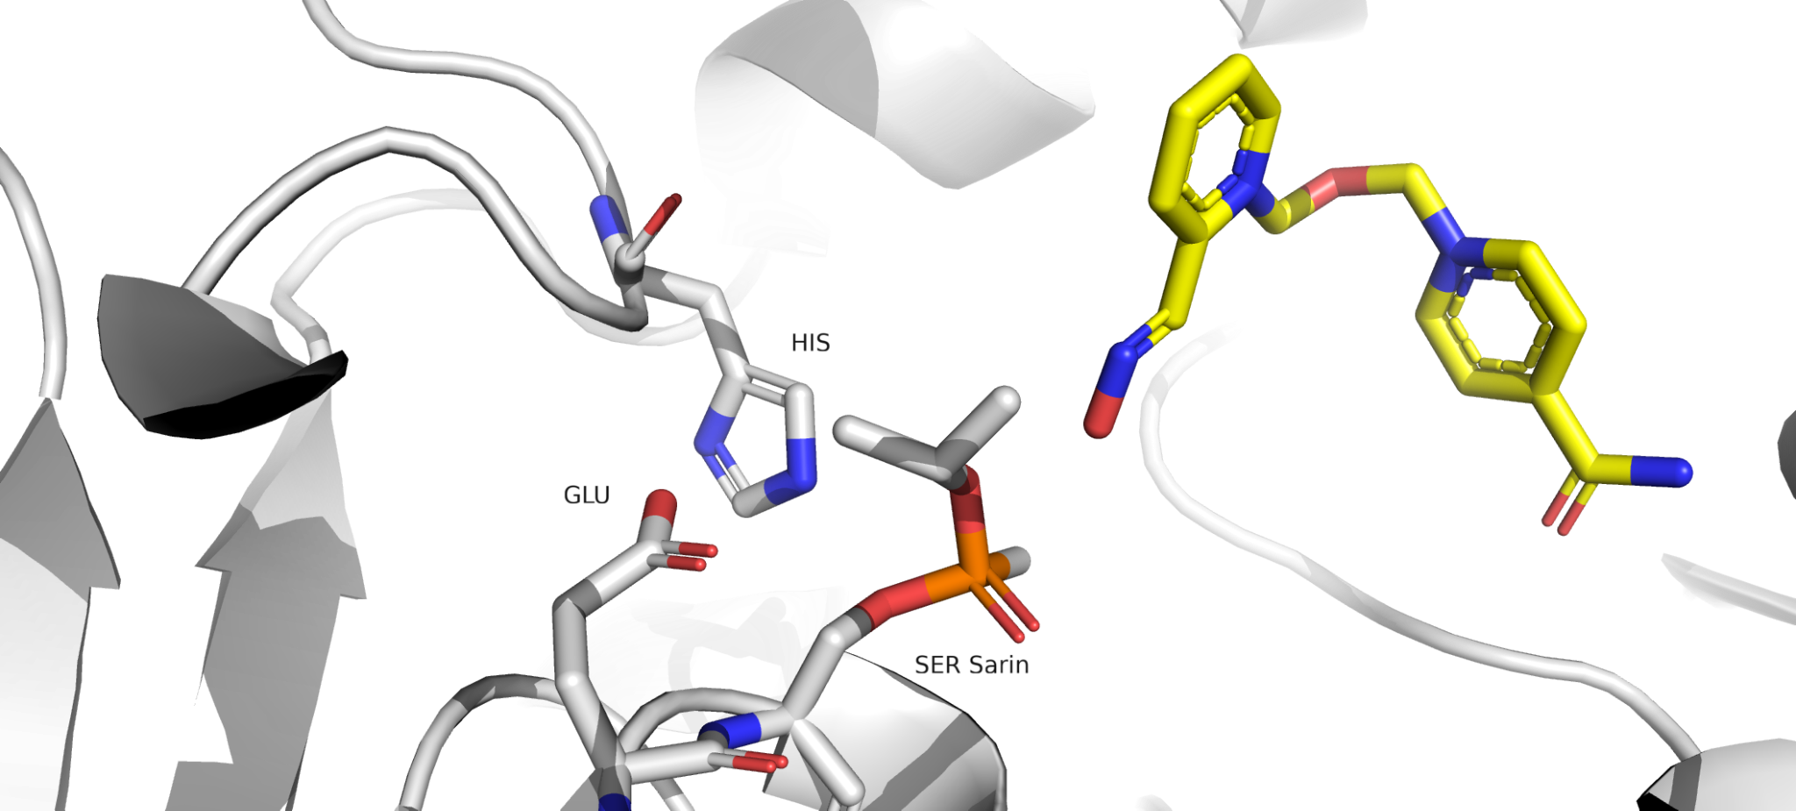
Figure 8: AChE bound to sarin and the potential antidote, HI-6

Question 5: Based on Figure 8, how do you think the antidote reacts to release sarin from the active site serine? Propose a structure of the antidote-sarin adduct, and show an arrow pushing mechanism. You can represent the parts of the molecule that don’t react as R groups in your structure. The pK_{a} of the antidote oxime functional group is 7.6.

Radić Z, Dale T, Kovarik Z, Berend S, Garcia E, Zhang L, Amitai G, Green C, Radić B, Duggan BM, Ajami D, Rebek J, Taylor P. (2013) Catalytic detoxification of nerve agent and pesticide organophosphates by butyrylcholinesterase assisted with non-pyridinium oximes. Biochem J. 450 (1), 231–42. doi: 10.1042/BJ20121612. PMID: 23216060; PMCID: PMC4772673.

