From Poison to Medicine
Enzyme Kinetics, Inhibition, and Alzheimer’s Treatment

An Introduction to Kinetics

Enzymes are biological catalysts that affect the kinetics of a reaction by speeding up the rate. Enzymes are able to accomplish this in part by lowering the activation energy of the rate-limiting step. Knowledge of enzyme kinetics can lead to a better understanding of an enzyme’s catalytic mechanism, how it may be inhibited, and the relative speed of an enzyme. In this case study, we’ve looked at acetylcholinesterase (AChE) and how it can be irreversibly inhibited by sarin, and now we’ll look at its potential as a therapeutic target in the treatment of Alzheimer’s Disease (AD).

In order to understand the significance of AChE’s properties, it is necessary to know the fundamental terms used in enzyme kinetics. The Michaelis-Menten equation is used to describe the behavior of enzymes and is based upon the following reaction scheme:

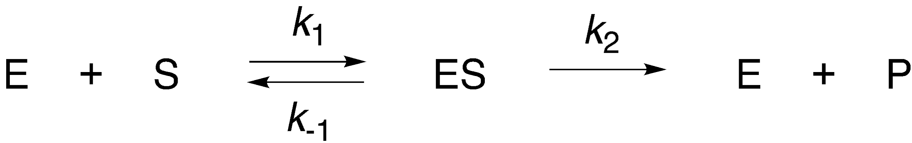
Scheme 1: General scheme for an enzyme-catalyzed reaction
E = enzyme, S = substrate, P = product, ES = enzyme-substrate complex; k₁ and k₋₁ are the rates for the forward and reverse reactions to form the enzyme–substrate complex [ES], respectively, and k₂ is the rate of product formation from [ES].

To derive the Michaelis-Menten equation, two assumptions are made.
- The reverse reaction of catalysis (k₋₂) is not incorporated because the equation describes initial rates when the concentration of product is near zero.
- The Steady State Approximation: the concentration of ES remains relatively constant as it is formed and broken down at the same rate.

The first term (V) is the velocity of an enzyme or its reaction rate. As the amount of substrate is increased, an enzyme becomes saturated and cannot react faster, no matter how much substrate is added. V_{max} is the maximum rate at which the enzyme-catalyzed reaction can proceed.

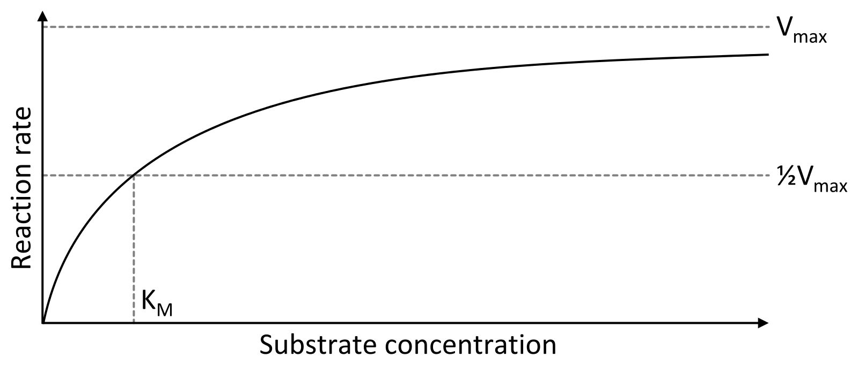
Figure 1. Saturation curve for an enzyme-catalyzed reaction, which relates the substrate concentration to the reaction rate.

K_{M} is the Michaelis constant and is independent of substrate or enzyme concentration. It also is the substrate concentration at half of the V_{max}, which can be derived from the Michaelis-Menten equation. In simple terms, it can be thought of as a measure of affinity, the smaller the K_{M}, the higher the affinity of the enzyme for the substrate.

k_{cat} (k₂) is also known as the turnover number and is the rate of product formation when an enzyme is saturated with substrate. It describes the number of product molecules made by each enzyme molecule per unit time.

Catalytic efficiency is k_{cat}/K_{M} and is a measure of enzyme efficiency that takes into account both the binding and catalytic events. Using these terms, a perfect enzyme would theoretically have a maximum catalytic efficiency of 10⁹ M⁻¹ s⁻¹.

Question 1: Using the variables K_{M} and k_{cat}, describe the relative magnitudes of these terms for a perfect enzyme.

Question 2: As described above, a perfect enzyme theoretically has a maximum catalytic efficiency of 10⁹ M⁻¹ s⁻¹. What are some potential factors that limit an enzyme from attaining catalytic perfection?

By rearranging the Michaelis-Menten equation, a plot can be generated that enables enzyme analysis (Figure 2). This is a Lineweaver–Burk plot in which the inverse of the reaction rate (1/v) is plotted against the inverse of the substrate concentration (1/[S]) to generate the double reciprocal plot. The y-intercept is 1/V_{max,} and the x-intercept is −1/K_{M}. This graph is useful for comparing reversible inhibitors as the x- and y-intercepts allow us to calculate differences in binding affinity (K_{M}) and reaction rate (v), respectively.

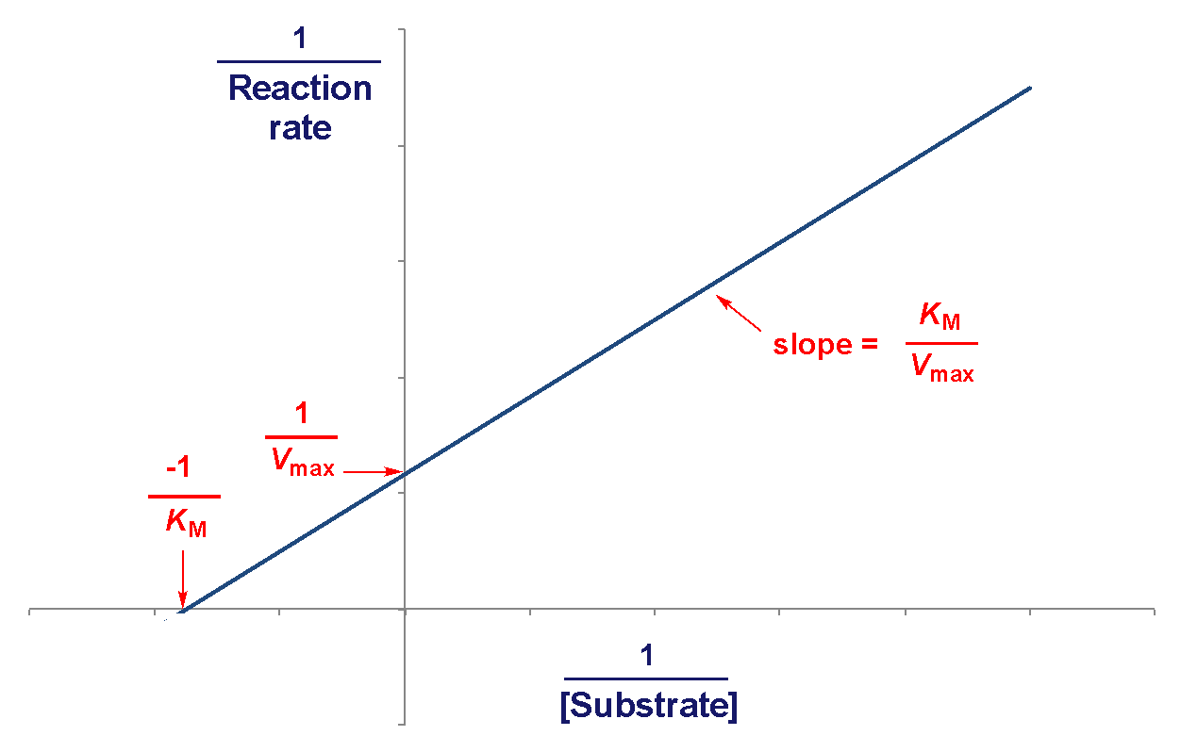

Figure 2. A Lineweaver-Burk plot is a “double reciprocal” plot in which the inverse of the reaction velocity is plotted against the inverse of the substrate concentration.

Enzyme Inhibition

There are multiple ways that an inhibitor can bind to an enzyme. Understanding the general scheme for enzyme-substrate binding is crucial to understanding the different types of inhibition. When Lineweaver-Burk plots for the uninhibited enzyme are graphed alongside a plot of the inhibited enzyme, characteristic patterns can be seen in the plot for each type of inhibition (Figure 3).

The main types of reversible inhibition include competitive, uncompetitive, and noncompetitive inhibition. In competitive inhibition, the inhibitor binds directly to the active site, in this case “E”. By binding to the active site, the substrate is not able to bind as often, increasing K_{M}. With a large enough amount of substrate, the V_{max} can still be achieved, therefore V_{max} is unchanged (Figure 3A).

In uncompetitive inhibition, the inhibitor binds only to the enzyme-substrate (ES) complex. The inhibitor binds to the enzyme after the substrate has bound to the active site, which means that the inhibitor binds to a location outside of the active site. The bound enzyme-substrate complex is not as efficient at producing product, resulting in a reduced V_{max}. The reduction in unbound enzyme-substrate complex results in a greater affinity for the substrate as the need to replenish ES increases, decreasing K_{M} (Figure 3B).

Noncompetitive inhibition involves a combination of both competitive and uncompetitive inhibition, as the inhibitor binds to both the enzyme (E) and the enzyme-substrate complex (ES). Thus, a noncompetitive inhibitor binds to a location outside of the active site and can do so whether or not the substrate has already bound. If the K_{M} is changed as a result, the noncompetitive inhibition is classified as “mixed”. A decrease in K_{M} indicates that the inhibitor has a preference for the ES complex (Figure 3C); an increase in K_{M} indicates that the inhibitor prefers free enzyme (Figure 3D). If the K_{M} is unchanged (indicating that the inhibitor binds to E and ES with equal affinity, the type of inhibition is classified as “pure” noncompetitive inhibition (Figure 3E).

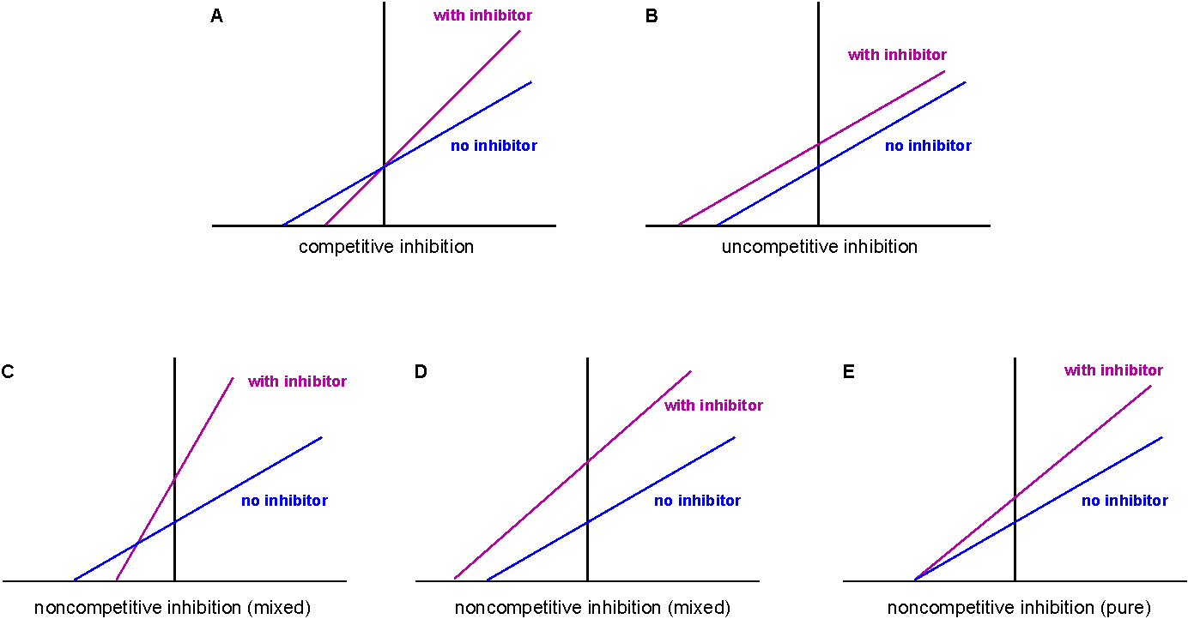

Figure 3. Lineweaver-Burk plots can be used to determine the type of inhibitor in an enzyme-catalyzed reaction. (A) A competitive inhibitor results in an increase in the K_{M} whereas the V_{max} is unchanged; (B) An uncompetitive inhibitor results in a proportional decrease in V_{max} and K_{M}, yielding plots with identical slopes; (C) A noncompetitive inhibitor results in a decreased V_{max} and either an increased K_{M}, (D) decreased K_{M}, or an (E) unchanged K_{M}, depending on the preference of the inhibitor for E or ES.

Similar to K_{M}, K_{I} is the dissociation constant for the inhibitor and the enzyme. Unlike K_{M,} which is a kinetic parameter, K_{I} is a thermodynamic parameter meaning that it shows the true affinity an inhibitor has for an enzyme. Because we potentially have inhibitors that bind either to free E or to the ES complex (or both), we designate two K_{I} values; K_{I} and K_{I}'. The K_{I} value indicates the affinity of the inhibitor for the free enzyme and the K_{I}' indicates the affinity of the inhibitor for the ES complex. A lower value indicates a greater affinity.

In order to calculate K_{I}, we need to determine α, and to calculate K_{I}', we need to calculate α'. Both α and α' are values that indicate the degree to which binding the inhibitor changes the enzyme kinetics for the substrate. These values are obtained by comparing the values of K_{M} and V_{max} with and without inhibitor. The changes expected for α and α’ for each type of the three inhibitors discussed are shown in Table 1. For example, you will calculate α by comparing either the slopes or the K_{M} values with and without inhibitor for a competitive inhibitor. You can calculate α' by comparing either the y-intercepts or the V_{max} values with and without inhibitor for either an uncompetitive inhibitor or a noncompetitive inhibitor.

 | Values of α and α' | y-intercept | x-intercept | slope
no inhibitor | α = 1  α' = 1 | $$\frac{1}{V_{max}}$$ | $$\frac{-1}{K_{M}}$$ | $$\frac{K_{M}}{V_{max}}$$
competitive | α > 1  α' = 1 | $$\frac{1}{V_{max}}$$ | $$\frac{-1}{αK_{M}}$$ | $$\frac{{αK}_{M}}{V_{max}}$$
uncompetitive | α = 1  α' > 1 | $$\frac{α'}{V_{max}}$$ | $$\frac{-α}{K_{M}}$$ | $$\frac{K_{M}}{V_{max}}$$
noncompetitive (mixed) | α > 1  α' > 1 | $$\frac{α'}{V_{max}}$$ | $$\frac{-α'}{{αK}_{M}}$$  if α = α', the x-intercept is ‒1/K_{M} | $$\frac{αK_{M}}{V_{max}}$$
Table 1: The variation in values of α and α' for the three types of reversible inhibitors.

Note: The values for K_{M} and V_{max} referred to in the above tables are the values without inhibitor. For example, if inspection of the graph reveals that the type of inhibition is competitive, you would determine the value of α by setting the value of the slope (with inhibitor) equal to αK_{M}/V_{max} (in which the K_{M} and V_{max} values are the values without inhibitor).

Once you have calculated the value of α, you can solve for K_{i} and K_{I}’ using the following equations:
$$α=1+ \frac{[I]}{K_{I}}$$

$$α'=1+ \frac{[I]}{K_{I}'}$$

Acetylcholinesterase as a Therapeutic Target in Alzheimer’s Treatment

The neurotoxin sarin exhibits irreversible inhibition of AChE, poisoning the enzyme by covalently bonding to the active site serine and shutting down catalysis. However, reversible inhibition of AChE has potential therapeutic benefits in the treatment of Alzheimer’s disease.

Alzheimer’s disease (AD) is a neurodegenerative disease that results in loss of cognitive function, which is characterized biochemically by the formation of amyloid beta plaques and neurofibrillary tangles in the brain. While there are many suspected causes of AD, is it certain that individuals with AD tend to have decreased levels of ACh. Accordingly, several reversible inhibitors of AChE are FDA approved drugs (Figure 4). Inhibiting the enzyme slows ACh breakdown to acetate and choline, raising the level of acetylcholine in the synapse, and alleviating some symptoms associated with AD. In addition to being a useful treatment for AD, the drug galantamine has also been explored as an antidote for sarin poisoning.

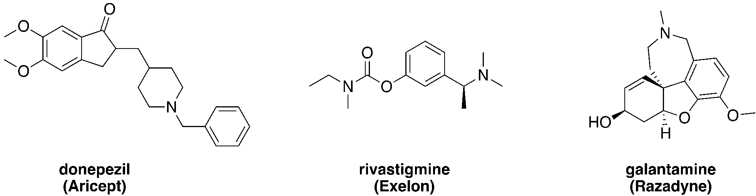

Figure 4. FDA-approved acetylcholinesterase inhibitors used in the treatment of Alzheimer’s disease.

Aricept is another cholinesterase inhibitor approved for the treatment of AD. Figures 5–8 detail the binding of Aricept. The binding site of AChE contains a catalytic site with a catalytic triad, and other binding regions including an anionic site, an oxyanion hole, and a peripheral anionic site. Aricept binding is driven by interactions with the anionic sites.

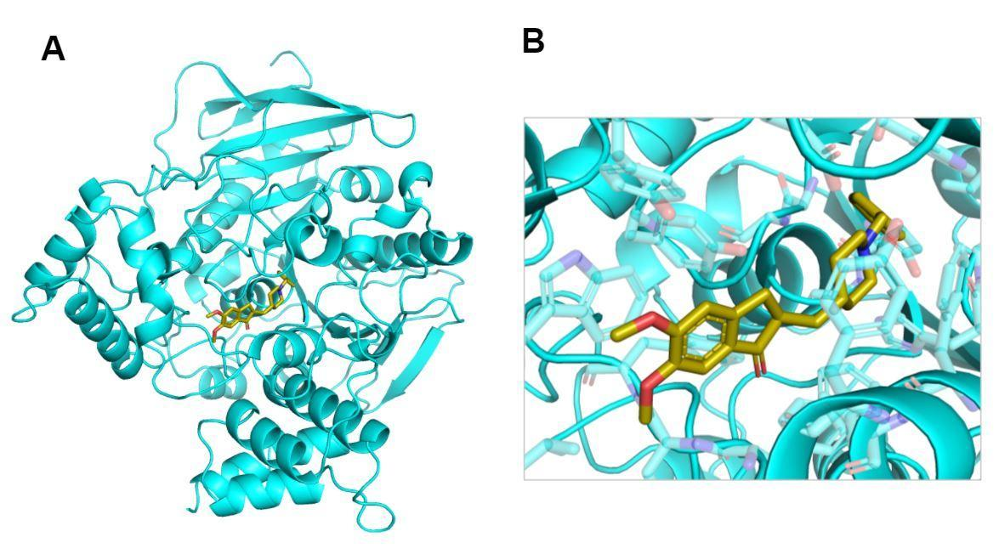
Figure 5. (A) Model of Aricept binding to AChE. (B) Zoomed in image of Aricept binding.

Figure 6. Aricept hydrogen bonding. Notice there are no direct hydrogen bonds between Aricept and the protein, instead, these are water-mediated hydrogen bonds. Water molecules are shown as red spheres, as hydrogens are typically not shown in PyMOL images.
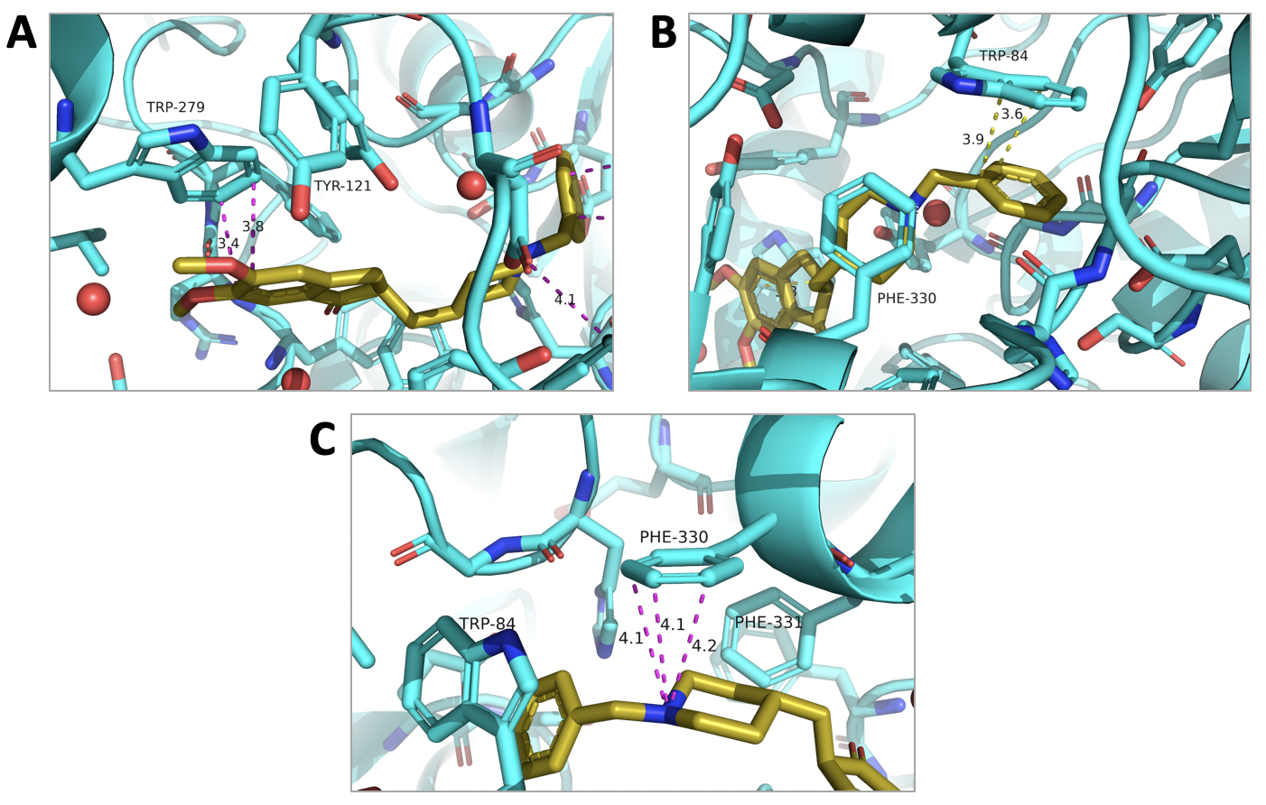
Figure 7. The binding interactions of Aricept largely involve interactions with aromatic amino acid residues. (A) and (B) illustrate π stacking interactions, while (C) shows a cation-π interaction between a Phe residue and the amine group of Aricept, which is protonated at pH 7.
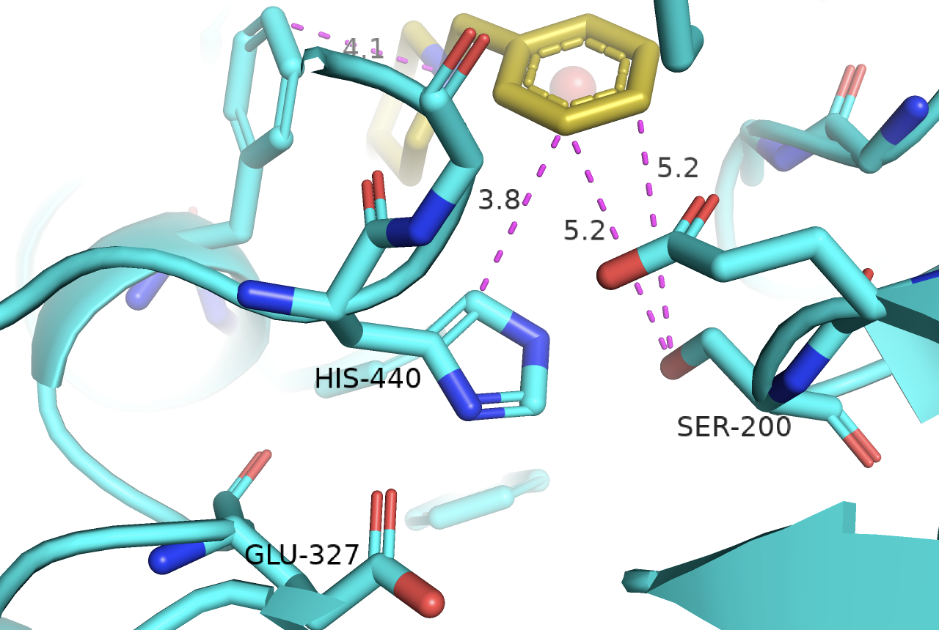

Figure 8. Aricept and distance measurements to the residues of the catalytic triad

Question 3: Construct a hypothesis in which you describe the type of inhibition exhibited by Aricept on AChE.

One study compared the binding of three structurally-related inhibitors (Figure 9). In medicinal chemistry, several strategies are often employed in an attempt to study and improve affinity. One of these is rigidification in which introducing double bonds and rings decreases the number of rotatable bonds, reducing the conformations a molecule can adopt. This strategy can sometimes increase affinity. Another common strategy in drug development is structure simplification. By removing groups, medicinal chemists and biochemists can explore which interactions are critical, and which functional groups may not be needed in further drug design.

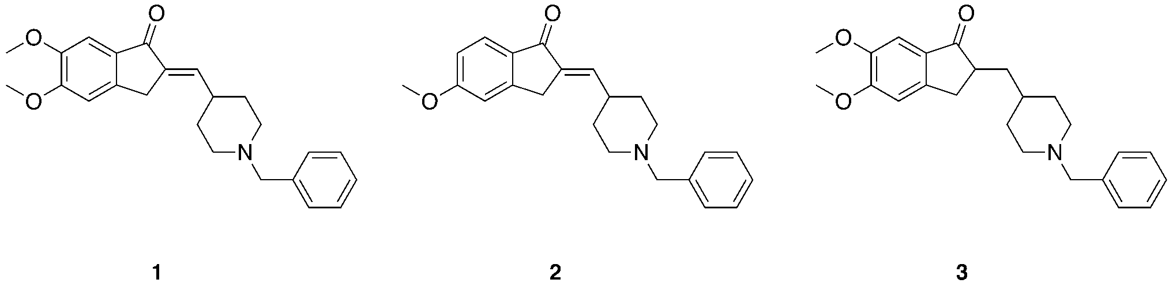

Figure 9. Inhibitors compared in this study.

Question 4: Which compound do you think is an example of a simplification strategy? Explain your answer. Compare the rigidity of the three structures; in your explanation, state which compound has the most free rotation about bonds.

Table 2 provides kinetic data for the three inhibitors. When comparing and testing the efficiency of drugs, a Lineweaver-Burk plot can be used to compare potential inhibitors directly.

[substrate], mM | v (no I), nM/s | v (w/ Inhibitor 1), nM/s | v (w/ Inhibitor 2), nM/s | v (w/ Inhibitor 3), nM/s
0.010 | 28.25 | 11.85 | 18.88 | 6.34
0.020 | 45.74 | 20.38 | 31.84 | 11.21
0.050 | 68.75 | 36.28 | 52.58 | 18.73
0.100 | 90.33 | 46.53 | 70.43 | 24.92
0.200 | 112.20 | 59.13 | 81.15 | 29.92
Table 2. Kinetic data obtained in the absence and in the presence of three potential AChE inhibitors labeled Inhibitor 1, Inhibitor 2, and Inhibitor 3.

Question 5: Using the data from Table 2, construct a single Lineweaver-Burk plot in which you plot 1/v versus 1/[S] for each of the four experiments. Use the information presented in Figure 6 to classify the type of inhibition for each inhibitor. For each inhibitor, describe how/where the inhibitor binds to the enzyme, e.g., competitive inhibitors bind to the active site.

Question 6: Calculate the V_{max} and the K_{M} for each of the four experiments, using the slopes and the y-intercepts obtained from the plot you constructed in Question 5. Organize your results in a table.

Question 7: Calculate the K_{I} and K_{I}’ values (as appropriate) for each of the inhibitors, given the information in Table 3.
 | Inhibitor 1 | Inhibitor 2 | Inhibitor 3
[E] in assay, ng/mL | 4.5
[I] in assay, nM | 20 | 20 | 10
Mwt of AChE, kD | 61.27
Table 3. Assay conditions

Question 8: Calculate the catalytic efficiency of acetylcholinesterase in the absence of inhibitor, given that the enzyme concentration in the appropriate experiment was 73.4 picomolar. Is acetylcholinesterase a particularly efficient enzyme or not? Explain.

Question 9: Which of the three inhibitors has the greatest potential to be used as a drug to treat Alzheimer’s patients? Explain your answer.

Question 10: Suppose you were tasked with designing a new drug to combat a sudden decrease in ACh levels. What type of inhibitor would you pursue as a treatment and why?

