Image | Source | Permissions
 | Malaria by Nick Youngson Pix4free | CC BY-SA 3.0
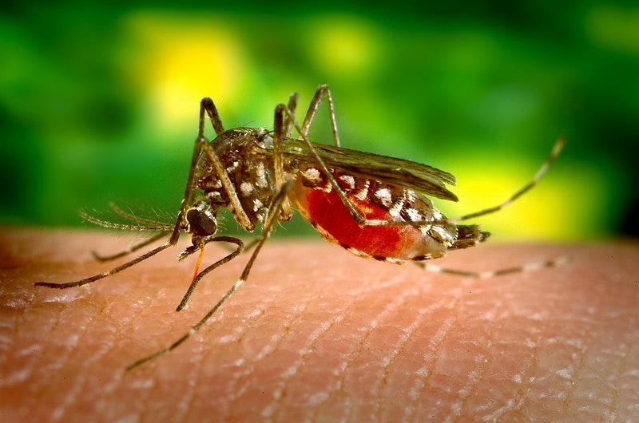 | Photo by James Gathany – CDC – Public Health Image Library (https://phil.cdc.gov/details.aspx?pid=7948)
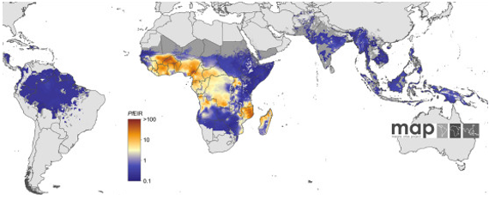 | https://commons.wikimedia.org/wiki/File:A-new-world-malaria-map-Plasmodium-falciparum-endemicity-in-2010-1475-2875-10-378-5.jpg | 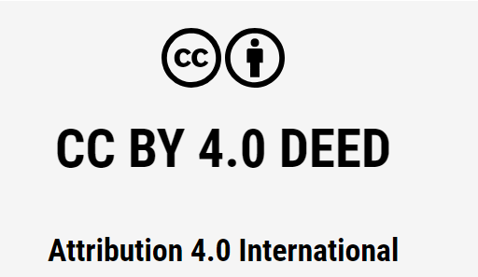
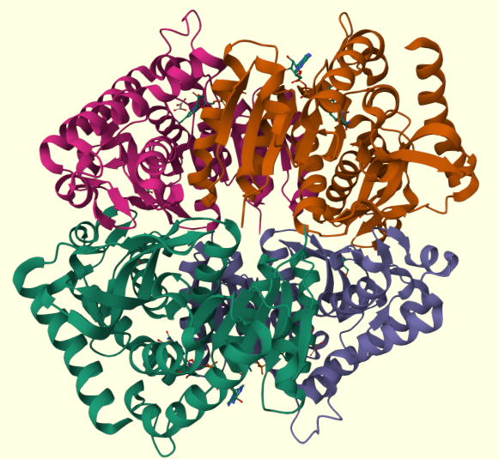 | Created by Didem Vardar-Ulu using data from RCSB PDB (PDB 1t24, Cameron et al., 2004) and Mol* | Original image

