Maria vs Malaria-AR Version

CASE CONTEXT
Learning Objectives for this section:
- Explain the cause of malaria and evaluate the current status of the malaria epidemic
- Identify where Malaria cases are most prominent and which demographics are at risk of contracting Malaria
- Describe how rapid diagnostics test (RDT) for Malaria works.
- Discuss how RDT and adequate treatment of Malaria can improve patient health
Maria is a 35 year old Environmental scientist from New York City, who recently visited the Amazon Rainforest for her research on a rare species of Red-Eyed Tree Frogs. For most of her trip, she camped in various parts of rural Brazil close to the lowland tropical rainforests where the warm wet swamps provided the ideal habitat and diet (crickets, flies, mosquitoes, and other insects) for the Red-Eyed Tree Frogs. After three weeks of research in Brazil, she returned to the States to prepare for her research symposium where she would share her findings. Unfortunately, about a week after her return, Maria began to feel very sick, with a high fever, headache, and diarrhea. Suspecting that she contracted malaria when she was in Brazil, and not wanting to wait for a doctor’s appointment, Maria purchased a Rapid Diagnostic Test (RDT) for Malaria.

Diagnosing Maria:
Rapid Diagnostic Test (RDT) is a very powerful technique that allows a fast diagnosis of certain disease-causing pathogens in the body usually in 20 minutes or less without the need for sophisticated instrumentation. It is low-cost, simple to operate and read, sensitive, specific, stable at high temperatures, and works in a short period of time. Rapid tests are most often used to diagnose infectious diseases including flu, strep throat, HIV, Covid 19, and Malaria, as well as to confirm conditions such as pregnancy.
Suspecting that she contracted malaria when she was in Brazil, Maria purchased an RDT for Malaria that detects the presence of specific malarial antigens in blood specimens including the histidine-rich protein II (HRP-II), aldolase, and parasite lactate dehydrogenase (pLDH) (Figure 1). To learn the immunoassay principles behind this test and the details of how the test works please watch this video. You can also watch a field application of this RDT for Ugandan patients here.

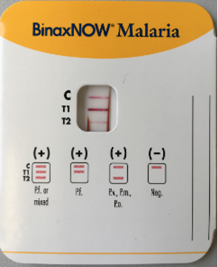 | Figure 1: The BinaxNOW™ Malaria test (Abbott)¹  https://commons.wikimedia.org/wiki/File:Malariaschnelltest.png CC-BY-SA 4.0

When the RTD confirmed her suspicion, Maria went to the hospital. Based on the extra blood tests her doctors requested, the malaria parasite she carried was identified as Plasmodium falciparum, a parasite found in the bite of a female mosquito with malaria and constituted 16.3% of the Malaria incidences in Brazil².
As the doctors were discussing which treatment would be best for Maria, she decided to learn more about this disease to be an informed participant in her own healthcare.

Understanding Malaria
Why is malaria one of the most common infectious diseases in the world, with nearly 247 million cases worldwide in 2021 with 619 000 deaths³?
Read this brief list of key malaria facts from the World Health Organization and watch this video to learn about what causes malaria and how it infects people. (Additional resources: CDC: https://www.cdc.gov/parasites/about.html)
REVIEW QUESTIONS: (Formatted for auto grading, can also be given as free response)

- Which of the following five Plasmodium (single-celled parasites) species is the deadliest malaria parasite and the most prevalent on the African continent? most intense malarial infection in humans?
              - Plasmodium vivax
              - Plasmodium malariae
              - Plasmodium falciparum
              - Plasmodium ovale
              - Plasmodium knowlesi

- What are some of the symptoms of this disease? Choose all that apply.
              - Fever
              - Cough
              - Vomiting
              - Nausea
              - Headache
              - Rashes

- Which demographics are most susceptible to it?
              - Children under 5 years old
              - White males
              - Pregnant women
              - HIV/AIDS patients

- Prevalence: In what regions is malaria most prevalent, and what do they have in common?
Malaria is most prevalent in ____ regions, especially after the rainy season that provides stagnant ___, such as puddles, for anopheles mosquitoes to breed in.

- Malaria transmission to humans: The figure shows the life cycle of malaria plasmodium. Note the numbered steps from 1-5.
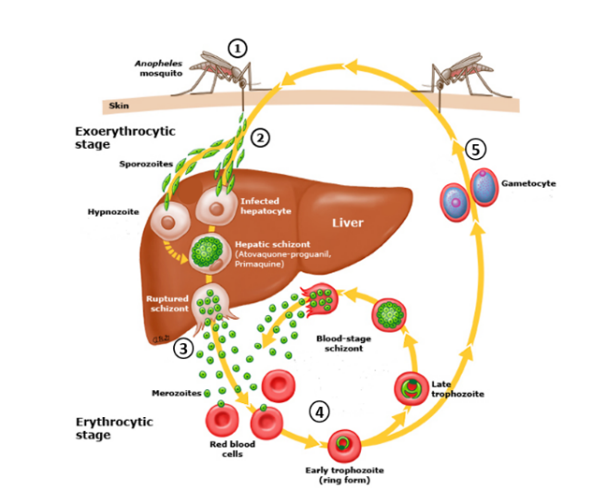

Figure 2: Malaria plasmodium life cycle, Hill A, CC BY 3.0
https://commons.wikimedia.org/wiki/File:Vaccines-against-malaria-rstb20110091-g1.jpg

Here is a description of the life cycle steps:
(A) Plasmodium-infected Anopheles mosquito bites a human and transmits sporozoites into the bloodstream.
(B) Some merozoites differentiate into male or female gametocytes. These cells are ingested by the Anopheles mosquito and mature in the midgut, where sporozoites develop and migrate to the salivary glands of the mosquito.
(C) Within red cells, merozoites mature from ring forms to trophozoites to multinucleated schizonts (erythrocytic stage).
(D) The schizonts rupture and release merozoites into the circulation where they invade red blood cells.
(E) Sporozoites migrate through the blood to the liver where they invade hepatocytes and divide to form multinucleated schizonts (pre-erythrocytic stage).

Match the listed lifecycle steps with the numbers shown on the figure.

For example, step 1: A, step 2: ____, step 3: ____, step 4: ___, step 5: ____

Or: Describe the life cycle of malaria plasmodium:

GETTING TO THE STRUCTURE:

Learning Objectives for this section:
- Describe the function of LDH in glucose metabolism.
- Describe the reaction LDH catalyzes including the substrates, products, and cofactors of this reaction.
- Describe the significance of anaerobic respiration in parasites
- Discuss how LDH can be used as a drug target to treat malaria

Maria reaches out to Michelangelo:
Upon learning about her malaria diagnosis, Maria frantically called Michelangelo, a colleague of hers at the CDC. She was worried that she wouldn’t be able to present her findings at the upcoming research symposium! Being also a close friend to Maria, Michelangelo agreed to do some research on the Plasmodium falciparum, taking special interest in how the parasite is able to multiply so rapidly.
As a part of his job, he was aware of the diagnostic usage of the serum levels of numerous enzymes for a variety of human conditions. The presence of enzymes normally confined to specific tissues or organs in the serum indicates that cellular damage has occurred resulting in the release of intracellular components into the blood. For example, when a physician orders an assay for liver enzymes, the purpose is to ascertain the potential for liver cell damage. Since Maria’s RDT indicated the presence of malarial parasite Lactate Dehydrogenase (LDH) enzyme in Maria’s blood, he decided to focus on understanding the role of LDH in malarial parasite survival and as a possible treatment target.

Role of Lactate Dehydrogenase in Energy Metabolism:
Adenosine triphosphate (ATP) is an organic compound and a hydrotrope that provides energy to drive many processes in living cells, such as muscle contraction, nerve impulse propagation, condensate dissolution, and chemical synthesis. All known forms of life, including aerobic and anaerobic organisms require ATP for survival and hence ATP is often referred to as the "molecular unit of currency" for intracellular energy transfer.
Glycolysis is a central pathway in carbohydrate metabolism that converts glucose into pyruvate and produces ATP along the way. NAD⁺ is a required cofactor for some of the enzymes in this pathway and is reduced to NADH while glucose is oxidized to pyruvate. Pyruvate that is formed as the product of this conversion has a few different paths it can follow. For organisms that require large amounts of energy (ATP) to function the predominant pathway is the “aerobic respiration” for which pyruvate is converted into acetyl-CoA and channeled into the Krebs cycle. For organisms that rely on “anaerobic respiration” other pathways are needed to avoid buildup of pyruvate and replenishment of glycolytic cofactors to continue ATP production through
glycolysis.
Lactate dehydrogenase (LDH) is the gatekeeper enzyme for lactic acid fermentation, one of the main alternative pathways for pyruvate and NADH recycling. It catalyzes the spontaneous conversion of pyruvate to lactate and requires NADH as the cofactor.

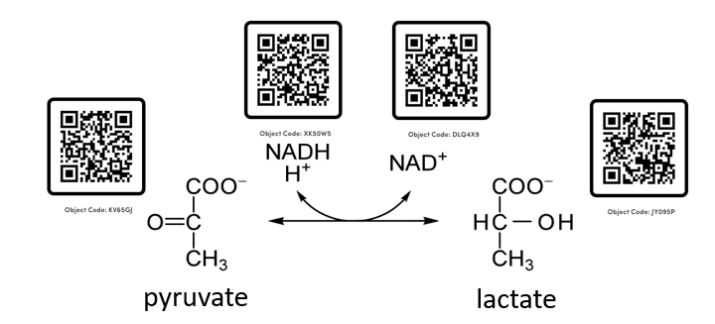Figure 3: Lactate dehydrogenase (LDH) catalyzed reaction of the reversible conversion of pyruvate to lactate. This is a redox reaction where the cofactor NADH gets oxidized to NAD⁺ as pyruvate is reduced to lactate.

Because LDH is essential in the breakdown of pyruvate into lactate under anaerobic conditions, and recycling of NAD⁺ for continual glycolysis, it is no surprise that LDH must be present in most living organisms that utilize glycolysis for ATP production.

Through his research Michelangelo learned that during erythrocyte stages of its life cycle, the Plasmodium falciparum parasite produces its energy mainly through glycolysis followed by lactic acid fermentation.

Q1. The malaria parasite is a protozoan, a eukaryotic organism. How does the predominant pathway for ATP generation in Malaria parasites differ from most other eukaryotic organisms? How can this difference be leveraged for disease treatment?

EXPLORING THE STRUCTURE
Learning Objectives for this section:
- Use UniProt and PDB to find specific sequences and structures of for Plasmodium falciparum and human LDH
- Use Bioinformatic tools ProtParam and Align, and the visualization tool Mol* to explore and compare parasite LDH and human LDH.
- Locate the active site of LDH and its coenzyme NADH/NAD⁺in the active site.
- Identify the different types of interactions between the coenzyme and the surrounding residues in pfLDH and hLDH
- Compare and contrast the pfLDH and hLDH active site structures

Michelangelo calls Maria:
Much to Maria’s surprise, she receives an eager call from Michelangelo. He tells her about the metabolic significance of LDH in the P. falciparum and how its inhibition could be used to combat malaria. She is ecstatic about this, but then confused. Don’t humans have LDH too? She remembers reading that levels of lactate dehydrogenase (LDH) in serum are especially diagnostic for myocardial infarction. Wouldn’t the inhibition of the pfLDH consequently inhibit her own human LDH? She shares this concern with Michelangelo who reassures her that inhibiting the pfLDH is a safe and effective way to treat malaria. He tells her that to understand why, she needs to gain a molecular understanding of how LDH works based on its structure. Maria gets to work.

Exploring the primary Structure of Plasmodium falciparum LDH (pfLDH) and human LDH (hLDH):

- Go to http://www.uniprot.org
- In the search field, enter “Plasmodium falciparum LDH” and choose the table view to view results.
- Find the entry for full length Plasmodium falciparum with the Protein Name: L-lactate dehydrogenase and entry name: LDH_PLAFD and check the box left of the entry ID.
- Once checked, find the tab “add” with a basket icon above the top banner and click it to add this protein sequence to the basket.
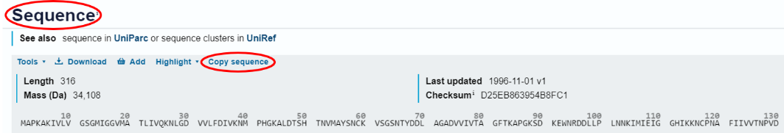
- Click on the entry ID next to the checkbox and scroll down to the “Sequence” section of the file that opens up (almost at the end) and “copy sequence”.
Q2. Copy and paste the pfLDH sequence below. Make sure to include the UniProt Entry ID # and the name on top of the sequence

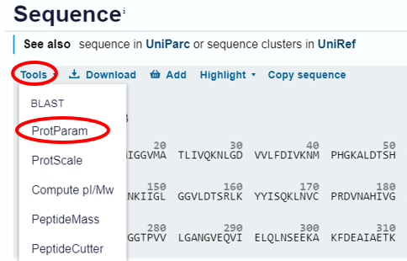
- Click the “Tools” dropdown menu and select ProtParam.
- Click submit at the bottom of the page that opens to run the analysis using the entire protein sequence.

Q3. Using the displayed results fill in the following information.
P. falciparum LDH (pfLDH) with the Protein Accession # Q27743 has __________ (include number of) amino acids and has a molecular weight of ____ Da. Its predicted pI is ____. It has ____negatively charged amino acids and ___ positively charged amino acids at physiological pH.

Unlike P. falciparum that has a single gene coding for a single polypeptide used to form its functional LDH (pfLDH), humans have two different genes that code for two different polypeptides (hLDH-A and hLDH-B) that can be used to assemble a functional hLDH. We will look at the formation of these assemblies (quaternary structure of LDH) in a later section. For now, let’s repeat the same exercise above, to obtain information on hLDH-B.

- Go back to the Table list of results you received after step 2 above and enter “human LDH” on the search bar at the top of this page.
- Find the entry for the human with the Protein Name: L-lactate dehydrogenase B chain, Entry Name: LDHB_HUMAN and check the box left of the entry ID.
- Repeat steps 4-7.

Q4. Paste the hLDH-B sequence below. Make sure to include the UniProt Entry ID # and the name on top of the sequence.

Q5. Using the displayed results fill in the following information.
Human LDHB (hLDHB) with the Protein Accession # P07195 ______has (include number of) amino acids and has a molecular weight of ____ Da. Its predicted pI is ___. It has ____negatively charged amino acids and ____ positively charged amino acids at physiological pH.

Now that you have compiled some basic physicochemical information for these two protein sequences (one from the parasite and one from humans) let’s compare them to one another to determine similarities and differences that might shed light to their biological functions.

Q6. Compare and contrast the total charges of pfLDH and hLDH-B. What is the overall charge difference between them?

UniProt also allows us to align protein sequences to compare the similarities and differences between them at each amino acid location along the sequence. To do this go to your “basket” on the upper right corner of your UniProt main page.

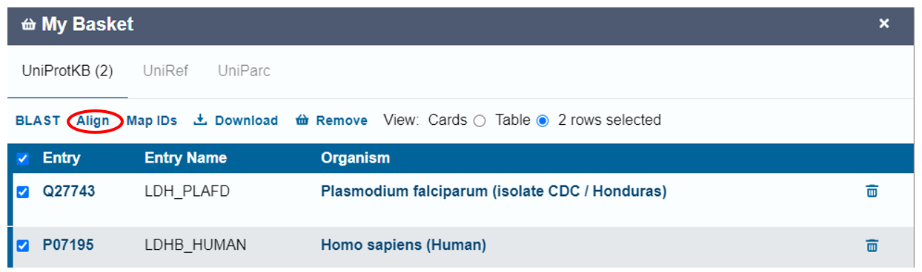
- Select the two sequences for pfLDH and LDH-B in the basket and click “Align” above the banner.

- Enter “pfLDH vs hLDH-B” as the name for your alignment job in the box below the sequences and click “run align” on the right bottom corner of the page.
- Once the alignment is completed, click on the word “completed” under the “status” column.

Q7. Take a screenshot of the displayed alignment and paste below.

- Using the two pull down menus “highlight properties” and “Select Annotation” explore the similarities and differences in physicochemical, structural, and functional aspects of these two sequences.

Q8. Under “Select Annotation” explore the “Active Site” for both sequences. List the residue(s) common to both pfLDH and hLDH-B at their active site. Then switch to the “Binding Site” residue view for both sequences and list the two aligned identical binding residues in both sequences. As you continue your comparisons, note other residues that are shown to be important for one residue but not the other.

Q9. Under “Highlight Properties” open up physical properties and select “polar”. Find the regions in the aligned sequences where the polarity is similar for both pfLDH and hLDH-B and other regions where they are different. List the residues in the longest stretch of consecutive polar residues in both sequences below. Then display the “charged” residues (you can also do them separately as positives and negatives) and comment on how your observations from the aligned sequence compare with your earlier Protparam analysis.

Q10. Using only the primary structural information you explored so far, what can you infer about the similarities and differences between pfLDH and LDH-B, in the context of glycolysis? How might these differences affect the enzyme’s catalytic ability?

Exploring the higher order structure of LDH using PDB and Mol*:
Now that you have had the opportunity to explore the primary structures of pfLDH and hLDH, you are prepared to analyze the differences in their secondary and tertiary structures. The amino acid sequences we found above dictates what secondary structures, and thus what tertiary structures are present in LDH, so it is important that we understand the important structural features of this protein before we move on to its functional properties. In this section, we will start by exploring the three-dimensional structural information for LDH hosted in the Protein Data Bank (PDB) and use Mol* to visualize the different protein structures to assess the conservation of structural features between human and Plasmodium species. For the human LDH we will be focusing on the LDH1 (heart) isozyme.
- Go to the RCSB Protein Data Bank (https://www.rcsb.org/). In the query box at the top of the webpage, input “LDH” and click search to explore various lactate dehydrogenases among organisms.
- To explore the structure of pfLDH enter the PDB identifier “1T2C” in the query box and press search.
- On a NEW tab repeat the search for the PDB identifier “7DBK”
You will be flipping between these two structures throughout your explorations so make sure to keep these two tabs separate on your browser.

Q11. Use the information presented on the structure summary page for each structure to fill out the following table.

Table 1: PDB summary at a glance for 1T2C, and 7DBK
PDB ID
Description
Organism(s)
Structure of the biological assembly
You can find this info under the “Biological Assembly” section on the upper left in the “global Stoichiometry” subheading
UniProt ID#
You can find this info in the “macromolecules” section under UniProt subheading.
Names and formula of ligands present in the structures
You can find this under the “small molecules” section following the “macromolecules” section.
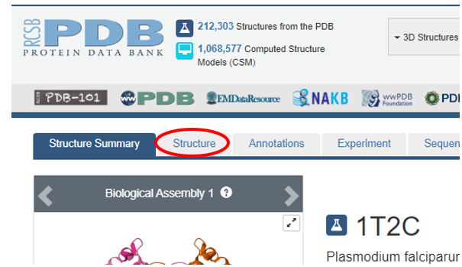
- Click on the “3D View” tab next to the “Structure Summary” tab at the top to reach the 3D crystal structure of the “biologically functional” LDH.

The 3D structural analysis view offers us several resources to visualize the protein structure and its interactions with other biological partners, such as ligands. These could be any molecule including substrates, cofactors, and inhibitors.

On the top of your screen, you will see the sequencing information of the protein and on the right-hand side is structural information as well as analysis tools you can use.

- To make the visualization cleaner, under the “components” panel on the right, hide water (click on the “eye” icon).
- Click and drag your mouse to see the molecule from different angles. Translate by pressing the right mouse button and moving or use Control + the left mouse button and move. Scroll in and out to zoom. You can always reset the program with the refresh icon at the top right.
- Rotate the molecules around to obtain a relatively similar view for pfLDH and hLDH.

Q12. Insert a screenshot of the displayed structures below, making sure to include the PDB ID# for each screenshot.
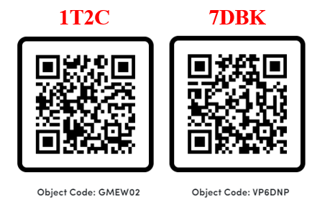

Q13. Based on the 3D structures displayed, what is the quaternary structure of functional LDH in Plasmodium falciparum vs homo sapiens? What do their quaternary structures tell you about the number of active sites in the functional LDH molecule for each species if you are given that each monomer contains a single active site?

Visualizing the structure of individual LDH subunits from pfLDH (1T2C) and hLDH (7DBK) using Mol*:

- Click on the selection tool on the Mol* Viewer canvas which brings up an additional selection panel on the canvas above the displayed structure. Switch the leftmost selection criteria to “Chain”. Make sure that the topmost blue banner information is set to the first option for each of the five options as shown below.
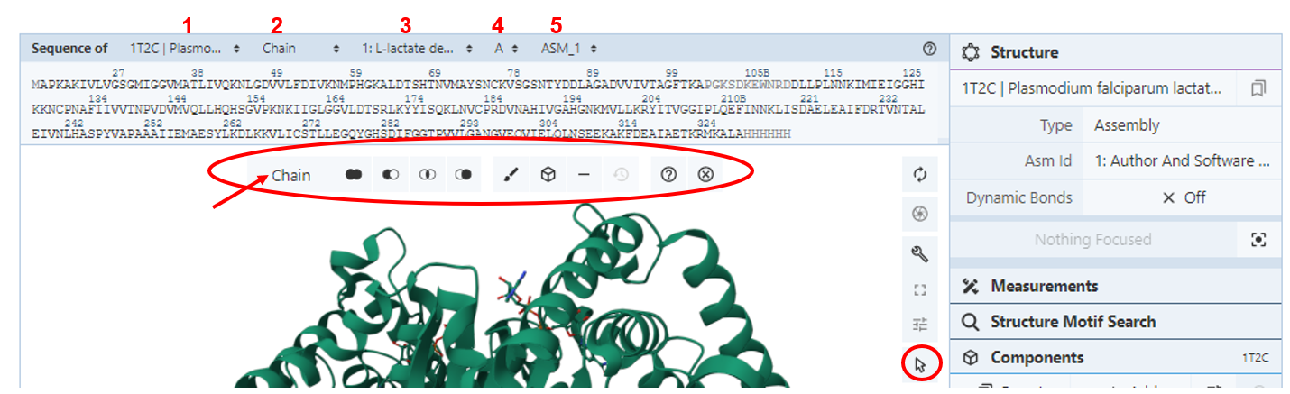

- Scroll and click on the displayed sequence which should highlight both the sequence and the corresponding subunit structure on the canvas. Then click on the “cube” icon to create a stand-alone object for this selected subunit. Change the “Representation” to cartoon and under options give the object a name you can remember (ex. pfLDH subunit). Then click “Create component”.
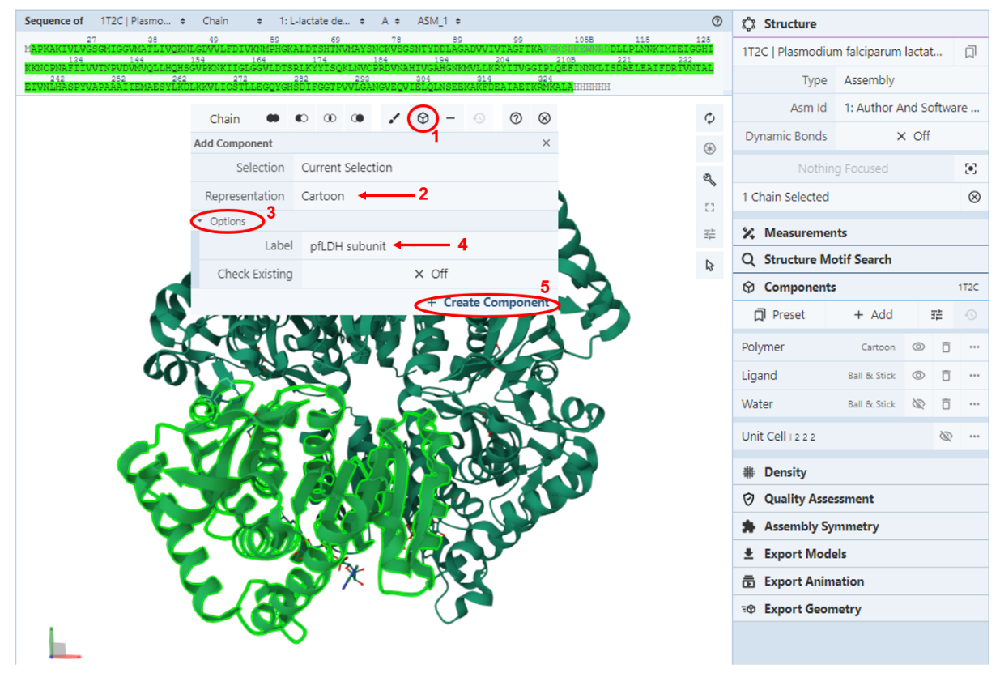

- This new object should now appear as a separate entity in the “Components” panel (below water)
- Hide all other components (toggling off the eye icon next to them) leaving only the subunit visible. Click on an empty space on your canvas to clear out the selection. Now you should be only looking at a single subunit of your chosen LDH.
- In the sidebar under Components, find “pfLDH subunit,” click the 3 dots symbol to the right of “your subunit,” then click “Add Representation” to see a dropdown menu of options. Explore the different methods by clicking on one (eg: Ball & Stick). This will close the menu and add the visualization.
Components → pfLDH subunit (3 dots) → Add Representation → Ball & Stick
- To show, hide, or delete a representation, click the 3 dots symbol to the right of “Polymer” again and adjust the trash or eye symbols until only the cartoon representation is visible.
Components → pfLDH subunit (3 dots) → Add Representation → Cartoon
- Now color your subunit, by secondary structure by going back to “your subunit” 3 dots symbol, clicking “Set Coloring” to open the dropdown menu, selecting “Residue Property,” then “Secondary Structure.” (You may need to scroll to see all the options.)
Components → pfLDH subunit (3 dots) → Set Coloring → Residue Property → Secondary Structure
- Repeat steps 3-9 on the other LDH molecule.
- Rotate the molecules around to obtain a relatively similar view for pfLDH and hLDH subunits

Q14. Insert a screen capture of both subunits colored by secondary structure below and label the N- and C- termini.

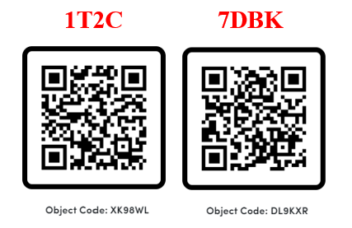

Q15. How do the secondary structural elements compare between pfLDH and hLDH-B subunits? How about the overall 3D fold of each subunit?

Exploring the LDH active site:

NADH Binding site:
Now that we have a fairly good idea about the overall structural features of each LDH subunit, let’s visualize the location of the active site with respect to the rest of the LDH subunit structure for both pfLDH (PDB ID 1T2C) and hLDH-B (PDB ID 7DBK). NADH is a cofactor of LDH that binds to the enzyme at the active site. So, we will start by visualizing NADH within the LDH subunit.
- Go back to each of your pfLDH subunit structure tab and display it using a surface representation
Components → pfLDH subunit (3 dots) → Add Representation → Molecular Surface

- In the blue bar above the sequence, following “Sequence of” change the third text box to NAI (1,4-DIHYDRONICOTINAMIDE ADENINE DINUCLEOTIDE), the second option.

- To the left of the sidebar, click the arrow symbol at the bottom of the tool icons to bring up a toolbar. The first text option can be set to “Residue” or “Chain” and click on the sequence, “NAI”, to select it.

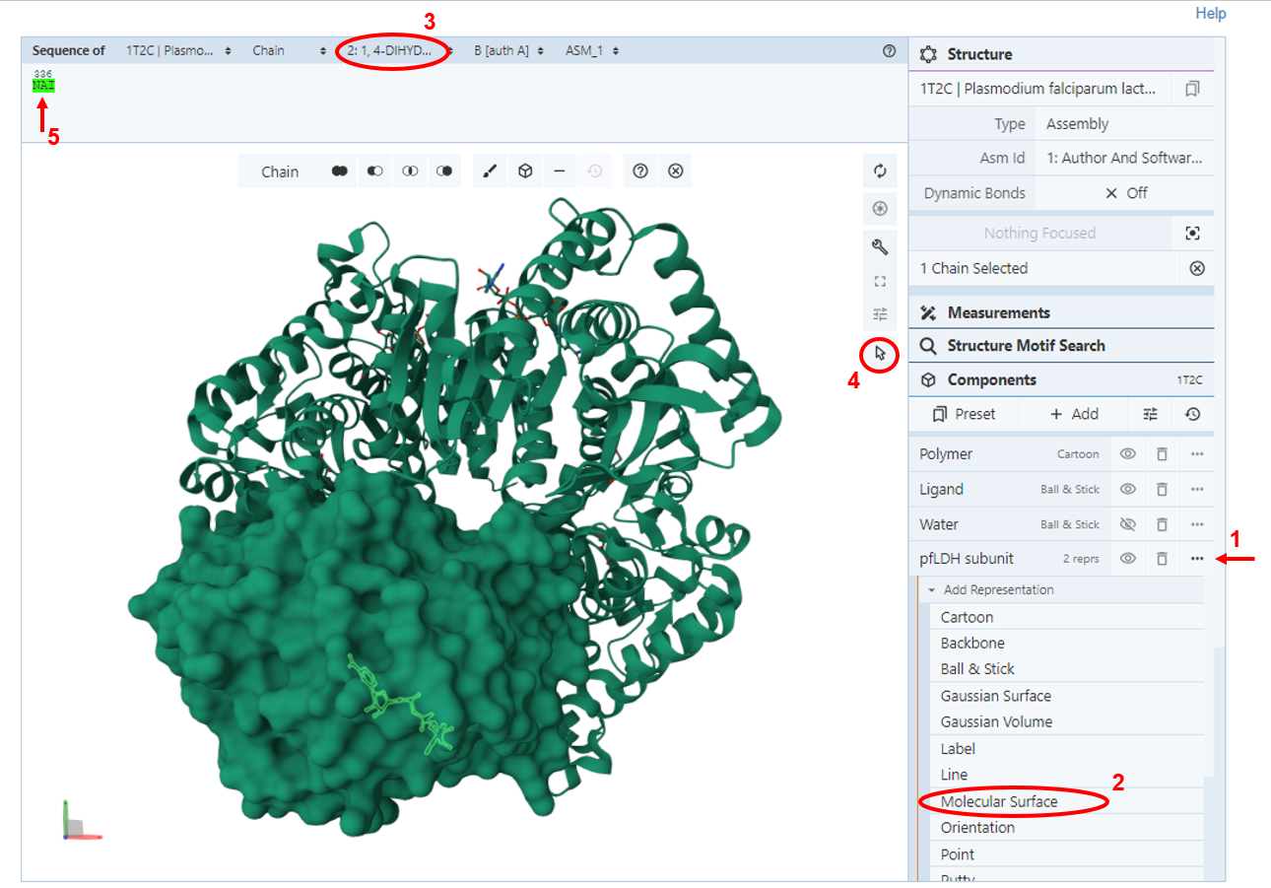

- To add NAI as a component, click the cube symbol in the toolbar, click “<Create Later>” to change the representation to “Molecular Surface.” Add a label to identify the cofactor by clicking “Options” and entering “NADH” next to “Label,” then “Create Component” to finish the action.
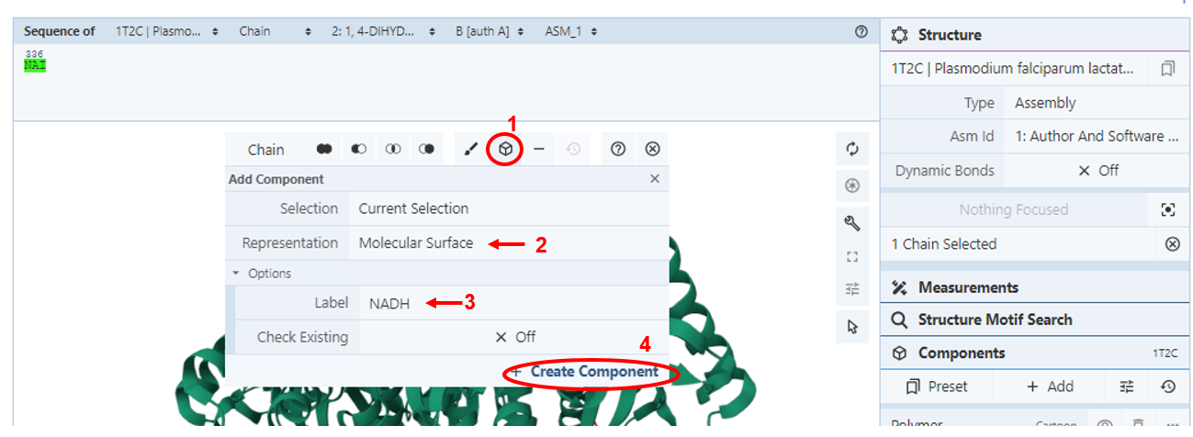

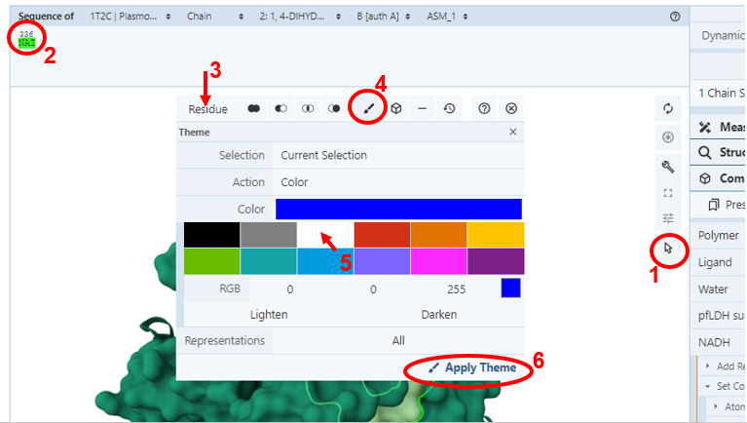
- After you complete this step you should see a new component called NADH on your right panel.
- To change the color of the NADH, click on the selection arrow to toggle on the selection mode, make sure that the selection choice is set to residue, select NADH by clicking on it on the structure or sequence and then click on the paintbrush symbol to choose a color and click “apply theme”

This should give you a view of the active site with the NADH cofactor. You may need to turn your molecule around to see the NADH.
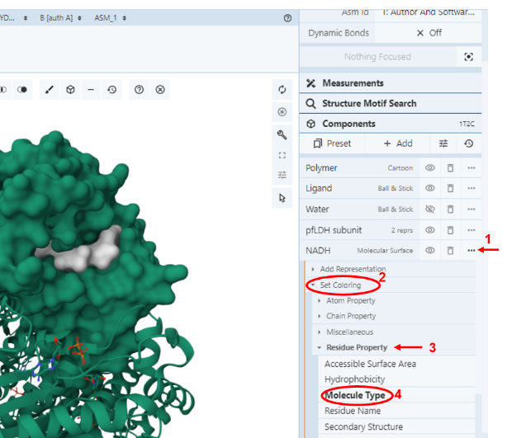
Alternatively, click the 3 dots symbol to the right of your new “NADH” component in the sidebar and click on “Set Coloring”. You have a variety of preset color themes to choose from. You can select anything that helps you to distinguish NADH from the rest of the protein.
Example: Residue Property Molecule type or residue name

- Repeat steps 1-6 on the other LDH molecule.
- Rotate the molecules around to obtain a relatively similar view for pfLDH and hLDH NADH binding sites.

Q16. Insert a screen capture of both subunits showing NADH in the active site below.
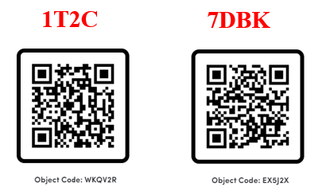

Q17. Do you observe any differences in the NADH binding between the two LDH subunits in their respective active sites?

LDH active site residues

- Change the representation of NADH molecule to “Ball & Stick”
Components → pfLDH subunit (3 dots) → Add Representation → Ball & stick
You will need to “hide” the molecular representation (toggle off the eye icon) to view only the ball and stick representation.

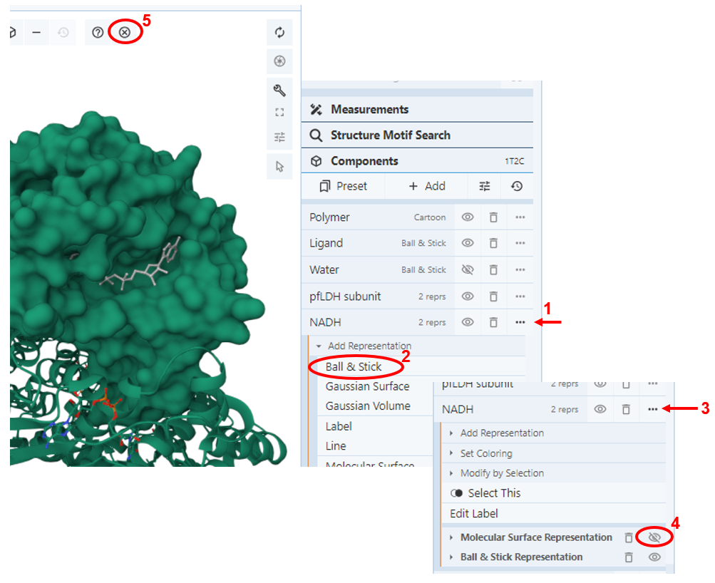
- Turn off the Selection Mode by clicking the arrow symbol or the x symbol on the right side of the toolbar.

- Focus on the ligand by clicking on to highlight it and zoom into its location.

Under “Components” there should be a tab titled “Focus: Surrounding 5A.” This shows the nearby residues and interactions within a 5 angstrom distance from the selection.

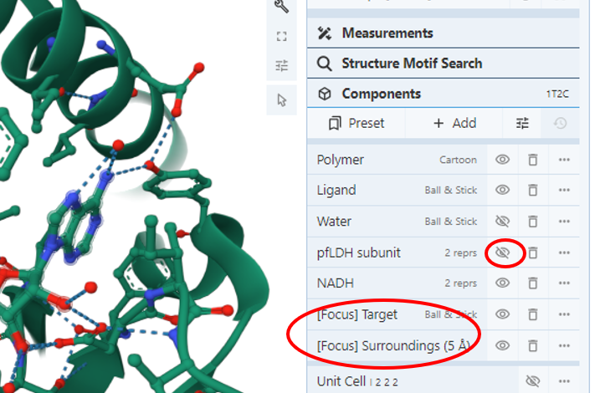
- Clean up the visualization by hiding the rest of the LDH subunit structure. In the sidebar click the eye symbol next to all components except for NADH and the [Focus] elements.

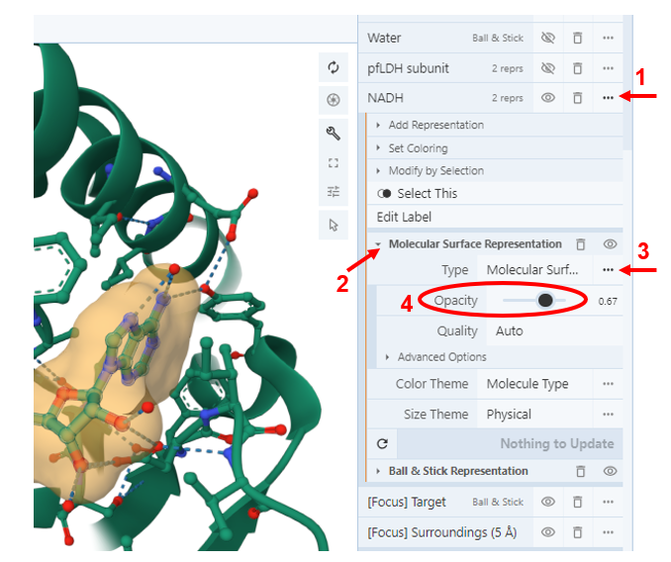

Since there are multiple residues visible, it can be difficult to see the NADH. You can unhide the molecular surface representation for NADH and adjust its color and opacity to create an envelope around the cofactor. To change opacity, click on “molecular surface representation” and then the three dots to its right to bring up the opacity slider.

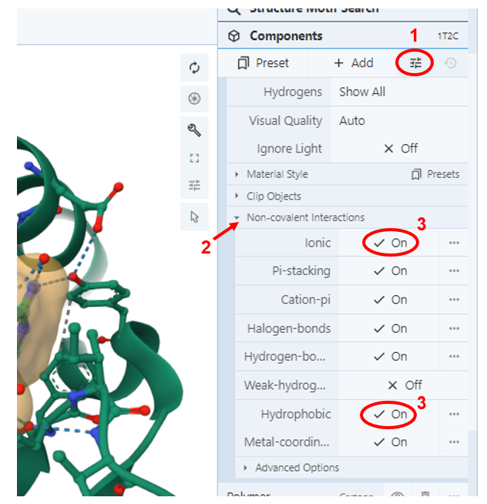
The dash lines shown indicate the default non-covalent interactions between NADH and all atoms within 5Å to it.

- To customize the visualized interactions, click on the slider icon below the “components”. Click on “Non-covalent Interactions” and choose the interactions you would like to visualize. (Try adding in the “ionic” and “hydrophobic”)

- Repeat steps 9-14 for hLDH-B.

Q18. Why do you think we can assume that amino acid residues that are up to 5 Å away from NADH are involved in binding the coenzyme to the enzyme?

Q19. Insert a screen capture of the pfLDH and hLDH-B active site residues interacting with NADH below.

- Label all the residues that are directly interacting with NADH on your figure.
To label the residues in Mol*, use the “Measurement” tool in the sidebar. You can only add one label at a time, so the Label tool will only apply to your most recent selection (appears with the number 1). This adds the corresponding three-letter code and number to each residue. You can adjust the font size but not the location
(Click residue) → Measurement → Add → Label (1st selection item)

- Identify and label the conserved Histidine residue in the active site.

- Do you see any other interactions that play an important role in orienting NADH in the active site?
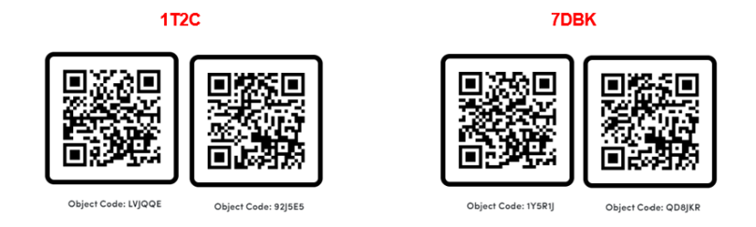

Q20. Compare the active site residues you identified through molecular visualization to the residues you identified during the analysis of the primary structure alignment.

CONNECTING STRUCTURE TO FUNCTION:
Learning Objectives for this section
- Explore the molecular details of the binding of a competitive inhibitor to the LDH active site.
- Compare and contrast the molecular details of the inhibitor binding to hLDH and pfLDH and discuss the meaning of those differences in terms of drug design for treating malaria.

After her molecular explorations of the LDH active site, Maria starts to understand how small structural differences, especially around the active sites of enzymes, can greatly impact enzyme function. She remembers from her biochemistry class in college that competitive inhibitors bind at the active site of an enzyme and compete for binding with the enzyme’s natural substrate. Hence, she reasons that it should be possible to find a competitive inhibitor which effectively inhibits pfLDH, but not hLDHB if the alteration of the kinetic parameters for the respective enzymes (pfLDH and hLDH-B) are sufficiently different due to differential binding of the inhibitor to the two active sites. While she is reviewing her understanding of how a competitive inhibitor works to reduce the activity of an enzyme, Michelangelo calls her to let her know that he has come across an azole-based compound, 4-HYDROXY-1,2,5-OXADIAZOLE-3-CARBOXYLIC ACID (known as OXD1 or OXQ) as a possible competitive inhibitor of pfLDH against its substrate lactate in a published journal article⁴.
During drug design, scientists examine proteins in painstaking detail to take advantage of small structural details in designing specific and potent drugs. The first step in this process is most often analyzing structures of protein targets in order to facilitate the design of molecular libraries that could have leads in specificity or potency. Specificity relates to how well a certain drug would interact with a protein of interest compared to any other similar protein, while potency is used to describe how effective the drug is at producing a desired effect.
Small structural differences especially around the active sites of enzymes can be used to guide inhibitor-based drugs. In the case of malaria, the authors of this paper synthesized a series of compounds they hoped to potently inhibit pfLDH without severe toxicity in humans due to differences in the site that determines substrate specificity. They identified the compound QXD1 via an enzyme assay-based high-throughput screen and showed that it inhibited pfLDH with over 100-fold lower IC₅₀ compared with hLDH. This meant that the concentration of OXD1 required for 50% inhibition of the LDH in a solution for human LDH is much greater than for parasitic LDH. Hence, QXD1 could selectively reduce the activity of pfLDH without a significant reduction in the human LDH activity.
Excited with the prospect of OXD1(also known as OXQ) as a suitable antimalarial drug, Maria and Michelangelo sat down to compare the crystal structures of the enzyme-inhibitor complexes solved by these researchers: PDB ID 1T24 (pfLDH complexed with OXQ and NAD⁺) and PDB ID 1T2F (hLDHB complexed with OXQ and NAD⁺)

Exploring the OXQ binding to LDH active site:

- Go to the RCSB Protein Data Bank (https://www.rcsb.org/) and search 1T24
- To explore pfLDH bound to OXQ and NAD⁺ enter “1T24” in the query box and press search.
- On a NEW tab repeat the search for hLDH bound to OXQ and NAD⁺ by entering “1T2F”.
- Go to the “Sequence” tab on the top which displays a graphical representation of several sequence derived information about this structure. You can click on the “View Features in 3D” to split your screen to have the sequence information on the left panel and the structure on the right so that you can locate each residue in the primary structure on the 3D structure.
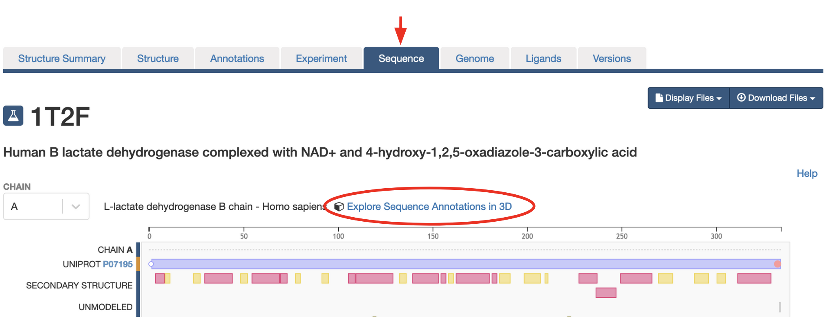

Q21. Based on the information presented, list the residue numbers for residues that bind to OXQ. What similarities and differences do you observe between the residues that bind the competitive inhibitor OXQ in each of the LDH molecules?

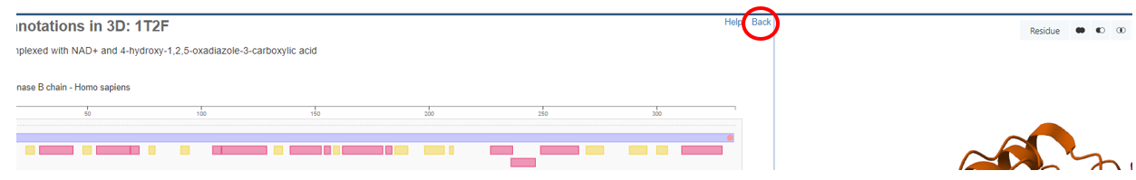
- Exit the split view by clicking on the “back” button on the upper right-hand side of the sequence panel in the split screen.

- Go to the “Structure” tab to display the 1T24/1T2F structure and set the representation to “Cartoon Representation” if it isn’t already and hide the water molecules.
- In the sequence bar, change the selection to OXQ (3: 4-Hydroxy-1, 2, 5-Oxadiazole-3-Carboxylic Acid) to focus on the ligand.
- Select and make this inhibitor a component labeled “OXQ” using “ball & stick” representation.
- Close the selection mode using the x symbol at the right of the toolbar, then click on that “OXQ” component to focus in on the inhibitor.
- Hover over the OXQ structure (check its identity in the bottom right corner) and click on it to make it the focus. The surrounding interactions will be visible.

Q22. What other small molecule is in this zoomed view? What does this imply in terms of the binding site for the inhibitor with respect to the functional enzyme?

- Under “Components” there should be a tab titled “Focus: Surrounding 5A.” This represents the nearby residues and interactions within a 5Å distance from the selection. Click on the 3 dots symbol to the right of this component and choose “Select This” on the dropdown menu to highlight all these surrounding residues.

- Under the “Components” section click on the “+Add” tab and make this selection a new component in “Ball & Stick” representation titled “Inhibitor Binding Residues.”
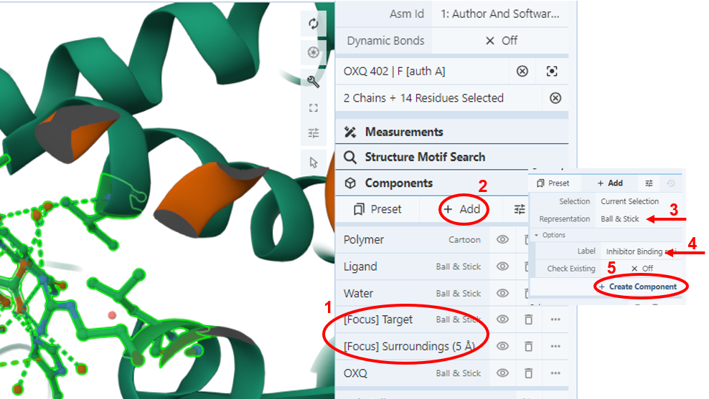

- Go to the “slider” icon next to “+Add” and click on the “Non-covalent Interactions” for the drop-down list of interactions you want to visualize. Add the “ionic” and “hydrophobic” interactions by checking them.
- After making sure that the “Inhibitor Binding Residues” component is selected, use the “Add” tab next to the slider icon to make another component by selecting “Non-covalent Interactions” for the representation and naming it “Interactions”
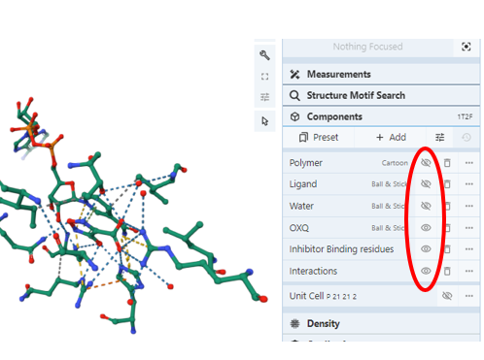
- Now you should have the following 3 components showing up in your component panel on the right: OXQ, Inhibitor Binding Residues, and Interactions.
- Clean up the visualization by hiding all the other components using the eye symbol next to them.

- Let’s now color the “carbons” of the inhibitor with a different color to make it stand out.
              - Click on the 3 dots next to the OXQ component in the sidebar to activate the menu and click “select this” (You should see the inhibitor highlighted in green on your canvas)
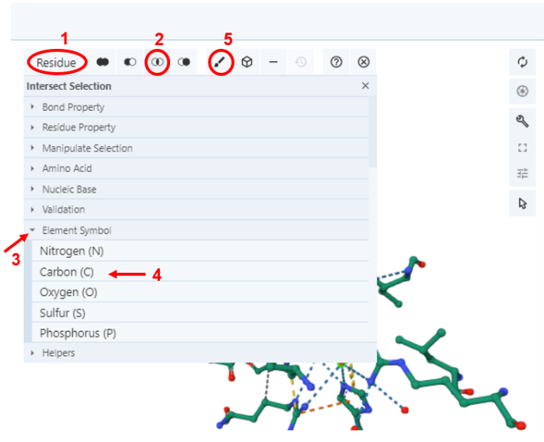
              - Make sure that the selection panel is set to “residue” (1) and then click on the “intersection” icon (2). Then activate the “Element symbol” (3) and choose carbon (4) (You may need to scroll down to see all elements).
              - Then go to the brush symbol (5) which opens up a color palette.
              - Choose any default color or type in the RGB color number designations to make your own colors. (Ex: Cyan is 0, 255, 255). You have the option of applying this color to “all” representations of your selection (in this example carbons of NAD⁺) or click on the “All” box to open up a dropdown menu to choose which representation you want the coloring to apply to. For this example, choose “Ball and Stick”.
              - Click “Apply Theme”

If you like you can repeat the same procedure to color the carbons of all the residues from LDH, another color of your choosing to make it easier to see.

- Label the inhibitor binding residues and rotate the structure, to find a good angle to see the OXQ inhibitor and most of the interacting residues.

Q23. Insert a screenshot of your annotated view. Your final figure should show the two ligands in two different colors, have labels for the LDH amino acid side chains within 5Å of OXQ as well as the observed non-covalent interactions.
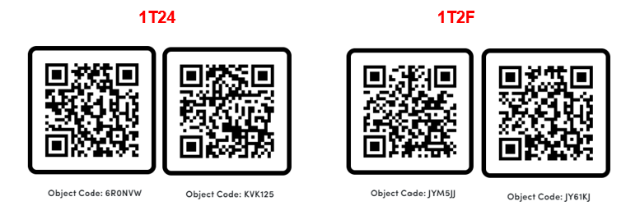

Q24. What are the different types of interactions between OXQ and its surroundings? (Note: each type of interaction is designated with a different color. You can hover over the dashed lines and read the identity of each interaction on the bottom right corner of the canvas). Which atoms do these interactions involve? Describe each interaction in your own words. Can you think of any other biochemistry contexts you might have encountered each of these interactions? List some examples you remember.

Q25. List the residues that bind to OXQ and the type of interaction they are involved in. Do they match the ones you retrieved from the PDB site in Q21? Support your answer by providing a screenshot of the interactions between LDH sidechains and OXQ.

Finally, let’s measure some distances between the inhibitor and the conserved Histidine in the active site. Note that this is H182(auth195) in the pfLDH and H193 in the hLDH 1T2F.

- Hide all the interactions to have a cleaner view.
- To measure bond distances, use the selection tool and change the type in the top toolbar from “Residue” to “Atom/Coarse Element.”
- Click on NE2 on H193 (the nitrogen on the ring closest to OXQ) and then on O7 on OXQ (the oxygen closest to H193)
- Click on “Measurement” in the sidebar, click “Add,” then “Distance” which adds the bond distance on the selected bond.
- Now add in all the other H-bonds distances between OXQ and the surrounding residues.

Q26. Insert a figure below showing all the H-bond distances between OXQ and the interacting residues in the pfLDH and hLDH-B active sites respectively. Also take a screenshot of all the corresponding distance measurements from the sidebar and include below.

After exploring the inhibitor binding to both LDH active sites separately, Maria is not sure if there are enough structural differences between the two enzymes in the active site to account for the reported 100-fold activity difference. So, she decides wants to do a structural alignment to get a better understanding.

Structural Alignment of pfLDH and hLDH-B active sites with the inhibitor OXQ:

- Go to https://www.rcsb.org/ and click on the “Analyze” tab on the top bar and select “Pairwise Structure Alignment”
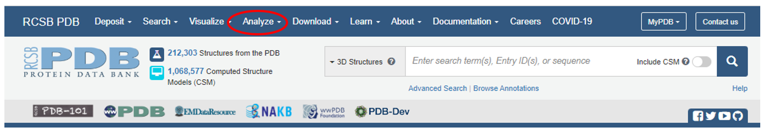
- Enter 1T24 and chain A in the first row of “compare structures” and 1T2F and chain A in the second row. Keep the default parameters for rigid body alignment. Click “compare”.

This will return a screen that has the two structures superimposed on their entire first subunit.
- Click on the wrench ()icon to expand the view to include full Mol* capabilities.
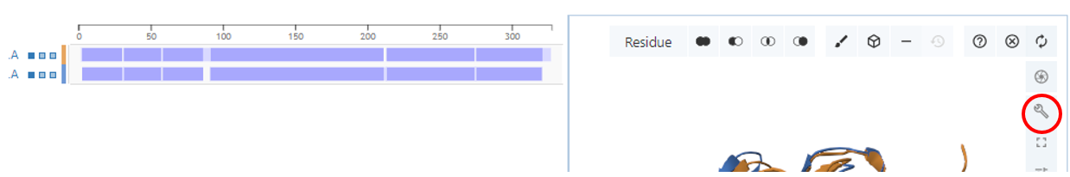
and adjust the left side of the canvas to increase the canvas area.
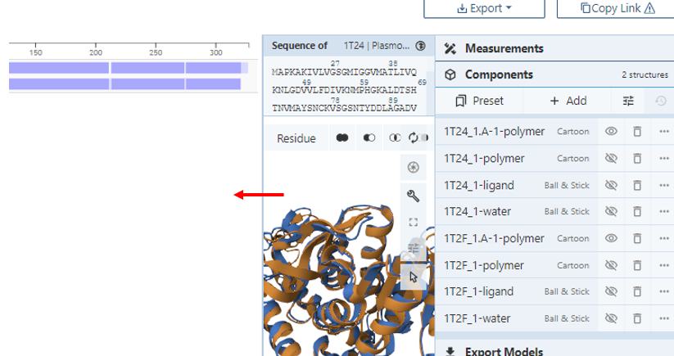

- At this point you will need to do some cleanup to get rid of components you are not interested in as the view can get very crowded quickly.
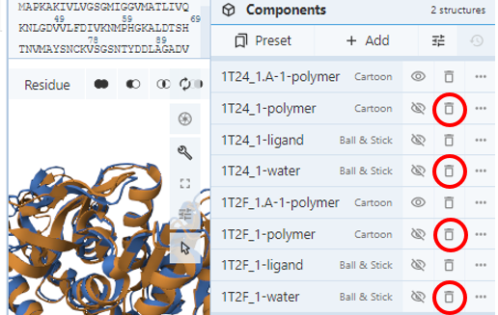
- In the components menu the aligned monomers of the two structures are designated with an additional “.A” in their names (i.e. 1T24_1.A-1 polymer and 1T2F_1.A-1 polymer). Remove the other two polymer components as well as the associated water components by clicking on the trash can icon next to the components.

- Then “unhide” the associated ligands by clicking on the eye icon “”
- Click on the inhibitor from 1T24 within the aligned monomers to bring it into focus and create a component called “inhibitor_1T24” with all the residues surrounding it as you did earlier.
- Repeat for the inhibitor in the second structure, calling it “inhibitor_1T2F”.
- Now hide all other components and just visualize the inhibitors and the residues they interact with in the aligned structures to identify major changes.

Q27. Insert a screenshot of the superposition of the inhibitor in the pfLDH structure with its interacting residues in the active site and the hLDH structure below and highlight some of the major differences.

Q28. Based on the structural changes you observed and the distances you measured for the different interactions between the inhibitor and the enzyme for pfLDH and hLDHB, do you expect the compound OXQ to bind more tightly to pfLDH or hLDH? Justify your choice by providing specific molecular support

Structural changes explain functional differences:

            - Go to Binding DB to obtain the K_{I} for OXQ
https://www.bindingdb.org/rwd/bind/index.jsp#
            - Enter in the search bar: 4-HYDROXY-1,2,5-OXADIAZOLE-3-CARBOXYLIC ACID. Select the first compound.

Q29. Based on the information in the “Affinity Data” columns,
              - What is the K_{I} for this compound for pfLDH and hLDHB
              - Would you expect the K_{I} to be higher or lower for human LDH if OXQ had lower binding affinity in hLDH compared to pfLDH?

Q30. Based on your analysis of the OXQ inhibitor, would you recommend that Maria uses OXQ as a safe and effective antimalarial drug? Why or why not? Be sure to include discussion of active sites and binding affinity in your answer.

ASSESSMENT OF STUDENT LEARNING:

Learning Objectives for this section:
- Evaluate the success of an alternative drug treatment
- Identify the components necessary for a viable drug inhibitor

Though these recent discoveries in antimalarial activity with the OXQ inhibitor have been promising, a mode of distributing it in an accessible drug form to the public has yet to be found and could take years to finalize. In the meantime, Maria must opt for a treatment that is already established. Fortunately for Maria, there has been major progress in malaria treatment, specifically with chloroquine! Chloroquine is an approved drug that effectively targets Plasmodium falciparum LDH.

Go to: https://go.drugbank.com/ and search for “Chloroquine”.

Q1. When and for which disease was Chloroquine first developed and FDA approved for? Since then, for the treatment of which other diseases has it been repurposed? Is it a FDA approved treatment for Covid-19?

View the following sources to familiarize yourself with the scope of chloroquine as an accessible malaria treatment, especially when traveling to Central America and the Caribbean.
https://www.cdc.gov/malaria/resources/pdf/fsp/drugs/Chloroquine.pdf

The paper below⁵ describes one of the studies of chloroquine inhibition of pfLDH (https://www.jbc.org/content/274/15/10213.full.pdf). Read the Experimental Procedures Section.

Q2. What were the reported K_{I} values of chloroquine to pig LDH and pfLDH?

Q3. Why did the researchers use pig LDH instead of human LDH? Justify their decision by performing a sequence alignment on pig LDH and human LDH using UniProt. Include a screenshot of your alignment below.

Search the PDB for a structure of Plasmodium falciparum in a complex with chloroquine and visualize the structure with Mol*.

Q4. What is the PDB ID for your selected structure?

Q5. By following directions from the previous sections, create a figure of chloroquine interacting with specific LDH residues. Label the important residues and ligands. Insert your screenshot below. Include a list of the interactions you observe between the enzyme and chloroquine.

Q6. Where on the molecule does chloroquine bind? What kind of inhibition does chloroquine pose on the Plasmodium falciparum LDH?

Q7. Using the study on chloroquine on pig LDH and pfLDH, as well as the structural characteristics you observed using Mol*, explain how chloroquine is an effective antimalarial agent?

Q8. Based on what you have learned about OXQ and chloroquine inhibition, what are the key characteristics of a viable drug inhibitor?

References:
            - Abbott, https://www.globalpointofcare.abbott/en/product-details/binaxnow-malaria.html Accessed 03/09/2023
            - Oliveira-Ferreira, J., Lacerda, M.V., Brasil, P. et al. Malaria in Brazil: an overview. Malar J 9, 115 (2010). https://doi.org/10.1186/1475-2875-9-115
            - World Health Organization-Malaria, https://www.who.int/news-room/fact-sheets/detail/malaria Accessed 03/09/2023.
            - Cameron, A.; et al. Identification and Activity of a Series of Azole-based Compounds with Lactate Dehydrogenase-directed Anti-malarial Activity. J. Biol. Chem. 2004, 279 (30), 31429-31439.
            - Read, J. A.; et. al. Chloroquine Binds in the Cofactor Binding Site of Plasmodium falciparum Lactate Dehydrogenase. J. Biol. Chem. 1999, 274(15), 10213-8

