A Case of Severe Insulin Resistance
By Melanie Lenahan¹, Shuchismita Dutta²*

¹Science and Engineering, Raritan Valley Community College, Branchburg, NJ
²Institute for Quantitative Biomedicine, Rutgers University, Piscataway NJ
*contact author: sdutta@rcsb.rutgers.edu

Part 1: “Megan, Jade, and Joanna” (9 points)

Jade and Megan have been best friends since second grade. While in school they spent a lot of time in each other’s homes. Jade’s older sister, Joanna or Jo, was their favorite go-to person – for help with school projects, personal advice, teenage troubles, and so much more. A few years ago, Jo got married and now lives with her husband and little baby girl in Texas. Currently the three of them live in different cities – Megan is in Massachusetts, studying in Boston College majoring in Biochemistry; Jade is in California studying in Los Angeles College of Music to become a pianist; and Jo is a nurse practitioner in Austin. Even though they live over 2600 miles away from each other, Megan and Jade still keep in touch.
Last month, Jade called Megan on a Sunday afternoon and anxiously said – “Do you know Jo told me that she was recently diagnosed with Diabetes, something about insulin resistance or something?” “She is just 32, not obese, you know, and is very particular about what she eats and stuff”. Megan sensed that Jade was worried. She knew Jade’s mom and maternal grandma had been diagnosed with diabetes in their thirties too, so she wondered if Jade was worrying about developing diabetes herself. A little later Jade mentioned ““Jo even said that she got tested and confirmed that it is not a MODY, do you know what that is?” Megan didn’t know but said she would find out. That afternoon they talked on the phone for an hour about family history, food, obesity, and diabetes. By the time Jade hung up, Megan was seriously thinking about Jade’s chances of getting diabetes, and for that matter, Joanna’s baby girl too.
The next morning Megan decided she wanted to learn more about diabetes and MODY. During her “Intro to Research” course Megan had learned about PubMed, a free online search engine for scientific literature on biological and biomedical topics with links to access their abstracts and full articles. She started searching online to see if I could find anything that could help her understand if and how diabetes could indeed be inherited. Megan found out that Maturity Onset Diabetes of the Young (MODY) was caused by mutations in specific genes that can lead to diabetes. Then she remembered that Jo’s test results for MODYs was negative. Megan wanted to learn more about insulin resistance. One particular paper that really caught her attention was titled “A Family with Severe Insulin Resistance and Diabetes Due to a Mutation in AKT2”. The family tree shown in the paper seemed very much like Jade’s family, so she became curious and opened the paper to read it in detail.

The Familial Connection

Q1 (2 pts) . Draw a pedigree tree for Jade and Joanna’s family with currently known information about diabetes in the family. You can draw this by hand or use a program like PowerPoint or there are programs that can draw this for you (search the internet). Hand drawing probably will be easier.

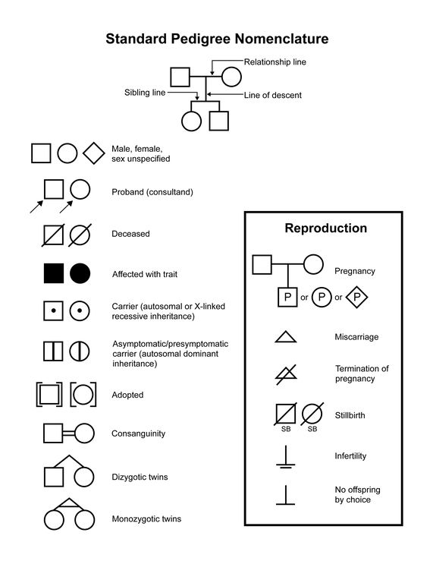

Figure 1. Standard pedigree nomenclature and common symbols.

- Read the abstract of the paper (George et al., 2004; https://doi.org/10.1126/science.1096706) that Megan found and let us join her in understanding what the paper described (found in Canvas Module).

Q2 (1 pt). Define the genetic term proband.

The paper describes the case of a non-obese 34-year-old female who developed diabetes at 30 years of age. The proband, her non-obese mother, her maternal grandmother, and a maternal uncle were all affected. The pedigree tree included in the paper shows the inheritance patterns of hyperinsulinemia and diabetes in the proband’s family. Here Proband is the individual/subject who brings a case to attention – e.g., the patient, or person who is being studied. Examine the figure 1D in the George et al., 2004 paper (also shown below for your convenience) and answer the following questions.

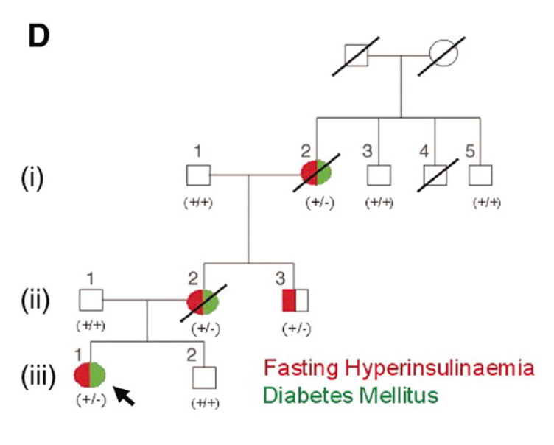
Figure 1D from George et al., 2004.

Q3 (2 pts). What is the relationship between hyperinsulinemia and diabetes mellitus in the three numbered generations [(i), (ii), (iii)] in the family tree shown above?

Figure 1a from Green et al., 2004.

Q4 (1 pt). The sequence of the DNA from the proband is shown in Figure 1a from George et al, 2004 (Shown above). The * marks the site of the base change. Explain the presence of two peaks (green and black) at the site of the mutation and why this is classified as N in the sequence.

Q5 (1 pt). DNA sequencing of the proband’s genome and selected family members revealed a G-to-A mutation in the AKT2 gene, changing the codon for amino acid 274 from CGC to CAC. Consult the genetic code (https://www.genome.gov/genetics-glossary/Genetic-Code) and list what mutation was seen in the proband.

Q6 (2 pts). Is the mutated residue side chain similar to or different from that found in the native protein? Draw the chemical structure of the side chains (or include an image) of these amino acids and explain in terms of the size and physicochemical properties.

Part 2: Understanding Insulin Resistance (10 Points)

The supplementary sections of the paper provide details on how members of the proband’s family with the AKT2 mutation had hyperinsulinemia – i.e., even when no or very little glucose was consumed these individuals produced higher amounts of insulin compared to control subjects from the population. Yet, many of these individuals developed diabetes.
Box 1: Concept
Insulin binding to Insulin receptors on the cell surface of a muscle cell initiates a series of signaling steps involving various players that eventually signal vesicles containing the Glucose transporter (GLUT4) to move to the cell membrane where they open to let in glucose from the blood into the cells.
If any of the signaling steps are missing or not functioning properly the signal to move GLUT4 transporters to the cell membrane can be disrupted as seen in insulin resistance.

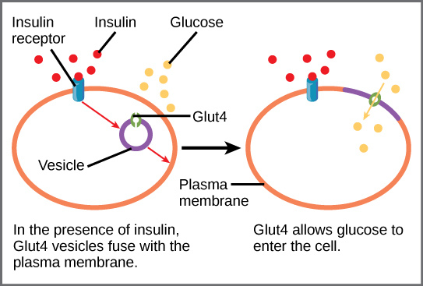
Figure 1. Insulin binding to the insulin receptor signals the fusion of vesicles containing the glucose transporter (GLUT4) with the plasma membrane. (Image taken from https://proteopedia.org/wiki/index.php/GLUT4.)

To better understand insulin resistance let us learn a little more about insulin signaling and the role of AKT2 using a resource called KEGG.

Box 2: Resource
Kyoto Encyclopedia of Genes and Genomes (KEGG, https://www.genome.jp/kegg/) has aggregated information about various types of biological interactions at the molecular, cellular, organismal, and ecosystem levels.
KEGG Pathway (https://www.genome.jp/kegg/pathway.html) is a collection of metabolic and signaling pathways in health and disease. This can be consulted to explore the names and interactions of key players in these pathways.

Q1 (1 pts). Go to the KEGG Pathway website and search for “insulin resistance” (either by typing it in the top search box or by looking through the Human Disease pathways). Save an image below of the muscle cell pathway.

Follow the pathway(s) from Insulin (INS) binding to Insulin Receptor (INSR) on the left of the page to GLUT4 vesicles being moved to the membrane for glucose uptake.

Q2 (2 pts). Identify all the key players in the shortest path that connects Insulin (INS) to GLUT4 (on the right side of the pathway) and list them in sequential order. Does this involve Akt2?

Q3 (1 pt). AKT2 is a receptor serine/threonine kinase. What is a kinase?

The George et al., 2004 paper that Megan was reading showed that the mutant AKT2 enzyme’s activity is altered. The AKT2 gene with and without the mutation was introduced into a mammalian cell line and the protein was expressed. Results of a kinase assay (Figure 2B) shows enzyme activity for both the wild type and mutant proteins, with (Ins) and without adding Insulin (Bas). Examine the figure (also shown below for your convenience) and answer the following questions.

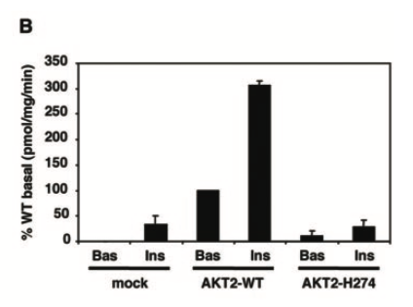
Figure 2B from George et al., 2004. Ins is with insulin; Bas is without insulin (baseline).

Q4 (2 pts). In the kinase assay results, the activity of the wild type protein changes significantly in the presence of insulin. Describe the change and explain why this change is observed in the presence of insulin? (Hint: examine the KEGG pathway and consider the insulin signaling steps in writing this answer).

Q5 (2 pts). What does the kinase assay results tell you about the activity of the H274 mutant in comparison with the wild type AKT2 enzyme?

Q6 (2 pts). Examine the KEGG pathway and explain the impact of inactivating the AKT2 enzyme. Why and how does this lead to insulin resistance?

Part 3: Insulin Resistance in Molecular Detail (12 points)

Megan wanted to “see” how a single mutation in AKT2 can impact insulin-signaling in such a big way. She also wanted to understand why changing the Arg at position 274 to His would have such a big effect on the activity of the enzyme. She decided to look at the structure of the protein in atomic detail, so went to the Protein Data Bank.
Box 3: Resource
RCSB Protein Data Bank (RCSB PDB, www.rcsb.org) provides access to 3D structural data of biological macromolecules (proteins, nucleic acids, carbohydrates and their various complexes). In addition, it provides information about the experiment used to derive the data, details about the molecules included in the experiment, and links to various bioinformatics resources that can provide additional information about the protein/molecule of interest. Each structure in the PDB is identified by a unique identifier (called PDB ID). Atomic coordinates form the PDB can be visualized and analyzed using various visualization software (some available from RCSB PDB).

When identifying the relevant PDB structures keep the following ideas in mind:
- Structures of inactive enzymes are often apoenzymes – i.e. without any substrate, cofactor etc. bound to it. In some instances, mutations in the active site residues will result in inactive enzyme – which does not function, even in the presence of relevant substrate(s) and cofactor(s).
- Structures of active enzymes are seen either as structures trapped in a transition state complex, with a substrate/ cofactor analog and or inhibitor bound. Some active enzyme structures may also be product complexes.

There are numerous PDB structures for Akt2 in the database. One inactive structure is 1mrv.

Q1 (1 pt). In RCSB, open PDB 1mrv and collect the following information:
PDB | 1mrv
Author(s) of entry
Year when the structure was published or released
Structure determination method
Macromolecule Entity

Q2 (4 pts). Click on the 3D View tab on the Structure summary page of the inactive AKT2 structure and view it. The protein has a bi-lobed shape.
- Highlight the secondary structures and proved a labeled figure of this protein.
- Polymer > … > Set coloring > Residue property > secondary structure
- Hide the water molecules
- Share a picture of the inactive AKT2 model
- Create a second image of the molecule using the rainbow coloring (similar to above, but Residue property > Sequence ID.
- Share a ‘Sequence ID’ coloration and indicate in your image the N- and C-termini of the model.

Q3 (2 pt). In RCSB, open PDB 1o6k and collect the following information:
PDB | 1o6k
Structure title
Author(s) of entry
Year when the structure was published or released
Structure determination method
Macromolecule Entities
Small molecules

Q4 (1 pt). What is ANP? Use the long name from the Structure Summary page to look up the identity of this molecule on PubChem. What is another name for this molecule?

Q5 (1 pt). Below, insert an image of ANP as well as an image of ATP (adenosine triphosphate). You can insert a 2D image from PubChem.

Q6 (2 pts). What is the significance of using ANP in the structure rather than using ATP?

Q7 (1 pt). What is TPO? Click on the TPO in the Structure Summary page to find out.

Part 4: Insulin Resistance – Contd. (18 points)

Let’s investigate the structure of the active AKT2 protein using RCSB. Open up the 3D Viewer for PDB 1o6k.

- Hide the water molecules. These are present based on the structure and may be important for the overall structure of the protein model, but we will not be investigating these interactions.
- Color the AKT2 protein based on secondary structures as done in the previous worksheet (selecting the Chain).
- Selecting Residue, label the N-terminal amino acid and the C-terminal amino acid.
  - Note that not all of the amino acids in the polypeptide sequence are shown in the structure. Label the amino acids that are at the ends.
  - The numbering of these amino acids may not be consistent with the amino acid sequence numbers.
- Select and color the ANP green. Make this space filling.
- Select and color the GSK3 peptide blue.

Q1 (3 pts). Once you have imaged your 1o6k model, download the image and include with this question. Label your image.

Q2 (1 pt). Create a figure legend to accompany your image.

Save a State image of this molecule for potential recovery.

Box: A mini-lesson on AKT2

AKT2 is a serine/threonine protein kinase that is itself activated by phosphorylation at Thr309 and Ser474. During the activation of this enzyme, the enzymes PI3K phosphorylates Thr309 while Ser474 is phosphorylated by mTORC2. Thus, AKT2 aggregates signals from multiple proteins and functions as a signaling node.

To study the activated form of AKT2, Thr309 and Ser474 may be phosphorylated or mutated (to Glu and Asp, respectively) to mimic the phosphorylated amino acid charges and interactions.

A linear schematic of the AKT2 protein showing the domains, specific amino acid residues that are phosphorylated, and the one that was mutated in the proband is shown in Figure 1B (shown below for convenience).

Figure 1B from George et al., 2004.

Using RCSB/Mol*, color the AKT2 protein one solid color (not showing the secondary structures as above). Use a different color than was used for the GSK3 and ANP molecules to allow those to standout. If you wish, you can change the colors to make the 3D model more clear.
You can hide the N- and C-terminal labels.

Identify the T309 (labeled as TPO in the sequence). Color the T309 (TPO) residue yellow (or make it a distinct color from the other parts of your model.
Label the TPO (T309) in the model.

Q3 (3 pts). Where is the T309 (TPO) relative to the GSK3 peptide in your model. Explain and include an image to support your explanation. Include a second (zoomed in) image of the TPO site in your answer.

The second potential phosphorylated amino acid (S474) has been mutated in this model. Highlight the mutated amino acid and color in magenta.

Q5 (1 pt). Where is this amino acid relative to the T309 (TPO) amino acid.

The active site (according to George et al., 2004) is the D275 residue. Highlight, color and label this residue.

The Proband in the case has a mutation in R274. Identify (and label) the R274 residue and color this residue distinctly from the other structures in your model.

Q6 (3 pts). Where is this amino acid (R274) located in relation to the TPO residue, substrate (GSK3 peptide) and manganese? Provide an image (zoomed in on the R274 but showing other labeled structures) to support your answer.

Save a ‘state’ image of your model (for backup).

The R274 (wild-type sequence) interacts with neighboring residues through hydrogen bonds. Using the Preset Options, identify the hydrogen bonds (hide the others) in which R274 interacts. Label the interacting amino acids in the structure.

Note: As you label the amino acids from the sequence, the numbering may not be consistent in the image.

Q7 (3 pts) What amino acid residues does R274 form hydrogen bonds with in the structure? Provide an image to support your answer.

Q8 (2 pts). How does your image (Q7) compare with Figure 2B from George et al., 2004 (shown below for easier reference)?

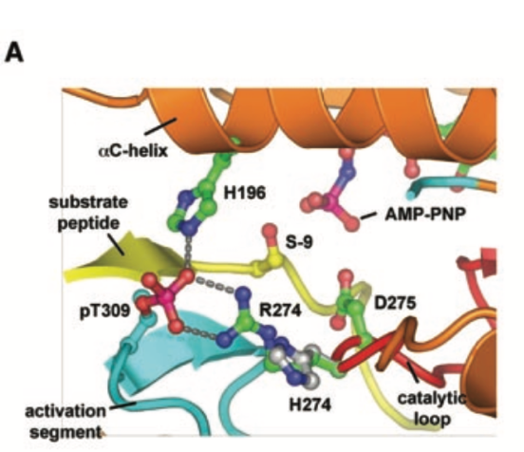
Figure 2b from George et al, 2004.

Part 5: Bypassing the Roadblock (5 points)

Two weeks ago, when Megan was walking by the departmental notice board, she stopped as she read the title – “Insulin Resistance and Improvements in Signal Transduction”. Wow! She thought this is exactly what she had been wondering about since she had read the George et al., 2004 paper. She decided to attend that seminar. The speaker, Dr. Laurie Goodyear, was a researcher at Joslin Diabetes Center, Boston, and spoke about the role of physical exercise in reducing blood glucose levels in type 2 diabetes. In this lecture Megan learned about insulin-independent glucose uptake!
------------------------------------------------------------------------
Examine the following simple figure from Dr. Goodyear’s seminar and notice the crosstalk between insulin dependent and insulin independent glucose uptake in skeletal muscle cells.

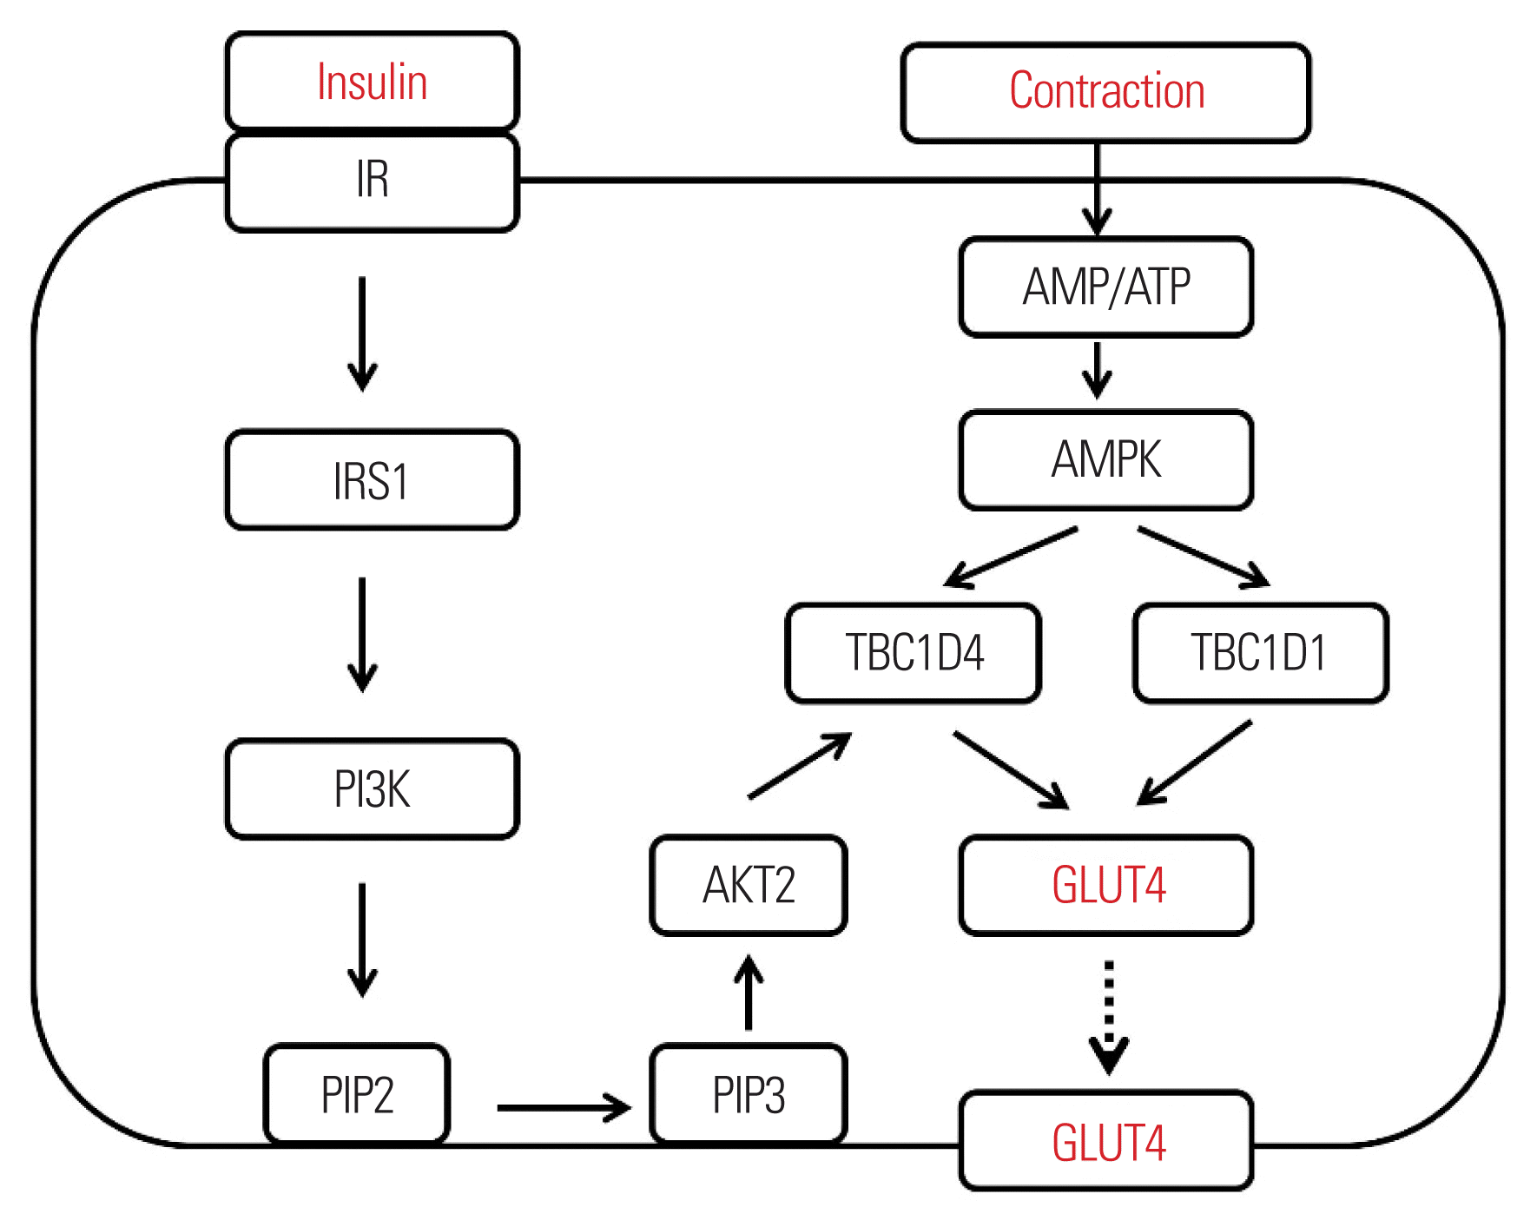
Figure 1. Journal of Obesity & Metabolic Syndrome 2018; 27(3): 150-157. doi: 10.7570/jomes.2018.27.3.150.

In the above figure do you notice that exercise uses up cellular ATP, activates AMP kinase, which in turn acts on TBC1D1 and TBC1D4 to facilitate the transport of GLUT4 receptors to the cell membrane for glucose uptake? So now even when the insulin signaling fails this pathway can be activated!

Megan was really excited and wants to write an email to Jade to explain all the things that she has found out about insulin resistance, its cause, and treatment approaches.

Q1 (3 pts). Help Megan write 1-2 paragraphs (5-10 sentences) to explain insulin resistance and possible ways to manage it. Feel free to add an image to help explain your point(s).

Highlight both the T309 (TPO) and R274 residues. To establish a distance between the residues, with them each highlighted, click Measurements > Add > Distances.

Q9 (1 pt). What is the distance in the structure between the T309 (TPO) and the R274 residues.

In the proband, the R274 is mutated to histidine (H). Examine the side chains of Arg (R) and His (H).
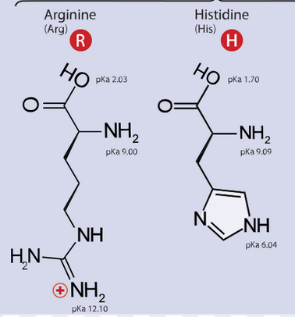

Q10 (1 pt). How might the R274H mutation (in the proband) be explained using the R274 model generated above?

Back to the Megan, Jade, and Joanna story …
------------------------------------------------------
When Megan had read through the paper, she was excited that she understood how the single mutation in AKT2 could result in insulin resistance and diabetes. However, she was also concerned – if the R274H mutation reduced the kinase activity, all signaling molecules downstream of AKT2 would not be able to pass on the signal to facilitate glucose uptake by cells. In fact, if any of the signaling molecules in the complex insulin signaling pathway was missing or non-functional it could lead to insulin resistance and diabetes. Megan also realized that many of the current diabetes treatment approaches either promote insulin secretion or inject more insulin into the system. Ironically, in the case of insulin resistance, all these approaches would probably not be helpful. For the past few weeks Megan has been wondering – how did they treat the proband and other individuals in their family?

